A hydropower project flows through Port of Vancouver USA
By: Robert L. Wallack | Issue #638 | Nov 20 2016 at 07:01 AM | Channel(s): Breakbulk & Projects Projects Energy Alternative
The 11,341-mile project cargo transit is part of the $370 million modernization of BPAs Celilo Converter Station - a move that flows through the Port of Vancouver USA
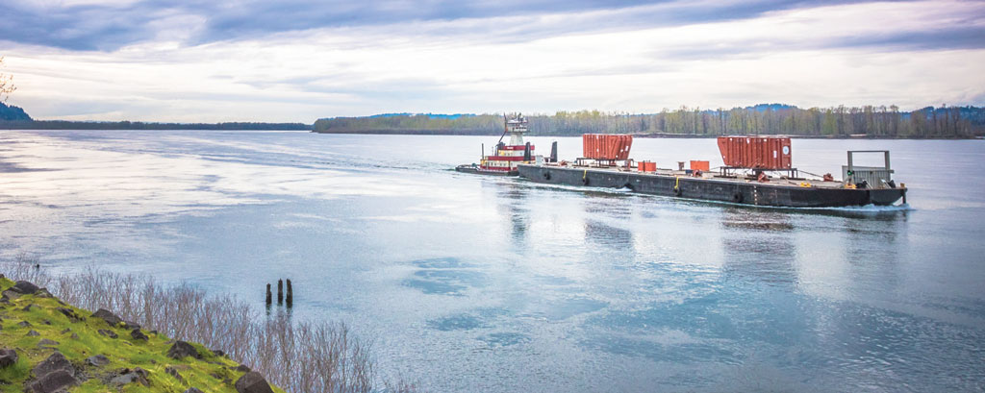Hydroelectric transformers being transported via river barge along the Columbia River

The Port of Vancouver, Washington was a pivotal transport node for a heavy haul project from Sweden to The Dalles, Oregon. It was needed to upgrade a regional hydroelectric system dating to 1961. TransProject, LLC orchestrated the logistics services with Scan Global Logistics of Copenhagen, Denmark to move seven transformers from factory-rail to ocean vessel to Columbia River barge, then conveyed on top of a new 105 feet long self-propelled modular transporter (SPMT) to the Celilo Generating Station. The hydroelectricity generated by the 31 dams of the Federal Columbus River Power System flows from the north to the south in Los Angeles and is carbon-free electricity affordable to customers in the Pacific Northwest and along the West Coast.
The route study and planning to move the seven transformers took one year until the first shipment in January 2015 and then took one year to deliver until January 2016. Each of the transformers weighs 862,000 pounds, or more than a 747 airliner.
The project was much more than these seven units. Each ship came with about 35 pieces per transformer of accessories. “The Port of Vancouver worked tirelessly with us to provide a storage plan for the large volume of accessories of which some required inside storage,” said Sue St. Germain, Executive Director of Projects, TransProject LLC, a division of Trans Group World Logistics based in Seattle, Washington in an interview with the American Journal of Transportation.
St. Germain explained that the Port dock was not used for the heavy lifts, since the vessel cranes lifted the units directly onto the barge for the 14 hours Columbia River voyage to The Dalles, Oregon dockage. However, “we visited the Port three times performing surveys of optimal solutions or a ‘plan b’ where dock strength was suitable which was not needed.” The Port was important to the planning by bringing all clients from Sweden, the U.S.A and the Bonneville Power Administration together as part of a kick-off meeting and during execution to make available the preferred berths and to process the accessories immediately for smooth deliveries.
ABB Sweden manufactured the seven massive high voltage direct current (HVDC) transformers in their Ludvika factory, and then was transported by rail in four days to the Port of Norrkoping on the Baltic Sea 80.7 miles (130 kilometers) south of Stockholm. Ocean vessel crane gear used at both ends lifted the units into the covered vessel stowage for a 45-day voyage through the Panama Canal to the Port of Vancouver. Jones Stevedoring provided the labor. “The crane drivers and crew delivered all seven units to the barge (2 per barge) with no damages or injuries,” commented St. Germain.
Marvel of Transport Engineering
A marvel in transport engineering occurred at The Dalles, Oregon on the Columbia River for the final 8 hours journey to the Celilo Generating Station. TransProject built a dockage for the self-propelled modular transporter (SPMT) vehicle. Contractors Cargo Company, super loads specialist in Compton, California purchased and operated under sub-contract “a brand spanking new” 105 feet long, 1.5 file wide (16 feet), 270,000 pounds SPMT explained St. Germain. The manufacturer was Germany’s Scheuerle-Kamag Transporttechnik Gmbh & Company, heavy duty transport experts since 1855 of the TII Group which combines Scheuerle, Nicolas, Kamag and Tratec companies.
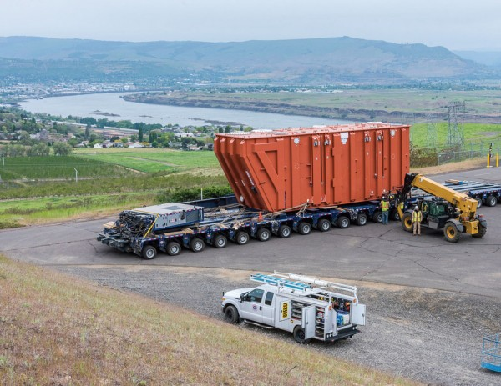Contractors Cargo Co. purchased and operated a 105 foot long, 16 foot wide, 270,000 pound SPMT for the transformers final 8 hour journey to the Celilo Generating Station.

TransProject’s Heavy Haul Method Statement depicts the SPMT in graphic details in order to win approvals by the Oregon State and local departments of transportation. The transporter has 12 tires on each of the 20 axles (4 drive axles) for a total of 240 tires on the ground needed to road transport individually the seven HVDC transformers alongside the Columbia River up to the Bonneville Power Adminstration’s Celilo hydroelectric power generating station.
11,341-Mile Project Cargo Move
The 11,341-mile project cargo move is part of the 2016 western transmission grid upgrade of hydroelectric power from the Columbia River’s Bonneville Dam by the Bonneville Power Administration (BPA). This $370 million modernization of BPAs Celilo Converter Station also involves upgrades on the 265-mile portion of the inertie that BPA owns from the Columbia River to the Nevada-Oregon border and will raise the inertie’s capacity to 3,220 megawatts of electric power for 2.4 million homes, according to BPA reports. In 1961, President John F. Kennedy authorized the project using HVDC technology from ASEA Sweden and by General Electric collaboration to send Columbia River’s hydroelectric power to southern California.
Pacific Direct Current Inertie (PDCI) is a HVDC system energized in 1970 with 1,440 megawatts and upgraded six times. The 846 mile electron super highway is the longest commercial transmission line in the United States connecting the northwest at Dalles, Oregon with Pacific southwest at Sylmar, California for the Los Angeles Department of Water and Power. At each end, a converter station changes alternating current (AC) to direct current (DC) and back. The Celilo Converting Station owned by Bonneville Power Administration is a non-federal lease-purchase program in cooperation with Port Morrow, Oregon.
In addition to the dockage built in The Dalles, TransProject’s year of planning was critical in overcoming numerous obstacles of a bridge, a round-about and a 9.2 percent incline to reach the Celilo Converter Station. The first challenge was the HVDC 862,000 pound payload on the transporter crossing the Chenowith Bridge after two days working time per transformer at the dockage in The Dalles. Prior to crossing the bridge, the crew removed two stand beams and assembled 4 wing axles (2 in front and 2 in back) to the SPMT to carry 8 wing dollies. Each dolly held 8 tires adding 64 tires to allow the weight of the transporter and transformer to spread laterally for safe passage over the bridge, according to the Heavy Haul Method Statement. One day was needed to remove the wing dollies, then one night for delivery per transformer to the site.
Careful planning and engineering were not always enough for this massive cargo logistics project. “During the first move, the city raised concerns about the retaining wall on the outside of the traffic circle. So, we were required to go around the traffic circle rather than straight through. Sort of like threading a needle with a 110 foot long 16 foot wide string,” said St. Germain.
Finally, a 9.2% grade just prior to the Celilo site presented another obstacle. Some of the ground crew of 45 persons assembled a tractor at the front to pull and a tractor-truck at the rear to push the SPMT and transformer. These push and pull prime movers of 46,000 pounds each provided tractive force for the approach to the Celilo Station and in fact lifted five of the axles at three miles per hour by 1,122 horsepower of a gross weight of 1,202,200 pounds. After reaching the site in the nighttime work, the crew rested for a day, then embarked on the procedure to jack and slide the transformer onto the foundation, which took one and a half days for each unit.
St. Germain had high praise for the Port of Vancouver making a person available to TransProject and for all stakeholders at any hour of the day every day of the week. The year of planning and engineering and the whole year of making deliveries of these seven transformers involved Oregon and Washington authorities of transportation, police, bridge engineers, traffic departments and Union Pacific rail crossover officials. In January, electricians prepared the transformers, tested them and commissioning was by March of 2016 to provide millions with clean energy.

Robert L. Wallack
American Journal of Transportation

