Air transport is improving cold chains for pharmaceuticals
By: Robert L. Wallack | Issue #636 | Oct 24 2016 at 08:11 AM | Channel(s): Transport Intermediaries
Temperature-sensitive pharmaceuticals are a rapidly expanding market segment but shifting standards are other regulatory challenges need to be met to realize market potential.
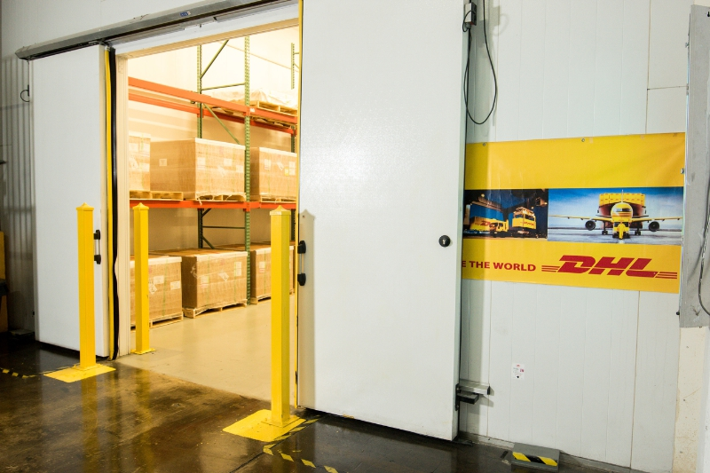DHL’s cold storage room in Puerto Rico

The demand for time and temperature-sensitive pharmaceutical products is challenging the air transport sector. In 2014, the International Air Transport Association (IATA) introduced the Center of Excellence for Independent Validators (CEIV) for certification excellence in pharmaceutical logistics to bring all stakeholders onto a harmonized system for regulations, audits and training. As a result, fragile medicines, vaccines and test kits can reach the needs of patients worldwide.
In April 2015, Rodrigo Reyes, regional manager, Airports Passenger Cargo and Security, IATA presented: “Healthcare in Air Transportation, Coping with the Challenges” at the Air Freight Logistics, Vietnam 2015 conference in Ho Chi Min City. “Only recently, has the industry moved cargo perishables in the belly of the plane. Thanks to technology more cargo can move through the air,” he said. However, he added that healthcare in transportation has challenges for time constraints, which are costly by air, and for temperature sensitivity which needs strong industry cooperation to liaise with all stakeholders to establish standards.
IATA’s Delivery Standards
Since 1945, IATA based in Montreal, Quebec, Canada, gained over 260 members to represent 84% of global air traffic and delivers standards and solutions to ensure successful air transport. Air transport has a very valuable contribution to world trade with only 0.5 percent of total volume across all transport modes (sea, air, rail, road), yet 35% of value for $6.4 trillion of goods. The need for speed in life and death vaccines, gene therapies and blood products is paramount, especially for emergencies and to developing countries.
Ocean container lines are answering the call to build refrigerated supply chains for food perishables and pharmaceuticals. “Ocean export is generally much cheaper than air export, but the transits from warehouse dock to consignee door are measured in weeks instead of days,” according to Reyes’ IATA presentation. Maersk Line invested in its cool chain capacity by ordering 14,800 new reefers in 2016 on top of 30,000 it acquired last year, and Hapag-Lloyd in August added 5,750 refrigerated containers for its reefer fleet, according to Lloyd’s Loading List.
Reyes said air transport as a reliable and safe mode of transport is losing market share of global pharmaceutical products transport from 17% in 2000 to 11% in 2013 despite pharma air cargo growth by services from air carriers, handlers and freight forwarders growing from 2008-2013 by 6% to 12% from 2013-2018. The causes are due to lack of compliance, standardization, accountability and transparency across the air transport supply chain. Annual product losses are between $2.5 billion to $12.5 billion for various reasons.
The Temperature Excursion
One reason is termed by the air transport sector as “temperature excursions” during transport and shipping. “From a typical door-to-door air transport time, almost 60% of it gets spent while the sensitive goods are in possession of airlines and their ground handlers,” said David Bang, global head of DHL Temperature Management Solutions/CEO LifeConEx, DHL Global Forwarding, in an interview with the American Journal of Transportation. From origin to destination, pharmaceutical products can be exposed to different climates that range in temperatures from 35 degrees Celsius (95 Fahrenheit) to -10 degrees Celsius (14 Fahrenheit) and involve many hand offs: trucks, freight forwarders, distributors, ground handlers, airlines and airports. Moreover, regulations, facilities, audits and training for transporting pharmaceutical products vary around the world.
The CEIV Pharma certification program is a global standardization approach that encompasses and supersedes existing standards, according to IATA. These include: IATA temperature-control regulations; the European Union Good Distribution Practices (GDP); the World Health Organization (WHO) Annex 5; United States Pharmacopeia Standards. In addition, the United States pharmaceutical industry along with transport and logistics will be challenged by track and trace electronic solutions required by the Food and Drug Administration (FDA), Drug Supply Chain Security Act (DSCSA) Title II, Drug Quality and Security Act of 2013 which is enacted in phases through 2023. This law impacts manufacturers, re-packagers, wholesalers, distributors and dispensers. Clearly, the complexities of the pharmaceutical supply chain need the CEIV Pharma to prevent sanitary issues caused by temperature excursions during transportation.
The tentacles of this IATA program are far reaching to every global region. The Airforwarders Association (AfA), based in Washington, D.C. commented, “we hosted a recent web event where CEIV people made a presentation to our membership [airlines and forwarders] and many are addressing the issues by obtaining CEIV accreditation, improving facilities and adopting processes to maintain temperature standards,” said Brandon Fried, executive director. American Airlines Cargo is moving forward with obtaining certification for its home base in Dallas-Fort Worth International, Miami International and in its dedicated 25,000 square-foot pharmaceutical and healthcare handling facility that opened in Philadelphia International in 2015. In Asia, Mark Whitehead, chief executive in Hong Kong Air Cargo Terminal Limited (Hactl) responded to this report by stating that, “at that time (2014), IATA CEIV was still in its infancy and our airline customers were more focused on GDP as their chosen standard. But CEIV is now more refined and more widely accepted and Hactl is now entering the CEIV accreditation process.”
IATA Certification
Certification by IATA independent validators is conducted over 10 weeks. This entails companies preparing for two weeks, then a 2-4 days assessment on site by validators with temperature-controlled audit checklist for recommendations into a report, then 2-4 days on site visit for validation six to eight weeks after assessment to review progress before certification. IATA training for a Pharmaceutical Handling Diploma occurs over the two to eight weeks. Additional training occurs 12 months after certification and recertification is every three years.
There are three ways certification is earned. The individual company can be CEIV Pharma Certified, a group of pharmaceutical handling companies at an airport can decide to get certified to form a pharma gateway, or a group of companies can get certified at several airports. “DHL Global Forwarding’s Belgium Station at Brussels Airport, is the first station within the DHL network to receive the IATA CEIV Pharma certification. We are currently at the beginning of 30 station global rollout of this certification,” said Mr. Bang. This summer, the DHL Carrier Award for Reliability and Excellence (CARE) went to American Airlines, Cathay Pacific, Swiss International Air Line and United Cargo as the top airline partners out of 15 airlines that demonstrated high reliability and excellence in handling life sciences and healthcare cargo.
Shippers, airline partners, regulators and IATA all benefit from the CEIV Pharma certification program. Simpler audits with lower losses from temperature excursions, assured product safety, higher revenue growth and rapid dissemination of standards all flow from this program. Pharmaceutical Commerce predicts a growth trend from 2012-2018 for global biopharma sales of $1.26 trillion by 2018 at a 31% growth rate of which cold chain will grow 61% to $307 billion. Asia is expected to account for the largest regional share with more than $1 billion of cold chain growth through 2018 and global biopharma cold chain logistics spending could reach $10.30 billion in 2018 from $7.3 billion in 2012.

Robert L. Wallack
American Journal of Transportation

