Asia Logistics and Maritime Conference brings industry experts to Hong Kong
By: Robert L. Wallack | Dec 29 2014 at 11:00 AM | Channel(s): International Trade
The Asia Logistics and Maritime Conference (ALMC) gathered over 1,600 industry experts from 32 countries to present and discuss current issues of logistics, supply chain management and maritime services on November 18-19 at the Hong Kong Convention and Exhibition Center. The event organizers were the Hong Kong Trade Development Council and the Government of the Hong Kong Special Administrative Region (SAR) of the People’s Republic of China (PRC). Some of the central themes were the importance of Hong Kong as the logistics and shipping hub for Asia or “super connector”, the growth of E-commerce in the new “speed economy” and the New Silk Road with the support of the new Hong Kong-Zhuhai-Macao Bridge.
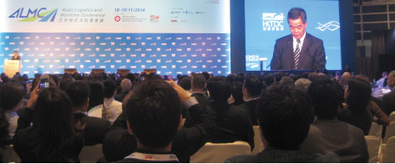CY Leung, Chief Executive, HKSAR of PRC, speaking at the podium
In the opening and plenary sessions “Drivers of Change: Navigating the New Competitive Landscape,” the keynote speakers set the tone for the conference by highlighting the major trends in the region. Chief Executive CY Leung, Hong Kong SAR of the PRC stated, “logistics is the life blood in Hong Kong” and is the “super connector” between Hong Kong and China and China and the world. The Hong Kong-Zhuhai-Macao Bridge will increase this connectivity by reducing travel time from 4 hours to 45 minutes. The Bridge will complete construction in 2016 and become operational in 2017. Hubert Escaith, Chief Statistician at the World Trade Organization spoke about the worldwide shipping market facing slower growth and smaller margins and the need to look at emerging markets or “to sell outside the high growth-low risk markets.” Finally, Dr. Karen Reddington, Regional Vice President, FedEx Express, South Pacific, noted the importance of E-commerce by stating, “the information is as important as moving the package.”
Over the two days, the conference conducted logistics, maritime and supply chain forums. Topics included, China’s E-commerce Boom: An Era of Logistics Transformation with speakers from SF Express, Yihaodian and Igetmall. The growth rate of China’s E-commerce is in the early stages with low penetration among Internet and smart device users and small and medium enterprises.
Harvey Wang, Vice President, Operations, Yihaodian, an on-line supermarket, keeps only 1 or 2 days worth of fresh inventory. They are always innovating with information technology and research and development for voice, smart stocking, order intensity tracking, optimized delivery route planning, mobile Transport Management System (TMS) and just-in-time-delivery (JIT). Igetmall is China’s only one-shop ground service provider for cross-border E-commerce in the western region of China, Chongqing. Ms. Ai Qing, General Manager, Igetmall stated that her inland location total costs of logistics, time, manpower and IT management are similar to coastal cities and that air cargo flattens the cost differential further.
The maritime forums discussed the outlook for tanker and gas trades and for liner and dry bulk shipping. “Tankers are the frontline of the logistics supply chain. If you don’t have the tankers with the fuel for everyone, you’ll never get your Alibaba delivery,” said Tim Huxley, moderator. At present, the supply of tankers has increased to almost double the demand for oil. Similarly, container liners are faced with overcapacity, lower profitability and demand for over 10,000 TEU mega containerships. Mr. Martin Stopford, of Clarksons Research, predicted, “our current rather gloomy cycle will continue until 2021.”
Finally, Hong Kong and neighboring PRC Guangxi Zhuang Autonomous Region (GZAR) are by location becoming the growth centers for the Pearl River Delta and Pan-Beibu Gulf regions for stronger trade with Southeast Asia. Master plans discussed in two sessions of One Belt, One Road (1B1R) and the Maritime Silk Road. Wang Xiongchang, Deputy Director, The Beibu Gulf Economic Zone and Cooperation with ASEAN Office of GZAR, described the “speed economy is based on the ‘time value’ of goods with E-commerce being a prime example. The advent of the ‘speed economy’ coupled with the 1B1R initiative, will unlock new opportunities for the shipping and logistics industry.”
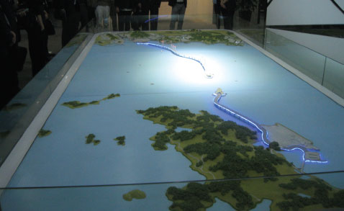Model of HK-Zhuhai-Macao Bridge

