CMA CGM advances cold chain logistics
By: Robert L. Wallack | Issue #666 | Mar 26 2018 at 03:02 PM | Channel(s): Maritime Liner Shipping
What do live lobsters, liquids, fruits and blood plasma have in common? All require refrigerated containers with temperature-controlled logistics. CMA CGM is at the forefront of refrigerated container shipping design, technology and service with innovations such as Aquaviva and REEFLEX.
Traditionally, lobsters are carried either frozen or alive with gel pack by air freight. In 2016, CMA CGM introduced the new Aquaviva containers with biological water filtration technology that controls water quality, temperature and oxygen levels. Lobsters can now travel by sea in optimal conditions mimicking their natural habitat to preserve the product’s quality. “The solution has been developed for the lobster and live seafood. We are in discussions with both oyster and mussel producers that are willing to explore moving their shellfish with the Aquaviva concept,” exclaimed Eric Legros, deputy vice president, Reefer, CMA CGM from Marseille, France headquarters in a recent interview with the AJOT.
Moreover, results are much better through Aquaviva rather than air freight. The mortality rate of lobsters transported with Aquaviva is close to zero percent compared to 20 percent for lobsters transported by plane. Also, when transported out of their natural environment, lobsters are easily stressed and can release ammonia which alters their taste, commented Legros.
Shift to Reefer Boxes
Reefer containers first appeared on the market in the 1950s. Traditional refrigerated ships placed perishables on pallets in a refrigerated hold of the ship. Over the years, reefer ships’ share dropped from 60% in 2000 to 26% in 2014 and in 2013 72% of refrigerated transport capacity in maritime shipping was in reefer containers from 33% in 1980, according to Port Technology in January 2018. Each reefer container works like a refrigerator with a self-containing refrigeration unit. Forecasts of seaborne perishables trade are to expand 4-5% per year until 2020. CMA CGM has 369,000 TEU reefer containers and 275,000 reefer plugs on board its vessels and is the second largest reefer carrier in the world with 9 percent of global volume.
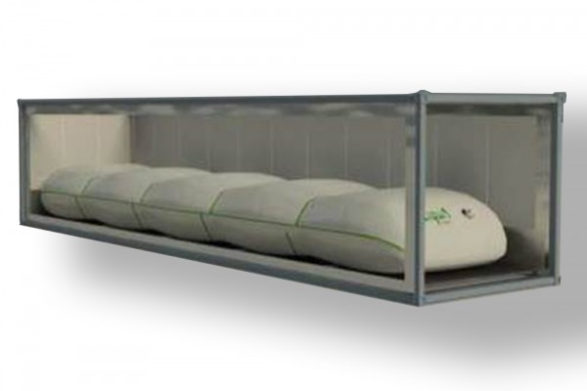
Partnerships are essential to CMA CGM reefer technology as noted in their REEFLEX presentation on February 7-9, 2018 at the Fruit Logistica conference in Berlin. CMA CGM worked with Teconja, based in Hamburg, Germany specializing in the transport of liquid foodstuffs and with Liqua with expertise in industrial packaging based in Instanbul, Turkey. REEFLEX is a bag placed in a 40-foot reefer container used to preserve liquids (juices, milk, compotes, oils) during transport. The bag takes three minutes to install and a pumping system fills and empties the bag in 35 minutes for volumes of liquids from 3,170 to 6,340 gallons (12,000 to 24,000 liters) with a temperature tolerance of -31 degrees to 68 degrees Fahrenheit (-35 to 20 Celsius).
REEFLEX is available worldwide with special accent today in Brazil, North Europe and the Mediterranean, the United States of America, Mexico, Turkey and China. “Customers are big juice players who want an optimal and cost-effective transportation solution,” said Legros. The REEFLEX technologies makes sure all types of beverages are kept at the right temperature in a sterilized environment throughout the transport and up to delivery.
Perishable items have different temperature levels depending on product and customer requirements. CMA CGM “Automated Cold Treatment” innovation is important to countries’ concerns and protocols over pest proliferation and the prohibiting of synthetic substances for organic produce as well as the U.S. Food and Drug Administration (FDA), Food Safety Modernization Act (FSMA) of 2011 implementation. In fact, “the proportion of the imported fresh fruit (mostly Latin America) eaten in the United States rose to 53.1% in 2016, from 23% in 1975 and fresh vegetables imports rose to 31.1% from 5.8%,” according to “Our New Global Garden”, New York Times, March 2018. The temperature in the reefer is maintained at zero degrees in transit without freezing produce to remove possible parasites (larvae, fruit flies) and reducing quarantine time at origin or destination. This is accomplished by twice daily reports from sensors planted in several fruits that feeds into a database, then consulted by the buyer for possible route changes, if temperatures are exceeded.
Preserving perishables’ shelf life and nutritional value found in taste are important to customers as are controlling costs associated with logistics. “Multi-Temperature” settings can program six different temperatures “automatically changing during the trip in order to meet the required biological pattern and specific operational procedure,” said Legros. For example, seed potatoes are gradually “warmed up” to match the soil temperature where they will be planted immediately after off loaded from the container. This helps growers to avoid investments in large warehouses where the warming process would have needed to take place. Fish, ice cream and frozen meat undergo the “high freezer” storage temperature and other items ultra-low temperature from -4 degrees to -31 Fahrenheit (-20 to -35 degrees Celsius).
Trade-offs
There are trade-offs and indeed competition between air and ocean freight in temperature-controlled logistics across the various trades. CMA CGM high-tech reefer boxes are pulling in pharmaceutical products to their portfolio for their very low temperature solution such as for blood plasma products. “More and more pharmaceutical products have been transported by sea into refrigerated containers instead of traditional more expensive methods by air freight. We see the conversion continuing and we are prepared to adapt ourselves to the shipment requirements,” asserted Legros.
Pharmaceutical products are needed to save lives around the world, especially in developing countries. Legros did not see a cold chain logistics constraint for exporters and importers for less developed economies. “The lack of infrastructure does not represent an obstacle, to the contrary, if CMA CGM can participate in developing infrastructure in emerging countries, it will do so, as it always has done.

