US chicken exports to China back in business
by Robert L. Wallack | March 9, 2020 | Temperature-Controlled Logistics | Published in Issue 703
Consumers in the People’s Republic of China (PRC) will be relieved by the lifting of the ban on United States (U.S.) chicken imports amidst the widespread coronavirus, African swine fever and a recent avian flu outbreak at a chicken farm in Hunan province of the PRC. Chicken meat exporting from the U.S. southeast poultry production areas will meet strict procedures by MTC Logistics, based in Baltimore, Maryland, from its new Mobile, Alabama facility. The USA Poultry and Egg Export Council (USAPEEC) expects a tremendous opportunity for years to come to serve the growing demand for alternative sources of animal-based protein in the PRC and other North Asia export markets, especially from rising middle class economies.
MTC Logistics is constructing a temperature-controlled distribution center at the Port of Mobile, AL.

Breeding experts and scientists are experimenting with the culinary versatile chicken to be an essential supply of protein to an additional 2.4 billion people added to the global population by 2050. Disease resistant chickens using no antibiotics, efficient breeding with new genomic tools and biosecurity measures are some of the methods agribusiness executives are advancing. In fact, chicken requires less land to produce than beef and pork and is cheaper which is important to price and environmentally conscious consumers.
Chicken Ban
China banned American poultry products in 2015 after the onset of avian influenza (AI). In November 2019, China lifted the ban even though others lifted the ban two years ago. However, the deal was that, “if China followed all our rules and regulations, then China could export fully cooked poultry to the USA, then we could justify food safety,” stated Mr. Jim Sumner, President, USA Poultry and Egg Export Council, based in Stone Mountain, Georgia, in a recent telephone

interview with the American Journal of Transportation. This quid pro quo deal could lead to sales of U.S. poultry of almost $2 billion to China, according to the Wall Street Journal.
The lifting of the ban will impact all regions of poultry production where the southeast dominates in the chicken agribusiness. Georgia is the number one producer in the U.S.A. and Alabama, Arkansas and Texas produce the most chickens with some in California. Turkey is produced in the upper Midwest and in North Carolina explained Sumner. He began working with USAPEEC thirty years ago after ten years in the dairy industry and director of the Pennsylvania department of agriculture for seven years.
Producers and logistics businesses will scale up shipments to the PRC at a rapid clip. “Once announced in November, ships were on the water by December. As of today, this week, 300 to 400 containers will go from the USA to China and will be a weekly basis,” said President Sumner. However, because of the coronavirus, ports are backed up and no workers are there to unload. Key U.S.A. ports laden with frozen chickens are Mobile, Alabama; Savannah, Georgia; New Orleans, Louisiana and rail lines going into Oakland, then off rails to container ships bound for China and North Asia chicken markets. In fact, Foster Farms in California was the first shipment in five years and is one of the 200 members of the USAPEEC which account for all U.S.A. companies in the poultry business.
New Opportunities
USAPEEC is spearheading an opportunity to change pork consuming countries to poultry consuming countries. Asian countries are among the top U.S. broiler export markets and are traditionally pork consumers. Japan is top for turkey, yet “we are working on Japan since they have specific boneless leg meat demand and the industry needs to do more boneless meat,” said Sumner. The trade agreement with China is now 35% duty on exports to China and needs to reduce or eliminate soon. In fact, 18.5% of U.S.A. total poultry production is exported when 30 years ago was less than 5 percent.
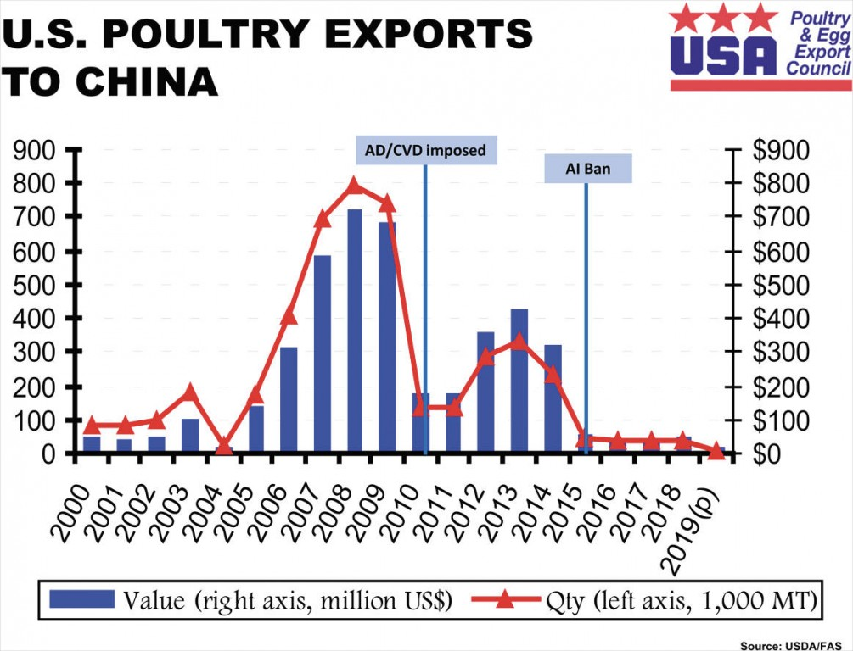

Exporting chicken is more complicated than domestic sales because of numerous food safety regulations. Each country has its own import requirements. Fifty different countries need their labels, import maximum residue, packaging and logistics requirements. Not the least of which is the need for refrigerated logistics capabilities.
MTC Logistics, based in Baltimore, Maryland, is one of the oldest and largest temperature-controlled logistics companies on the East Coast since 1928. They are now constructing a $61 million, 12 million cubic feet international temperature-controlled distribution center at the Port of Mobile, Alabama to be completed in the fourth quarter of 2020. This new facility will enable MTC to perform blast freezing by accommodating 30 truckloads per day and providing 40,000 racked pallet positions of storage. Baltimore blast freezes 10 to 15 loads per day.
A chicken export shipment starts from poultry moving from the grow-out facility to the production plant for processing. Processed chicken is then either blast frozen within 24 hours at the site or chilled to a third-party logistics cold storage (3PLCS) company such as Americold or Seaonus in Mobile. United States Department of Agriculture (USDA) regulations state the product for export must be frozen within 72 hours from the time the freezing process starts. Inland freezers such as Dothan Warehouse in Dothan, Alabama supply more export container product through Mobile. 3PLCS companies need to be approved for export to a specific country and product is boxed for shipment.
The 3PLCS enterprise fulfill order details for shipping such as special labeling by country or customers, booking number, ocean carrier, destination country and sail date. 3PLCS also arranges export inspections with Food Safety and Inspection Service (FSIS) inspectors prior to loading which includes health certificates signed by FSIS veterinarians after inspections. “MTC Logistics has their own fleet of reefers and tractors for drayage and utilize dedicated third parties to the port allowing for better coordination with the port and efficiencies with loading,” said Ernie Ferguson, vice president, Sales, MTC Logistics in a recent interview with the American Journal of Transportation. Finally, ocean reefer containers are generally floor loaded to maximize cargo.
The public health information system (PHIS) electronic portal of the USDA FSIS is an electronic certificate with the PRC as of January 27, 2020 to simplify and standardize U.S.A. exports to avoid fraud and counterfeit certificates. The PHIS is also operating with Mexico and Vietnam.
“The chicken export shipment process is for all major receiving ports in China as well as to Hong Kong, Taiwan, Vietnam, the Philippines and Japan, all major export markets for U.S. poultry,” said Ferguson.

