Garment industry takes measure of the logistic challenges and opportunities
By: Robert L. Wallack | Issue #662 | Dec 18 2017 at 08:00 AM | Channel(s): International Trade
The garment industry is facing a number of challenging issues from renewing the East Coast ports’ labor contract to e-commerce. Foremost is the American Apparel and Footwear Association (AAFA) among 26 trade associations of shippers, consignees and drayage providers petitioning the Federal Maritime Commission (FMC) to clarify by policy statement the detention and demurrage charges at congested ports in the United States. New sourcing channels from Ethiopia are also presenting opportunities to garment logistics.
In December 2016, the Coalition for Fair Port Practices filed their Petition for Rulemaking (P4-16) with the FMC. The Coalition of 26 trade associations represents importers, exporters, drayage providers, freight forwarders, customs brokers and third-party logistics providers requesting that the FMC interpret the Shipping Act of 1984, 46 U.S.C. 41102 (c). Specifically, “to clarify what constitutes ‘just and reasonable rules and practices’ with respect to the assessment of demurrage, detention and per diem charges by ocean common carriers and marine terminal operators (MTO) when ports are congested or otherwise inaccessible that prevent the timely pickup of cargo or return of equipment,” according to formal documents filed along with 15 verified statements from stakeholders.
Nate Herman, senior vice president, AAFA, explained to the AJOT that periodic events and what if scenarios such as the 2016 Hanjin Shipping bankruptcy crisis, another port lockout and severe weather issues “impacts their members and cargo owners get caught in the middle.” The AAFA is an advocacy representing more than 1,000 world famous brands in the apparel and footwear industry which involves 4 million workers and its contribution of $384 billion in annual retail sales. He said, “there is a need to establish standard procedures” by FMC for detention and demurrage charges that amount to millions of dollars assessed to shippers, consignees and drayage providers.
The Coalition’s Petition requests FMC guidance to ensure that these charges are not used inappropriately to generate revenues for cash-strapped ocean common carriers or for marine terminal operators that typically lack contractual relationships with the parties paying the charges. MTOs believe that there are underlying operational causes for port congestion such as vessel size and tight berth windows. Other factors to consider are fierce competition among marine terminals, and that there are well established mechanisms to resolve disputes over demurrage and detention and therefore, federal regulation is unnecessary and counterproductive to supply chain efficiency, according to one MTO document requesting to testify at the FMC public hearing January 16-17, 2018 in Washington, D.C.
What’s Free in Free Time?
A major point of contention is the “free time” extension by carriers for shippers at the ports. Demurrage charges are assessed for shippers’ cargo occupying terminal space and arranged by carriers through MTOs and detention is the charge to shippers and consignees for use of ocean containers and other equipment (e.g. chassis). Per diem charges are by day to drayage providers for use of ocean containers and equipment, according to the Coalition’s Petition document filed with the FMC. “Those charges do not accrue until the expiration of ‘free time’ period allowing for efficient removal of cargo or return of equipment during which no charges accrue.”
Chico FAS Inc., a specialty retailer of private label women’s apparel, imports about 850 forty equivalent unit (FEU) containers per year from Asia to their distribution center in Atlanta, Georgia for customers in their 1,518 boutiques and via the Internet in the U.S.A. and Canada. The 2014 Los Angeles and Long Beach labor issues disrupted Chico FAS flows of merchandise. “Before the congestion issues arose, Chico’s FAS had four days of free time to retrieve its containers, which was sufficient. But when the congestion began, the time needed to retrieve containers more than doubled to 7-9 days. As a result, Chico’s incurred approximately $80,000 in demurrage.”
Port congestion by increasing dwell times will continue to constrain relations between shippers and their ocean carriers and MTOs at US ports. The recent labor contract extension to 2022 by the International Longshore and Warehouse Union (ILWU) and Pacific Maritime Association (PMA) is applauded by supply chain stakeholders for West Coast shipments, but the East Coast labor agreement by the International Longshoremen’s Association (ILA), AFL-CIO, representing 65,000 longshoremen on the Atlantic and Gulf Coasts, Great Lakes, major U.S. rivers and Eastern Canada expires on September 20, 2018 and concerns AAFA members according to Herman. The last time there was a problem over labor contracts shipments to the East Coast were only 15% of total imports. Now, 25% of product is imported to the East Coast because of the Panama Canal expansion and larger container vessels.
Ethiopian Garment Sourcing
Ethiopia is becoming more competitive as a garment manufacturing source for global brands and mentioned by Herman along with the dominant source of China as well as Indonesia, Southeast Asia and South America, but sourcing decisions are based on availability of shipping transportation. “Port of Djibouti, of the Republic of Djibouti, is located in the Horn of Africa with Ethiopia in the west and south and the Red Sea at the east. The Port is served by DB World, Doraleh Container Terminal as a modern logistics platform handling most of Ethiopia’s imports and exports and strategically located for the world’s busiest shipping lanes (Asia, Africa, Europe) accessing the Indian Ocean to South Asia,” said Robin Carruthers, veteran transport consultant, the World Bank in a recent interview with the AJOT.
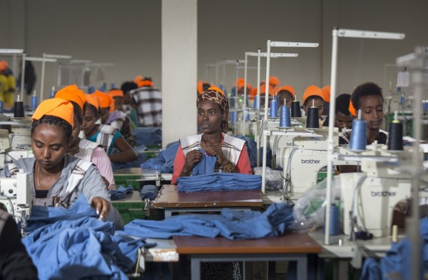
Ethiopia competitiveness is bolstered by a new railway and a trade agreement with the U.S.A. This year, Africa’s first electric transnational railway opened and built and financed $4 billion by China between Djibouti and Addis Ababa, the Ethiopia capital. This railway will cut to 12 hours what was a long 3-4 day trip by truck. In 2015, Ethiopia acceded to the African Growth and Opportunity Act (AGOA) until 2025 providing duty-free access into the U.S. These factors coupled with below $60 per month wages for garment workers versus Kenya’s $120-$150 per month, according to an April, 2015 McKinsey report, make Ethiopia competitive even against Indonesia attempts to attract China textile manufacturers. According to AAFA’s U.S. 2016 volume of imports of apparel as measured in millions of square meter equivalents from 35 countries, Ethiopia’s are still small, but increased 86.5 percent over 2015 whereas those from Kenya were down 8.3% with data dating to 2001 when AGOA began.
E-commerce ranks as a significant issue to AAFA members along with detention and demurrage policy clarification and garment sourcing as an “ongoing concern.” Herman remarked that “e-commerce is at the front of the minds of all members with a need to set up logistics in an e-commerce world.” Today’s world is less a concern of needing 20 containers in three weeks out of Asia, but how to get a quick response in an e-commerce world.

Robert L. Wallack

