Hy-Vee partners with TempTRIP to improve supply chain visibility
By: Robert L. Wallack | Issue #645 | Mar 27 2017 at 08:49 AM | Channel(s): Transport Intermediaries
Reefer equipment has come a long-ways, and the TempTRIP technology represents next-gen for temperature controlled logistics.
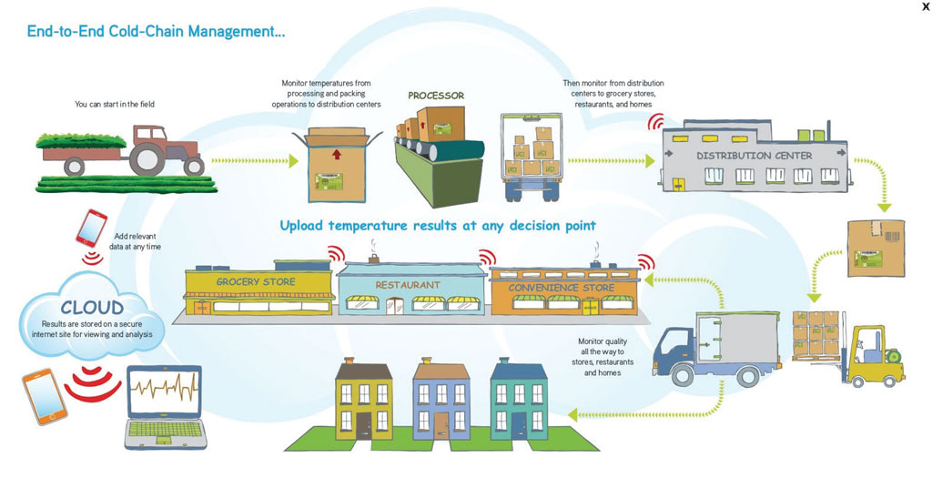
Fresh grocery items in the supermarket aisles are possible whether chilled or frozen varieties because of cold chain technologies. Temperature controlled logistics is partnering with sensor technology providers, retailers and their suppliers to ensure quality, health and integrity of perishable foods. Temperature sensitive products whether transported in the Midwestern United States or across the rails on the new Silk Road between China and Germany are monitored to satisfy shoppers’ demand for fresh food all year.
Charles Hyde and David Vrendenburg opened a small general store in Beaconsfield, Iowa in 1930 and is now Hy-Vee, an employee-owned grocery chain, with 240 supermarkets across eight Midwestern States with annual sales of $9.3 billion and employing 82,000. In 1982, Perishable Distributors of Iowa (PDI) began a distribution system to handle perishable products for Iowa customers and is now a wholly-owned subsidiary of Hy-Vee, Inc. with annual sales over $1 billion and a product list of over 7,400 fresh and frozen items.
Hy-Vee relies on suppliers to transport dairy products, fresh meats, seafood, deli items, produce and frozen goods to their distribution centers. The variability of temperatures is a challenge and needs 100 percent accuracy for a perfect shopper experience. In order to monitor these temperatures, Hy-Vee located a partner TempTRIP, a RFID cold chain solution provider based in Colorado that specializes in shipping, storage, receiving and temperature control. TempTRIP estimates that one-third of worldwide food, or $750 billion per year is lost or wasted and that one in seven truckloads of perishable products is thrown away according to their video clip on their website: http://www.temptrip.com
Temperature Monitoring
Hy-Vee requires suppliers to use TempTRIP temperature monitoring solution of RFID (radio frequency identification) tags, readers and antenna system with every order. TempTRIP, a subsidiary of Sealed Air Corporation, relies on Impinj, Inc., a Seattle based and publicly traded, manufacturer of RFID devices and software. Impinj is a “fantastic vendor for components or our tags,” said Leland Curkendall, Chief Technology Officer, TempTRIP and holder of multiple patents for RFID and database design for the supply chain in a recent interview with the American Journal of Transportation.
“The Impinj platform is a comprehensive set of end points, connectivity and software which uses RAIN RFID, a form of wireless communication that uses the global ultrahigh frequency (UHF) RFID protocol standard developed by GS1 and ISO (International Organization of Standardization),” said Erika Goodmanson, spokeswoman for Impinj in a recent AJOT interview. RAIN is an acronym for RAdio frequency IdentificatioN to link UHF RFID and the cloud where RFID based data can be stored, managed and shared via the Internet. Impinj views this data as Item Intelligence in an increasing world of Internet of Things.
Goodmanson explained that their technology is deployed by TempTRIP for Hy-Vee food items and for other customers and is wirelessly connecting billions of everyday items such as apparel, medical supplies, automobile parts, drivers’ licenses from the logistics and supply chain to front of store and customer environments. In fact, Impinj sold more than 16 billion tag chips to date including 5.1 billion in the 12 months ended September 30, 2016. “The tag chips power themselves from a reader’s radio waves so do not need batteries, are readable to 30 feet without line-of-sight, yet sell for pennies.” She continued to define the technology: “our reader chips, readers and gateways can identify and locate more than 1,000 items-per-second. Our reader chips sell for tens of dollars and our readers and gateways sell for hundreds to thousands of dollars.” PDI needs this accuracy and connectivity managing Hy-Vee shipments as well as for 450 other customers traveling 175,000 miles each week involving a 350,000 sq./ft. warehouse in Iowa.
Partnerships
The Hy-Vee-TempTRIP partnership requires food suppliers to affix TempTRIP UHF Gen2 RFID tags (Impinj Monza X-8K chips) to each order on the side of the carton or pallet. The tags record time and temperature readings on pre-set intervals from shipping to receiving. Once the truck unloads orders on the docks and passes through the distribution centers’ doors, the Impinj Speedway Revolution readers placed between the doors and connected to 11 antennas using Impinj Speedway Antenna Hubs reads the tags and sends the data to TempTRIPs’ servers. The data links with algorithms per product to be evaluated and analyzed based on the specific temperature settings in the program. The data is then sent to Hy-Vee’s website. Hy-Vee can then make decisions on that order and products(s) and relay that information to drivers, carriers and suppliers for any necessary corrective actions. This end to end supply chain temperature control solution is with 100 percent monitoring and these tags can be cleared and configured for reuse, according to the Impinj website, Retail Case Study: Hy-Vee.
Curkendall emphasized that their real-time temperature monitoring solution “looks at the quality of the load and points out the issue in the first place to the suppliers. For example, is the lettuce wilted and stressed? This is an ongoing understanding of the quality of the shipments to get a higher quality product since they have no control over consumer use of purchased product, but have of suppliers in transit and storage.” This points to the most sophisticated trend in the supply chain of prescriptive visibility. Not just where a product is, but what actions can be taken.
TempTRIP’s temperature monitoring solutions are deployed worldwide. “We fully installed 5 new DCs for a food retailer over the last few months in the northeast of the United States and four other retailers are in the plans,” said Curkendall. Also, installations were in a food retailer in China, an ocean going monitoring system for a quick service restaurant with shipments from Brazil to the Middle East and for a home delivery grocery, he said. When asked about the Food Safety Modernization Act of the U.S.A., he explained that their solutions will increase “because they provide an easy way for customers to comply with those regulations without the extra work for temperature monitoring.”
Global Reach
High end chocolates, wines, beer and baby formula (milk powder) are also receiving temperature controlled monitoring in their refrigerated containers (reefers) on the rails between China and Germany. Global Tracker, a privately held Danish company involved in sensor-based tracking in the cold chain, signed an agreement with Kazakhstan Temir Zholy (KTZExpress), a logistics service provider for Eurasian trade and dry port operator on the Eastern Gate of the Khorgos Special Economic Zone with China, for real time monitoring and alarms of temperature sensitive goods. “This trade lane is growing very quickly as new logistics providers come on board and we expect the frequency of trains to increase as it has over the past two years,” said Daulet Kakim, Director, Container Transport Department, KTZE in an email reply for the AJOT.
Global Tracker monitors dwell times at all station stops on a web interface. The sensors inside the cargo area collect temperature and door event data and alarms can be set if the temperature is exceeded, then the sensor will wake up the device to send an emergency alarm communication. KTZE has a control tower to monitor the trains’ containers along the route and the customers can log into the Internet based site to view all their containers.
Technologies of RFID tag chips, readers and antennas are changing the real-time visibility for temperature sensitive shipments. These devices are enabling food retailers, food suppliers and logistics service companies to remove costs associated with redundant labor, data entry and loss of sales because of food spoiling. Hy-Vee’s partnership with TempTRIP and Impinj is showing the way in this important supply chain trend.

Robert L. Wallack
American Journal of Transportation

