Inland ports are integral to US economy
By: Robert L. Wallack | Issue #642 | Feb 13 2017 at 09:21 AM | Channel(s): Ports & Terminals Ports
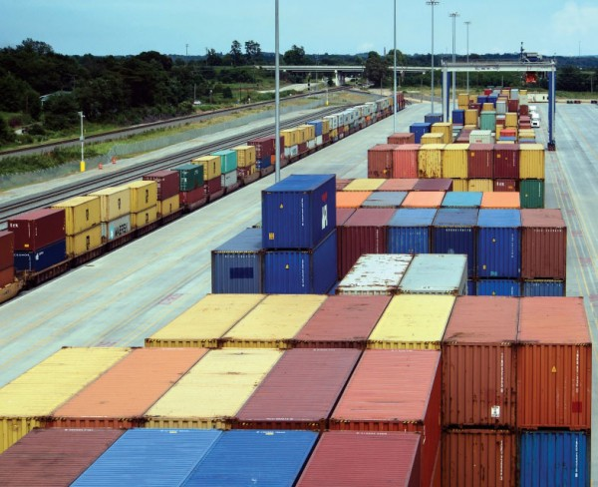Inland port at Greer SC

America’s inland ports are gaining importance as trillions of dollars of goods and services are moved throughout the arteries of the nation’s transportation network. Years ago, Illinois in the Joliet region and Ohio at Rickenbacker airport became distributor hubs for economic development, and now landlocked Iowa and Utah are embarking on plans to build inland ports. The reasons why dry ports are gaining importance are numerous, among which are e-commerce, rising freight congestion on the coastal seaports and as part of improving the United States’ multimodal freight systems for national, regional and metropolitan economic development.
Inland ports are an integral part of upgrading and expanding the nation’s multimodal infrastructure. The Coalition for America’s Gateways and Trade Corridors (CAGTC), a Washington, D.C. 60-member public and private organization, revealed some startling statistics in their call for a “strategic campaign of infrastructure investment.” The cost of congestion for domestic manufacturers was a loss of $6.5 billion in 2014 in sales of $4.4 trillion. In January, CAGTC published their second edition booklet of “Freight Can’t Wait” which lists in detail 43-United States’ freight projects needing federal partnership. By region, the West has 20, the Central has 9 and the East has 14. Listed highway and bridge projects needing funding and construction will be necessary to inland port development.
A rail trans-load facility or “Railport” located in Des Moines, Iowa is one of the 43 projects. The site is located at the cross roads of I-35, a primary North American Free Trade Agreement (NAFTA) corridor, and I-80, an interstate route connecting New York and San Francisco. This 1500 feet by 600 feet $12 million project is planned on 30 acres of city-owned property and a “unique site because of access to three Class I railroads: Union Pacific (UP), Burlington Northern Santa Fe (BNSF) and Norfolk Southern as well as Iowa Intrastate Railroad,” according to the rail market analysis and feasibility project reports. The current rail trans-load facility has limited tracks for UP only and the proposed site will be for industrial development with better handling capacities. John Deere is interested in the new Railport since they have finished goods manufacturing nearby of farm equipment (balers) for domestic distribution and exporting. “We are in the implementing stage and past the reference for proposal (RFP) stage, now. We hope to have an operator this year and have no construction, yet,” said Gunnar Olson and Zach Young of the Des Moines Area Metropolitan Planning Organization, in a recent interview with the American Journal of Transportation.
The World Trade Center (WTC) Utah in Salt Lake City is in the early stages of scoping a site by Governor Herbert creating an Inland Port Exploratory Committee of 15 to 20 stakeholders. Members of the Committee are from the public and private sectors that include city and county officials, a real estate developer, logistics companies, Union Pacific, the nearby international airport authority and exporters such as Rio Tinto mining, Boeing with operations in the area as well as a large food agriculture exporter. The Committee will hire a consultant to write a feasibility study and in nine months present recommendations to the Governor and state legislature.
Salt Lake City
Derek Miller, co-chair of the Committee from the WTC Utah, explained to the American Journal of Transportation that “Salt Lake City is already a logistics hub for goods moving from east to west and north to south and that the airport is already expanding.” Main exports from Utah are to the United Kingdom, Hong Kong, Canada, Mexico and the People’s Republic of China. A new inland port would be “not just for Utah, but an intra-mountain states’ regional hub for exporting.” The intention is to attract an e-commerce entity such as Amazon or automobile manufacturing to spur economic growth in the region. Preliminary work was visiting Hong Kong port system and the Committee plans to visit Kansas City and South Carolina inland ports. Rickenbacker Inland Port is anchored by the cargo-dedicated Rickenbacker International Airport in central Ohio of the Columbus Regional Airport Authority which operates three airports including the newly re-named John Glenn Columbus International Airport for passengers. Rickenbacker Airport has an illustrious history dating to World War I and is named after Eddie Rickenbacker, an aviation pioneer and fighter pilot ace of WWI. This former Army Air Base still has a strong military presence, but since 1980 developed into an important inland distribution, multimodal transportation and industrial hub. Now, Rickenbacker Inland Port has an industrial capacity of 100 million square feet of which 70 million square feet of warehouse and distribution space is under roof in the Rickenbacker area. This is in proximity within a 10-hour truck drive to almost half of U.S. consumers and producers.
In the third quarter of 2016, Amazon, the e-commerce juggernaut, began operations at a new 1 million square feet fulfillment center in Rickenbacker Global Logistics Park to add to another 800,000 square feet center in Etna, Ohio and three data centers in Central Ohio for a total investment of $1.1 billion over the past three years. The Norfolk Southern Rickenbacker Intermodal Terminal is located on 175 acres in this inland port and handles 225,000 containers per year with the capacity for 400,000 annual lifts.
The likes of BASF, American Showa, Boars Head, Gap, Eddie Bauer, Kraft and Build-A-Bear warehouse in the Rickenbacker area. “A vast majority of the containers are international and the mix is approximately 50 percent East Coast and 50 percent West Coast ports,” said David Whitaker, Chief Commercial Officer, Columbus Regional Airport Authority in a recent e-mail to the American Journal of Transportation. When asked about the new Panama Canal, he said it “could increase the percentage of containers received from the East Coast, but would be a cost related decision by shippers.”
CenterPoint Intermodal Center is North America’s largest inland port situated 40 miles southwest of Chicago, Illinois across 6,400 acres. Will County Center for Economic Development and CenterPoint Properties have developed an inland port in the last 15 years by handling 3 million (6 million capacity) twenty equivalent units (TEUs) containers in 2015. This is just behind ocean ports of New York/New Jersey and Los Angeles/Long Beach. Anchor tenants are the BNSF Logistics Park-Chicago in Elwood since 2002 on 780 acres and Union Pacific-Joliet Intermodal Terminal since 2010 on 835 acres. Economic activity accounted for over $65 billion of products and 76 million bushels of grain exported annually with 100 million square feet of new industrial space developed since 2002. Will County (Port of Will County, Barge Terminal for river trade) is “the third largest metro area in the U.S. and an important link in the global supply chain,” said John Greuling, President and CEO, Will County Center for Economic Development in a recent correspondence with the American Journal of Transportation.
Infrastructure Projects on Tap
Numerous transportation and logistics infrastructure projects are in the works in support of the growing number of tenants (39) across many industries. These include Amazon with four fulfillment centers, Ikea, Samsung, Bob’s Discount Furniture, Dick’s Sporting Goods, Ferrara Candy, Con-Way, APL Logistics, Diageo and Whirlpool as over 2.5 million square feet developed in 2015. Some of these projects are: the Illiana Expressway (Illinois-Indiana) east-west connection to serve as a freight by-pass, but delayed for budget and legal reasons; a public-private partnership for $190 million Joliet bridge to span the Des Plaines River BNSF Railroad tracks from I-80 to the CenterPoint Intermodal Center; and the RidgePort Logistics Center in Wilmington, Illinois on 20 million square feet (1,500 acres) rail-served park near BNSF and I-55 access and will feature 70 acres of commercial hotels, restaurants and retail.
E-commerce requirements for last mile customer service, freight congestion and the need for economic growth are causing higher investments in transportation and logistics projects. Inland ports are integral and in the exploratory stage in Utah, advancing in Iowa and expanding rapidly in Ohio and Illinois. Amazon is one of many companies reshaping the strategic significance of inland ports with $107 billion in sales in 2015.

Robert L. Wallack
American Journal of Transportation

