Mongolia: Taking action on import and export prospects
By: Robert Wallack | Dec 18 2014 at 10:09 AM | Channel(s): International Trade
The economic prognosticators paint a darkening landscape in Mongolia, but there are signs of a colorful and confident future as Mongolians are experiencing an increase in births. At present, the drastic macroeconomic situation is a result of the sharp drop in foreign direct investment (FDI) in the primary mining sector. Parliament and the Mongolian government are revising laws and correcting mistakes in policies in order to offset the depreciating Mongolia tugrik (MNT), reduce inflationary pressures, and build investor confidence.
Mongolia made much progress towards a market economy since separating from the planned economy of the Soviet Union in 1990 and transitioned to a democratic political system as well. The country is landlocked and the Zamyn Uud international border dry port with Erlian, Inner Mongolia, People’s Rebublic of China (PRC) is about 400 miles from the nearest seaport in Tianjin, PRC. The economy grew only 5 percent in the first half of 2014 after double digit growth from 2011-2013. Total gross domestic product (GDP) was $11.5 billion and $4,000 per capita in 2013 whereas its northern border neighbor Russia has a $2 trillion economy and to the south the PRC a $9.24 trillion economy in 2013. In the first seven months of 2014, China, the main trading partner, accounted for 32 percent of Mongolia’s imports and 90 percent of its exports, according to the National Statistics Office of Mongolia (NSO).
The Mongolia economy is dependent on the mining sector for 90 percent of overall exports and 83 percent of FDI. The October, 2009 Investment Agreement between the government of Mongolia and the Ivanhoe Mines (renamed Turquoise Hill Resources)-Rio Tinto strategic partnership began the above ground Oyu Tolgoi copper-gold mining complex for development. On July 9, 2013, the first copper concentrates exported by truck to the China market across the South Gobi border crossing at Gashin Sukhait by trans-loading for the Ganqimaodao, Inner Mongolia, PRC border and then onward to copper smelters. In the first six months of 2014, Mongolia exported 580,000 tons of copper concentrate of which Oyu Tolgoi exported 320,000 tons for $660 million. In addition, 5.4 tons of gold exported from the Oyu Tolgoi mine. The Oyu Tolgoi copper-gold mining area is the cornerstone of the new economy.
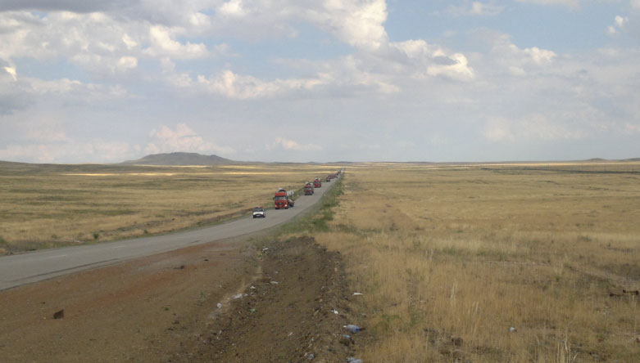Very difficult road conditions in the South Gobi posed challenges in transporting 40-55 ton components across the Mongolian steppes.
In terms of revenue, copper makes up 40 percent of total exports, coal 18 percent and oil makes up 13 percent, said Mr. D. Galsandorj, President of the Mongolian Exporters’ Association in a recent interview in Ulaanbaatar. The government commissioned a technical and feasibility study led by the United States’ Bechtel Engineering to construct a $10 billion industrial complex in Sainshand, Dornogobi province (aimag) on the Ulaanbaatar to Zamyn Uud road-rail corridor for export to China and other markets. The purpose is to process the extracted raw materials to higher value to sell in export markets. “It is a good dream. They talk so well on television. Even if Mongolia produces final products, will China purchase?” Galsandorj bluntly asserted. The precipitous 70 percent drop in FDI over 2013 to $380 million in the first half of 2014 is a result of a few policies by the government that scared away mining and other investors over the past few years. The Parliament began its new session in September to rectify “the confiscation of 126 mining licenses, stabilize the laws for investors by ensuring that contracts are honored and building infrastructure in the mining sites and not just in Ulaanbaatar,” commented a Chief Executive Officer of a Canadian copper and gold mining company operating in Mongolia in a recent investment conference in Ulaanbaatar. At stake is the multi-billion underground Oyu Tolgoi mining site to expand the first phase which could draw more investments to Mongolia in all sectors of the economy.
The drop in FDI is impacting Mongolia’s balance of payments. In the first seven months of 2014, total external trade was $6 billion of which $2,940.5 billion was exports and $3,148.1 billion was imports for a trade deficit of $207. 6 billion. This contributes to the further depreciating MNT. The lower value of the MNT is demonstrated by the October exchange rate of 1833 MNT to the United States dollar from April’s 1767 MNT for an average of 1820 MNT according to http://www.exchangerates.org.uk. The foreign exchange reserves dropped to $1.3 billion in June, 2014 sufficient for only 2.7 months of the import bill, according to Masa Igata, Founder & CEO of Frontier Securities in Ulaanbaatar. Food, consumer goods, construction material, and equipment of $1 billion accounted for the import bill for China’s 32.3 percent of the import total and oil, electricity and wheat comprised the $915.7 million import bill to Russia’s 29.1 percent in the first seven months of 2014, from NSO Mongolia reports. One of the reasons for the foreign exchange drawdown is from the central bank subsidies. “Meat, fuel and electricity are subsidized, if not inflation would be more drastic than the current 15 percent,” according to a foreign mining executive in Mongolia in a recent interview in Ulaanbaatar for the American Journal of Transportation.
In addition improving the investment climate for foreign investors, the government is trying a number of policies to strengthen other sectors of the economy. These include the livestock, agriculture, construction and tourism sectors. The nation’s 45.3 million livestock of sheep, goats, cattle and horses are promoted to export markets for their wool, world renowned cashmere, leather and meat. Mongolians are proud of their relative independence even during the Soviet Union era which is evident in their shift to self-reliance in growing more vegetables and producing more construction materials such as cement, domestically.
Agriculture and construction sectors grew 16.3 percent and 10.1 percent, respectively in the current economic downturn. In 2013, 85 percent of total cement consumption in Mongolia was imported with rising prices from China suppliers, according to the UB Post. Therefore, the government policy of “Import Substitution Industrialization” removed value added tax on imports of machinery and equipment which resulted in more foreign investment and donor aid for new cement factories opening. An additional boost to the economy will occur in the tourism sector. Recently, the government announced a 10 year 35 billion MNT ($20 million) investment in tourism.
These policies cannot succeed without improving the transportation and trade infrastructure for greater integration with the global economy. The 2012-16 Action Plan is a road construction project to connect all 21 provinces (aimags) to the capital, Ulaanbaatar. There are persistent delays at the main international border at Zamyn Uud with Erlian, Inner Mongolia, PRC for both road and rail. Progress is made on establishing a Mongolian Railway State Owned Shareholding Company (MTZ) in 2008 and in 2010 a State Policy on Railway Transportation for a national rail network. The management and investment of the existing railway is a relic from the Soviet era in a 51 percent Russian Railways- Mongolia joint venture (UBTZ) from the Russian border to the Chinese border. The rail gauge issue continues to be a costly delay to logistics and supply chains in and out of Mongolia. Russia and Mongolia use the wide gauge: 1520 mm whereas China uses the international standard narrower gauge: 1435 mm. Resolution to this problem will further Mongolia’s trade integration and lessen its isolation. In fact, the World Bank’s Logistics Performance Index (LPI) pegs Mongolia near the bottom in assessing of Customs, infrastructure, quality of logistics services and track and trace by 135 out of 160 countries in the “Connecting to Compete 2014” report.
However, passenger and freight capacity will increase by air transportation with a new international airport in 2016. The current Chinggis Khaan International Airport is surrounded by mountains and limits service whereas the new facility will be 60 kilometers south with 6 runways for 3 million passenger capacity per year from the current 600,000. The Japanese government will soft loan over 40 years most of the cost of $356 million and with construction by Mitsubishi Corporation and Chiyoda Corporation, according to the Report Mongolia 2014, Oxford Business Group.
The trade and investment regimes are open and liberal by Asia standards as Mongolia joined the World Trade Organization in 1997. However, the country still needs much assistance, especially as seen by visits in late August and early September from Chinese President Xi Jinping and Russia President Vladimir Putin. In particular, a second currency swap agreement or loan of $2 billion between Mongol Bank and the People’s Bank of China will help liquidity and stimulate bilateral trade as well as hold off more austere International Monetary Fund interventions. A recent Free Trade Agreement (FTA) with Japan and the extension of the trial period for the Altanbulag Free Trade Zone (FTZ) near the Russia border are aimed at improving Mongolia’s geographic position as a trade and logistics transit point for the region and perhaps, globally.
The centuries of nomadic herder lifestyle across the vast grasslands and under the blue sky still exists, yet progress for modern trade integration with its two neighbors and with the world is also occurring. Health statistics for the first seven months demonstrate a hopeful future as there were 226 births per day as the total population approaches 3 million. Mongolia administrative, government and trade traditions prove that difficult economic and trade conditions can be conquered even through harsh weather and landlocked geography.

