Mongolia’s first: the Salkhit Wind Farm
By: Robert Wallack | Sep 11 2014 at 10:59 AM | Channel(s): Breakbulk & Projects
AJOT correspondent Robert L. Wallack, reporting from Ulaanbaatar Mongolia, writes about the nation’s first wind power project. The extreme conditions in the South Gobi desert are legendary and delivering the 40 plus ton components to the Salkhit project site required grit and determination. But wind power could make Mongolia a regional powerhouse as a key player in the ASG (Asia Super Grid).
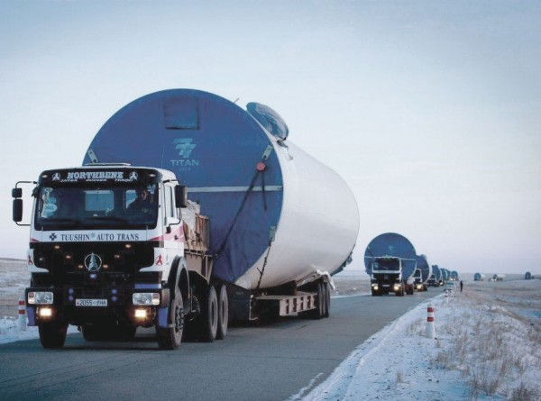Four project cargo service providers arranged and transported these oversized components.
The rolling Salkhit Mountains are the site of Mongolia’s first renewable energy wind farm about 70 kilometers (43 miles) southeast of the nation’s capital, Ulaanbaatar. Clean Energy LLC of Mongolia’s Newcom Group led the wind farm project along with several project cargo logistics service providers. Very difficult road conditions in the South Gobi posed challenges to transport the 40-55 ton components across soft sand and mud, and through the extreme weather conditions on the 700 kilometer (434 mile) journey within Mongolia.
The Salkhit wind farm is the proving ground for Mongolia to become a regional leader in producing and transmitting clean energy from the wind across the relatively flat terrain. The 50 megawatt capacity Salkhit is powered by General Electric (GE) 1.6 megawatt turbines. It will offset 180 thousand tons of CO2 emissions, save 1.6 million tons of fresh water, and reduce coal usage by 122 thousand tons annually, according to Clean Energy LLC. This $120 million project will provide energy to 100,000 consumer households in Ulaanbaatar. Clean Energy is the first independent power provider in Mongolia and connects to the Central Network. This achievement can bring improvements to the air quality in Ulaanbaatar, which is especially poor in the long and cold winter months.
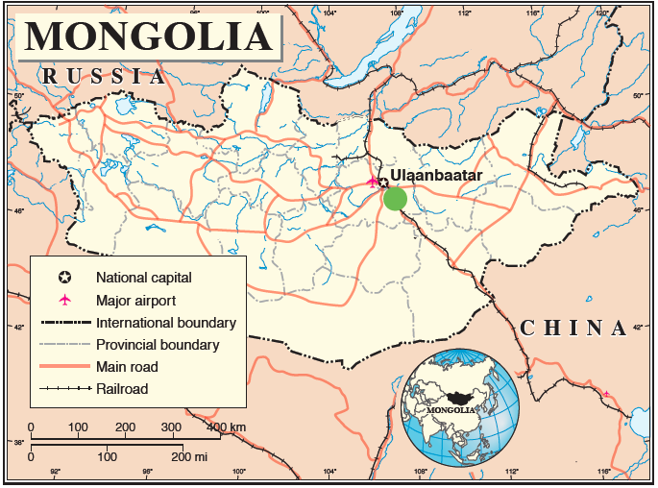
Gankhuyag, Chief Infrastructure Officer, Newcom Group, was the Salkhit project director for six years until the wind farm was commissioned on June 20, 2013. He described the top part of the wind tower as the nacelle or gearbox of the turbine main parts and a hub with the three blades connecting with the nacelle. The tower supports this assembly and is in three separate parts in which each component weighs 40-55 tons. The conveyance method was two hubs on one truck and the three blades were on one low bed trailer. “These were very, very difficult road conditions and needed bulldozers to smooth the sandy area,” he said. Four project cargo service providers arranged and transported these oversized components. Leighton Asia, the construction and mining service provider, performed the balance of plan (BOP) to accept delivery of the equipment and install the 31 wind turbine towers across the Salkhit Mountain area. GE had the turbine supply agreement (TSA) for the manufactured components from factories in Shanghai and Beijing, China. GE has a 24% financing of the project whereas Newcom has 51%, the European Bank for Reconstruction and Development (EBRD), 20.5% and FMO, a Dutch development bank has the balance. Moreover, the EBRD will be awarded by the U.S. Department of Treasury in the annual Development Impact Honors for their contribution to the Salkhit Wind Farm.
Leighton contracted with Tuushin, a Mongolian international freight forwarder, to perform the truck transport of the windmill components in the 12-18 truck convoy. By international transport treaty, Mongolia trucks cannot cross into China territory and vice versa, thus Tuushin partnered with Seattle, Washington based TransGroup USA to pick up the components from factories in Shanghai, Shenyang, Liaoning province, and Baotou, Inner Mongolia Autonomous Region (IMAR), China to the Erlian, IMAR, China and Zamin Uud, Mongolia border-crossing area. Both Tuushin and TransGroup are heavy lift project logistics experts and members of the Queensland, Australia based Project Professional Group that certifies its members to provide clients with project freight management.
Mongoljingoo, Vice President and Sanchir, Manager, Mining and Project at Tuushin described, “very poor road infrastructure of natural road covered by soft sand and rocks” on the 500 kilometer (310 miles) from the Mongolia border to Choir. The remaining distance was 7-10 hours to the wind farm site and paved, but narrow for the project cargo convoy. Police guards had to assist in stopping traffic from the opposite side of the road as the convoy made the 20 kilometer (12 mile) per hour snail pace to the site.
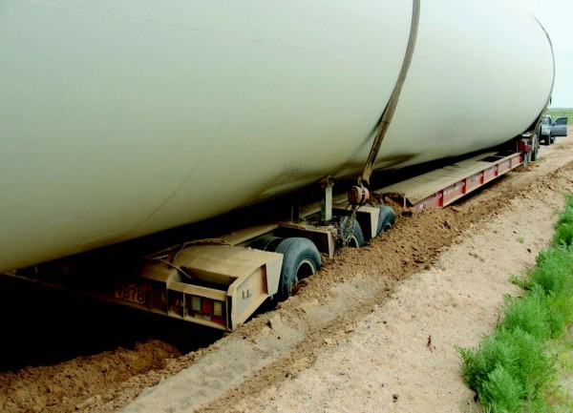Very difficult road conditions in the South Gobi posed challenges to transport the 40-55 ton components across soft sand and mud.
From April, 2012 to December, 2012, the truck convoy went back and forth from the border to pick up factory components to deliver to the wind farm site in rain, snow and cold. Mr. Mongoljingoo and Sanchir were supervisors, “we both traveled with the convoy to check the road conditions ahead of the convoy and do repairs, especially from the Zamin Uud border to Choir.” At times the trucks stuck in the soft sand and mud and a bulldozer or excavator grader pulled the truck by long rope and by manual laborers digging out with shovels. At the site, “thirty-one turbines were in different places with serial numbers from top to bottom components of the towers and they could not be unloaded in windy conditions. So we had to wait overnight and also required an excavator to pull trucks by rope on top of the hilly mountain,” they explained. The fourth project cargo service provider was Landbridge, another Mongolia based leading international freight forwarder. Leighton assembled the wind tower components with the preparation of the civil works and earthworks foundation, firstly. Then, a China-manufactured 650 ton capacity crane erected the tower and blade assembly. The crane operator and engineers on top of the tower exhibited heavy lift precision and balance to align and attach the bolts to fasten the nacelle to the three bladed hub.
After the completed wind farm construction, Landbridge arranged 78 tons gross weight in eleven trucks with low bed trailers and air suspension and four container trucks of parts and bulk to transport the dismantled 650 ton crane to the border. In Erlian, the project crane transloaded to Chinese trucks en route to Tianjin seaport for shipment to a Southeast Asia project.
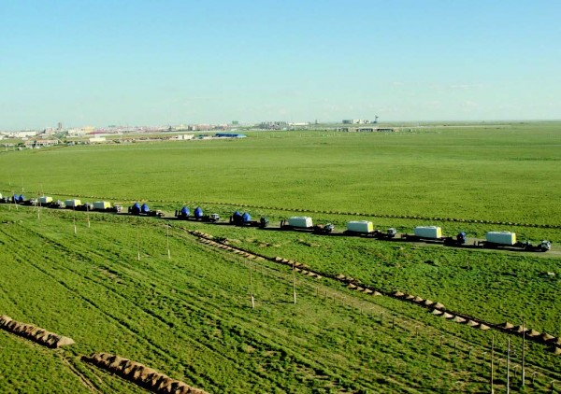
Leighton contracted with Tuushin, a Mongolian international freight forwarder, to perform the truck transport of the windmill components in the 12-18 truck convoy.
Baigalmaa, Head of Export, Landbridge, explained the requirement that Leighton placed on them in the delicate transport of the wind farm crane. “The red and white paint on the outside of the crane was expensive and cannot have any scratches. The 1-2 ton capacity ratchet strapped the crane to the truck, but causes scratches. The road condition of holes and sand would cause problems. So, we used an iron chain to strap down with flattened and wide rubber truck tires and tape underneath and no scratches occurred during the heavy lift transport.” The crane truck convoy from the Salkhit site to Zamin Uud took two days, then one day to clear Mongolia Customs for the fifteen trucks and 2-3 days transload in Erlian with Customs clearance.
The Salkhit wind farm could prove the potential for Mongolia to become a regional powerhouse. Gobitec is a strategy for an Asia Super Grid (ASG) to interconnect electricity generation from the Gobi Desert by big wind farms for export to Northeast Asia countries of China, South Korea, Japan and Russia. In the next 16 years, Mongolia could earn $9 billion and create 880,000 jobs in projects costing $237 billion to produce 2,600 terawatts of solar and wind energy per hour, according to the UB Post. “The technical and commercial issues can be solved, but the political issues are more difficult to solve for Mongolia and their potential energy export partners and neighbors,” said Gankhuyag in a recent interview with the American Journal of Transportation.
The tranquil and vast deserts and grasslands of Mongolia’s terrain occupied by herdsmen tending sheep, goats and horses and dotted by their Ger (Yurt - Russian) homes is slowly transforming into a major supplier of domestic and regional renewable energy.
American Journal of Transportation

