Octopi by Navis gives general cargo better productivity
by Robert L. Wallack | Published in Issue 698, Breakbulk, November 25, 2019
Page 1: Out of the Box TOS
Page 2: Cost Efficiency
Improving productivity in general cargo terminals by real-time automation of operations is realized by Octopi by Navis terminal operating systems (TOS). Octopi is automating challenges faced by thousands of small to medium general and mixed cargo seaports worldwide. Vessel discharge, item tallies and yard management are easily managed by the web-based platform.
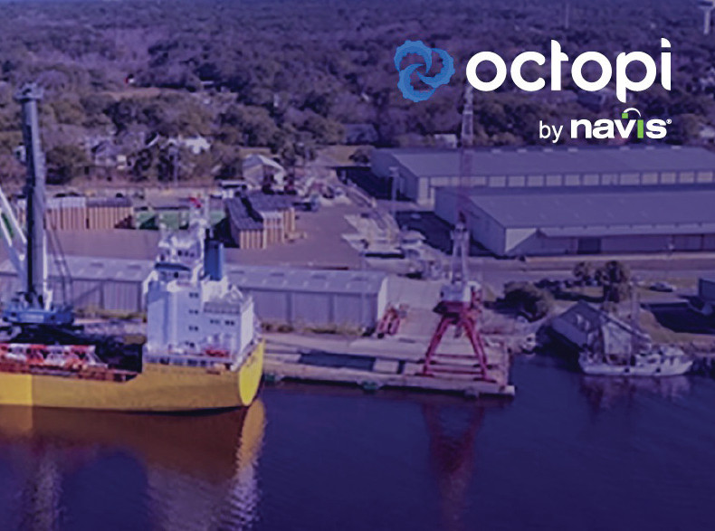

Navis, a part of Cargotec Corporation and known for their N4 TOS, acquired Miami, Florida based Octopi in March of this year. Luc Castera, founder and director of product, Octopi explained in a November 12th webinar, “Understanding General Cargo: Challenges and Opportunities” that over the past five years they visited many general cargo terminals to better understand their difficulties. Customer challenges in the small to medium mixed and general cargo terminals are numerous and technology providers have ignored them for many years. His webinar presentation explained intense intra-regional competition, high labor costs, extreme weather events, complex mechanization and standardization of operations, uncertain trade issues and their non-specialized facilities.
Out of the Box TOS
Director Castera also provided information to a recent interview with the American Journal of Transportation that “smaller general cargo terminals are left with pen and paper, Excel spreadsheets, or limited software solutions built in house.” As a result, they track their inventory loosely and management has poor visibility of cargo at the port. This can cause cargo loss and slow operations to take the time to locate cargo. “All of this has direct impact on the operating cost of the terminal.”
These general cargo terminals will not take business away from box terminals, as containerization has limits. In fact, Octopi estimates 3.2% average annual growth of general cargo from 2016-2021 period. However, container terminals lack the special needs of smaller terminals and general cargo terminals and can be made “more efficient and cost-effective so that they can better compete in the marketplace,” he said.
Octopi by Navis is a web-based TOS with their numerous functionalities accessible on a desktop or a tablet. This is a software as a service (SaaS) platform hosted on the cloud so there is no need to buy and manage servers. Some of the features are Over, Short and Damaged (OS&D) reports for accurate inventory automation, especially useful for general cargo pallets containing a diversity of cargo: packages, drums, boxes, cans; as well as, dynamic yard by satellite view and graphic representation; real time tracking and visibility; barcodes, since pallets look the same, but the software reads different barcodes after discharge; invoicing, stock transfers, equipment management, key performance indicators (KPIs) and a business intelligence (BI) dashboard that appears when users log in to the Octopi TOS.
Cost Efficiency
Improving productivity is essential to reducing costs and to generate more volume in smaller general cargo terminals. Director Castera explained two main ways to AJOT. “Octopi reduces back office data entry work to once with friendly interfaces in real-time. Some of our customers have processes that would take them a whole day and are now converted to a 15-minute process in Octopi. The second way is better transparency in “building a culture of KPIs” on-site by the BI dashboard in Octopi. “You basically apply gamification to terminal operating processes. People start to compete with themselves to beat their numbers and that culture of statistics makes a huge improvement to your productivity,” he said.

Octopi offers a set of new features and updates. The reefer (refrigerated container) BI dashboard now shows a visual in colors: which reefers have not had monitoring for temperatures recently, which reefers have abnormal readings and which reefers are scheduled to arrive soon at the terminal to better prepare. All Octopi features translate into cost savings.
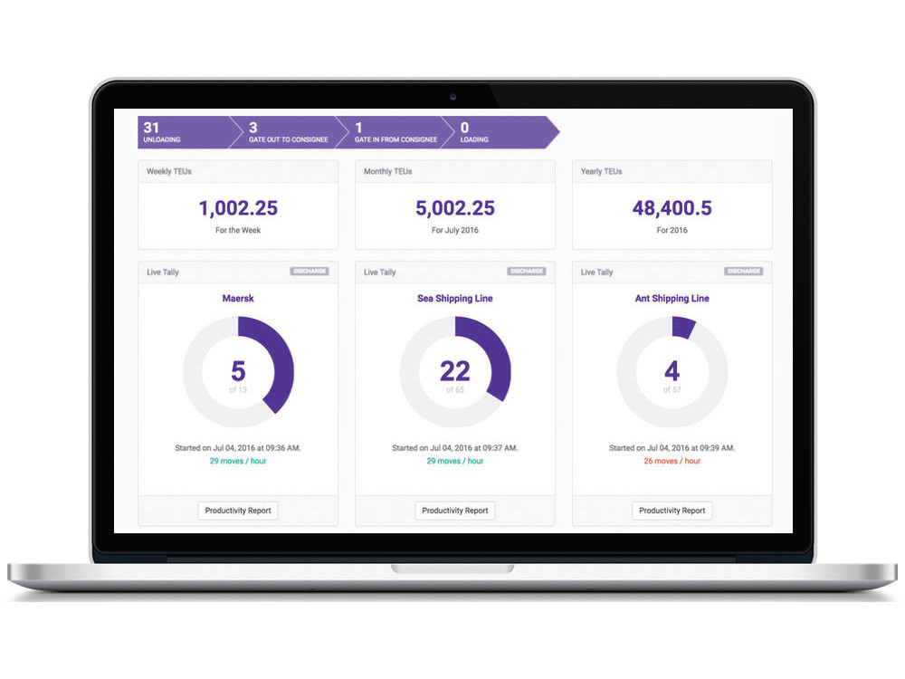
“A customer took a whole week to go through tons of spreadsheets and to produce invoices to charge for a general cargo storage at their terminal. We automated that process to zero minutes,” exclaimed Director Castera. Another cost savings was found in a customer reconciling their vessel tallies with the shipping agents by comparing two tally sheets row by row. “We built a way for the shipping agents to have access to Octopi and verify each tally moved reconciled by the terminal in real-time so that at the end of the operation, the reconciliation is automatically completed and they can get paid,” stated Director Castera. Finally, with tighter inventory controls, customers have less claims and pay less in penalties.
At present, Octopi by Navis has implementations in 13 sites and 7 countries. In the second half of this year, Octopi signed a subscription agreement for Octopi by Navis with Tropical Shipping in St. Thomas that has 1500 short tons of general cargo and 95,000 twenty equivalent unit (TEU) containers throughput per year. Octopi will improve inventory accuracy, operation efficiencies and visibility with direct access to ports in the United States of America, Canada and the Virgin Islands. Also, Port Fernandina, northeast Florida,

signed an agreement in their modernization project by Worldwide Terminals Fernandina to implement Octopi for better vessel planning and to attract new liners as well as tracking of cargoes by truck, vessel, rail and share real-time data by electronic data interchange (EDI) with customers. The Port has 300,000 tons of breakbulk cargo per year now near the South Atlantic in Fernandina Beach, Florida.
Earlier this year, Octopi went live in three months from spreadsheet-based pen and paper system at the Port International Du Cap Haitien. The Port went from manual process inaccuracies to automated inventory tracking. Other improvements were individuals mapping the yard with Octopi graphic representation and the ability to handle EDI manifests and vessel cargo information.
Director Castera concluded the webinar by giving a demonstration of the discharge of breakbulk general cargo at a port terminal in real-time on the “pending tallies” page in Octopi. He first created a new yard to store the general cargo by pallets in the graphic representation “satellite view” page on Octopi. Details of each terminal operation are easily learned and viewed on the platform by crane name, items discharged such as 140 boxes of Amazon Kindles, 2 pallets of rum, 2 drums of clothes, and 5 bundles of rebar. The mapped-out yard area on the platform page is where the tallies such as an allocation of 20 Amazon Kindle boxes would be inventoried in the yard and by “splitting and merging” functionality of the diverse cargo discharged from the vessel.

