Overweight shipping containers causing controversy
by Robert L. Wallack May 26, 2020 | Published in Issue 707
The weights of international shipping containers crossing national, ocean and state boundaries are pushing the limits of safety in order to reach volume cost-efficiencies and emission reductions. Abiding by the ocean container weight regulations for verified gross mass (VGM) is the responsibility of shippers as required by the IMO, SOLAS amended and effective since July 1, 2016. Blurring the overweight ocean container issue is the different state, county and city permit regulations wherein some states allow overweight dedicated corridors near seaports. A web-based solution is in the works by Kansas based Oversize.io to address the lack of harmonization among state permits and overweight ocean containers.
The International Maritime Organization (IMO) based in London, England issued guidelines for the verified gross mass (VGM) of a container carrying cargo in 2014 from their Maritime Safety Committee. These guidelines stem from the amendment of the 1972 International Convention for the Safety of Life at Sea (SOLAS). The stipulation is that packed containers gross mass is verified prior to stowage aboard ships. This requirement is to ensure the safety of the ship, the safety of workers both aboard ships and ashore, the safety of cargo and overall safety at sea.
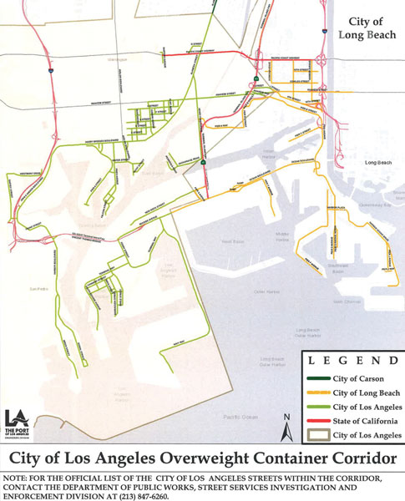
The salient issue for the ocean carrier, port terminals and truckers is that the shipper is responsible for weighing the containers and for the documentation. The SOLAS amendment provides that there are two methods shippers may use to determine the container weight once the container packing process has taken place, according to the IMO SOLAS and World Shipping Council official documents. Method 1 requires weighing the container after it has been packed, or Method 2 requires weighing all the cargo and contents of the container and adding these weights to the container’s tare weight as indicated on the door end of the container. Estimating weight is not permitted. The carrier does not need to be a “verifier” of the shipper’s weight verification.
Further to SOLAS, Chapter VI, regulation 2 is that “shipper means a legal entity or person named on the bill of lading (BOL) or seaway bill or equivalent multimodal transport document (e.g. ‘through’ bill of lading).” The shipper is also responsible for ensuring that VGM is communicated in the shipping documents sufficiently in advance to be used by the ship’s master and the terminal representative in the preparation of the ship stowage plan. The container cannot be loaded unless the VGM of the packed container is conveyed.
The weights of the imported containers are based on “national legislation” and are causing some problems in the United States ports. Weston LeBar is Executive Director of the Harbor Trucking Association, a coalition of intermodal carriers serving America’s West Coast ports of Los Angeles, Long Beach, Oakland, Seattle and Tacoma. He explained to the American Journal of Transportation in a recent telephone interview that “we operate on the bill of lading and that the weights on the bills of lading are not accurate.” The container terminals assume the weights are legal and checks of weights by the California Highway Patrol show weights are not the same as the bills of lading and “the truckers become liable,” he said.
The United States Coast Guard (USCG) cannot help when it comes to overweight import containers. “Our charge is to make sure that the United States is in compliance with SOLAS and that the correct weights of export containers are provided to the vessel for vessel stability and stack weight purposes,” said Jim Bull, Office of Port and Facility Compliance, USCG in a recent e-mail reply to the AJOT. For the purposes of determining the VGM of a container, any equipment currently being used to comply with Federal or State laws, including the Intermodal Safe Container Transportation Act and the container weight requirements in 29 CFR 1918.85(b), are acceptable for the purpose of complying with SOLAS, according to the Marine Safety Information Bulletin document provided by Jim Bull. The responsibility of the overweight container for imports to the United States is with the enforcement of the rules with their “Contracting Governments.”
“We don’t scale unless there is a reason for us to scale which is very rare. The bill of lading is the legal document. So, we go by the weight that is on that document,” said Harbor Trucking Association member, Jason Farina, vice president of Sales and Marketing, Heavy Weight Transport, Inc. of Long Beach, California in a recent interview with AJOT. Similar remarks are from another member of HTA.
“A bigger issue is that there are truckers that are picking up heavy containers on standard tandem chassis and draying, the overweight containers to destinations outside the overweight corridor,” said Vice President Farina. These overweight corridors are located throughout the United States. The objective is to aid truck carriers to use designated city streets near city port areas for safety and congestion reasons.
One example is the City of Los Angeles, City of Long Beach and State of California with the Department of Public Works approved a measure that allows permits to be granted for overweight container loads in the Port area. The permits allow the gross vehicles to be at 95,000 pounds weight of the truck, chassis, container and contents/43,130 kilograms (with proper equipment). By comparison, the maximum allowable gross vehicle weight on a 20-foot container is 80,000 pounds if loaded on a 20-foot intermodal chassis and a 40-foot container is 90,000 pounds if loaded on a 40-foot intermodal chassis. However, permits for weights over 80,000 pounds vary by states, cities and counties. For the sake of uniformity, “there is a need to get agreement of all seaports in the United States where all the overweight corridors are. In Los Angeles and Long Beach, a five-mile route can have three different permits,” said LeBar.
On October 2, 2019, the City of Los Angeles and City of Long Beach Department of Public Works provided a map of the official list of streets within the overweight corridor.
Trucks are responsible to review the map which identify the proper agency responsible for that highway. The agency will issue the overweight permit. If the truck route passes through multiple city jurisdictions on the map, then permits (Overweight Vehicle Special Permit) will be required from each jurisdiction. Cargo weight guidelines are based on the 20-foot or 40-foot chassis types: standard steamship chassis, tri-axle slider chassis or tri-axle slider chassis with 4-axle tractor, according to the Port of Los Angeles website.
Troy Deocharran of OEC Group in New York does freight forwarding container shipments of dense cargo for the United States and China trades of flooring and building supplies. There is no consistency in the United States for overweight container permits. “California ports have the shortest transit times from China to the U.S.A. and some importers have warehouses all over the U.S.A.
For 100,000 pounds of flooring to Savannah, Georgia some states have permits for 90,000 pounds and some for 84,000 pounds and is very inconsistent with no easy way to know of the overweight permits,” said Deocharran in a recent telephone interview with AJOT. Some cargo is defined as divisible load to be broken down to get to under 80,000 pounds maximum weight. His frustration extends not just between states, but within states. “Illinois has state permit, city permit and county permit or three permits to move containers.” Permits are a source of revenue for governments which are used for road maintenance and repairs caused by overweight cargoes.
A possible solution to the overweight shipping container controversy is from Oversize.io platform. “We currently have the first part of a solution ready to go. It’s a maximum axle weight calculatorthat can apply the federal bridge formula to any load under 80,000 pounds. This is important as over 80,000 pounds each state dictatesits own rules, regulations, and pricing,” said Drew Jahnke, founder and director of sales of Oversize.io. The calculatoralso has an interactive map that can determine the maximum permitted weight on non-divisible loads throughout the United States. This will be availableas a mobile application in the next couple of weeks.

