PRC and Vietnam Border Crossing Points (3) and Border Crossing Towns (6)
By Robert L. Wallack, Logistics and Institution Specialist, United States of America.

Lao Cai

Geographic, Demographic and Trade Profiles

1. Lao Cai province is a mountainous area of 683,000 people of which 64 percent are from 25 ethnic groups. Lao Cai is located in northwest Vietnam and has a 182,086 kilometer border with the People’s Republic of China (PRC) in Yunnan province. Lao Cai city is divided by the Red river from Hekou city border area on the PRC side. The Lao Cai Border Economic Zone is a strategic trade and transportation point on the North-South Economic Corridor (Kunming, Yunnan-Lao Cai-Hanoi-Haiphong seaport) with many advantages across all modes of transportation: road, rail and the seaport of Haiphong. All these modes combine to connect Vietnam to southern China and the Greater Mekong Subregion (GMS) countries. Its main border trade are minerals and agriculture products of rubber, coffee, cashews, fresh fruits exports and machinery/equipment, fertilizer and chemical imports as well as for tourism. The total import-export turnover in the period of 2011-2015 was $9.44 billion and in 2015 was $2.255 billion with 3.6 million people and 200,000 vehicles crossing in 2016. Budget revenues from border-gate operations in the period of 2011-2015 were $7.576 billion

Strategic Development

2. The Lao Cai Border Economic Zone has central government priority since 1996 for Border Gate Economic Zone (BGEZ) development along with Mong Cai, Quang Ninh with a plan to build 30 BGEZs by 2020. The Prime Minister’s master plan extended Lao Cai’s BEZ to 15,929.9 hectares along the border with China. Part of the government of Vietnam’s (GoV) solution to State budget constraints is to give priority to 9 BGEZs from 2016-2020 among which are: Lao Cai, Lao Cai province, Dong Dang-Lang Song, Lang Son province and Mong Cai, Qiang Ninh province. The Prime Minister allocated investment capital of no less than 70 percent of investment support funds from the central budget under annual Five Year Plans.

3. The actual situation of development of Lao Cai BGEZ is significant to handle the growing cross-border and regional trade growth. To date, Lao Cai Border-Gate Economic Zone has completed its functional areas:
- Lao Cai International Border-Gate Zone is the area of commercial activities, tourism, and services;
- Pho Moi is the area of the International Railway Station and ICD Port;
- Industrial - Commercial Area

Many other works are completed and put into use with a total investment capital for infrastructure of Lao Cai Border-Gate Economic Zone in the period 2003-2011 of over $101,199. (VND 2,300 billion). This meets requirements for infrastructure for commercial, export-import, exit-entry activities and the like.

4. So far, the development of Lao Cai Border-Gate Economic Zone led to more services and tourism, contributing to a strong economic restructuring. With the average annual increase of import-export turnover of 3.5%, Lao Cai border-gate had become "billion-dollar" border-gate in 2011, and it is expected that the figure will double as of 2020. In particular, the Lao Cai Border-Gate Economic Zone has a 2.5% annual increase in budget revenue elevating Lao Cai province from a poor province to the club of provinces having annual budget revenues of over $44,000 (VND 1,000 billion) budget, thereby showing the boom of commercial activities along the Viet Nam - China border line. In addition, its contribution to the State budget is $75,000 (1.7 billion VND) and is equal to 30 percent of the budget income of the province.

5. Lao Cao Border Economic Zone is an international status border crossing with five local border gates. There are many plans proposed by the Lao Cai government officials to continue on their path of border area and economic growth. The number two main border gate is Kim Thanh (plan border gate on 194 ha), Ban Vuoc (local border gate plan on 44 ha) and there is the railway border gate. Lao Cai Border Areas have infrastructure and industrial zone plans until 2025 valued at 5.337 billion VND. The Ban Vuoc and Kim Thanh border gate has detailed plans (5 zones) for a new bridge, import/export (plan on 228 ha), logistics (plan on 332 ha), parking, tourism complex (plan on 332 ha), a Trade and Industrial Zone with Integrated Urban Area.
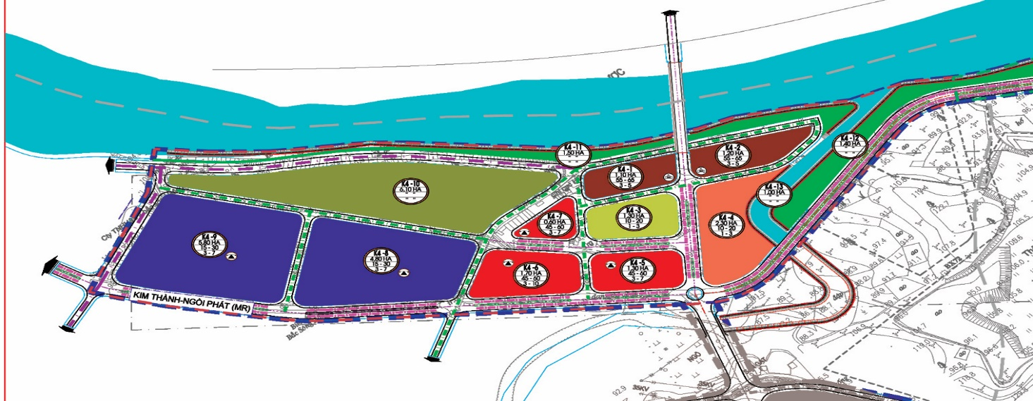
PROPOSED BRIDGE
Figure 1 Lao Cai BEZ Plan

The two Lao Cai border area plans for industrial zones (IZ) are actually for agriculture processing and each estimated to cost 1 billion VND located in Bac Duyen Hai on 85 ha and Dong Pho Moi on 100 ha.

So far, in the industrial zones and the Kim Thanh commercial area, there were 173 registered investment projects (an increase of 40 projects compared to 2010), with total registered capital of investments of VND 23,808 billion (an increase of about VND 4,000 billion compared to 2010). Revenue in 2015 was VND 20,262 billion, an increase of 3.07 times compared to 2010; the industrial production value in 2015 is VND 4,422.6 billion, an increase of 11.7 times compared to 2010 and payments to the State budget in 2015 were 4.6 times higher than those in 2010.

Out of the registered investment projects, 108 projects have gone into operation; 19 projects are under construction; 46 projects are finalizing investment procedures. So far, the industrial zones of Bac Duyen Hai and Dong Pho Moi have achieved the occupation rate of over 90%, while the Kim Thanh commercial-industrial has achieved the occupation rate of 80%. Investment projects focus mainly on trading, import and export, mineral processing, and construction. The structure of sectors and industries, products and capital scales has witnessed significant changes. Many new lines, sectors and products have appeared. Goods and products are increasingly plentiful, diversified, and brand-oriented.

Cross Border Trade: Lao Cai, Vietnam-Hekou, PRC Border Crossing Area

6. Lao Cai border trade is characterized as transit trade and temporary import, then exported to China and to third countries of agriculture products, mostly. Chinese trucks reach the checking point, then are trans-loaded to Vietnam trucks without a Common Customs Area or one stop checking point. Customs formalities are done twice on both sides. These are Customs issues discussed in border crossing meetings. There are no finished goods produced in the area and exported at this time.

7. Day traders and other stakeholders (brokers) involved in cross border trade are very diverse and account for a significant amount of cross border activities. The Vietnam government does not have policies for these traders, yet. There are about 200 merchants involved in this border trade in Lao Cai of which 25 percent are from Lao Cai and 75 percent are traders from other provinces throughout the country.

8. These household or informal border traders (visible in Lang Son and Mong Cai as well) are underserved for the growing demand with a lack of facilities, services and knowledge about exporting and importing, payment mechanisms, market information, pricing and trade with China and other markets. Much of the border trade activities occurs in “bordergate baazars”. However, a number of commercial banks set up branches in Lao Cai at the border for border trade payments of which 60 percent are in the home currency, but the process is monotonous involving vouchers. In Lao Cai these include: Agribank, VietinBank, BIDV, Vietncombank and Techcombank of which some have agreements with Chinese banks.

Transport and Logistics

7. At present, Lao Cai has road, rail and seaport (Haiphong) strategic location advantages, yet need huge investments to realize full potential as a regional production and logistics hub. Chinese expressed interest in furthering cross border economic zone talks for infrastructure development in Lao Cai with a large refrigerated area in the planned logistics complex as important. The railway is an important link to cross border and regional markets from the Lao Cai border area with trucks moving cargo five kilometers from the zone to a rail spur for onward shipments. There are proposals to improve connection by rail with Hekou by widening the railway area and the Chinese agree, but the process is slow.

Border Economic Zone Potential

8. Kim Thanh commercial area border gate is central to cross border integration with Hekou. Both sides agree to an 11 square kilometer area on both sides separated by the Red River and a new bridge to close the link. This will connect Lao Cai city and logistics facilities to the expressway for the Hanoi- Haiphong cargo traffic as well as to a more integrated border crossing (IBC) with Hekou in China to improve value chain opportunities. Kim Thanh will become a “satellite city” in the planned Lao Cai economic zone to provide housing, financial, banking, telecommunications and technical services for an expected labor force. The investments ($150 million) will increase the Lao Cai capacity in Kim Thanh border area to a target trade turnover of $6 billion and a population increase of 10,000. The total area of Kim Thanh border crossing and the logistics services area will be 700 square kilometers. This “satellite city” is expected to draw more investors.

9. As for manufacturing in the border area, there are three large factories in the area on the Chinese side with more plans for the two industrial zones in Lao Cai border area. This creates an influx of a labor force from Vietnam for these production opportunities. Both sides need cooperation to manage the labor force requirements. An “open bridge” pilot project is proposed for workers to cross over, but still needs agreement from the different ministries to be realized.

Public Private Consultation Status (Cross Border and National)

10. Now, there are informal cross border meetings twice per year. The private sector is informed of logistics projects just for investors and not for international logistics companies at this time.

11. As for national coordination consultations, The establishment of the Economic Zone Management Board on the basis of the reorganization of the Board of Management of Industrial zones of Lao Cai province and Board of Management of Border-Gates of Lao Cai province has increased the capacity in the management of economic activities in general as well as of the private sector within the scope of management in particular. The Board has been actively addressing difficulties and promoting investments to support the private economic sector in the industrial areas; assistance in export-import activities have brought about positive results. In addition, the Board has been coordinating with relevant sectors and industries to seriously implement the directions and instructions of the Provincial Party Committee, People's Council, and People's Committee to maintain the order and stability at border-gates, meeting the requirements in import-export as well as exit-entry activities.

12. Comments and recommendations of enterprises in the private sector are acknowledged, obstacles are promptly settled and short-comings are early identified for timely adjustment. In addition, the Board is rightly encouraging and complimenting typical cases, pointing out shortcomings and weaknesses of enterprises to have timely remedy measures.

13. Improvements in administrative procedures are given a focus, bringing about positive results, having strong impacts on the operation of the private economic sector, and are receiving high appreciation from enterprises. Good coordination with relevant units in the State inspection and examination of private enterprises has reduced the overlapping in inspection and examination activities that has been troubling enterprises.

14. Strictly performing the service-providing function, the Board has directed the deployment of overnight goods keeping services, renting of warehouses and business facilities, sanitary services, and vehicle-keeping services. Generally speaking, the services are handled well and in accordance with current regulations, creating favorable conditions for enterprises and individuals operating in the Economic Zone.

15. The Provincial Committee is for decision making in Lao Cai. This body could be useful to localize national and cross border coordination institutions for consultation with business and government officials. Possible agenda items are to implement the master plan to build a duty free area, CBEZ area of 11 square kilometers on both sides, all investments needed for development of Lao Cai BEZ, one stop check point agreement, data exchanges (electronic data interchange) and better connectivity to PRC side for electronic Customs declarations and clearance of cargo shipments.

Lang Song-Dong Dang

Geographic, Demographic and Trade Profiles

16. Lang Son province has a population of 760,000 and divided into 11 districts. It shares a border with Guangxi Zhuang Autonomous Region (GZAR) in the PRC of 231 kilometers and the main border town of Pingxiang. The Lang Son-Dong Dang Border Gate Economic Zone is an important node on the North South Economic Corridor and trade lane from capital city Nanning, GZAR-Chongzuo-Pingxiang-Lang Son-Hanoi-Haiphong seaport. Lang Son has strategic modal connections of road, rail and seaport (Haiphong) to link Vietnam industrial and agriculture exports and bulk and consumer goods imports with South China (Pan Beibu Gulf) and ASEAN markets. Lang Son’s two international and ten auxiliary border gates are conducting trading, import/export, services, and tourism. Every year, over 2,000 businesses and economic entities across the country conduct import and export business activities through the province's border-gates. The total import-export turnover in 2015 is estimated to be $3.500 billion, 1.7 times higher than that in 2010, with the average annual increase of 11.04 percent, of which export turnover was $1.550 billion, an average increase of 16.44 percent and import turnover was $1.950 billion, an average increase of 7.65 percent. In the first quarter of 2016, the management board estimated the province’s total border trade (exports and imports) of $640 million of which $300 million were exports. Moreover, the province’s composition of trade is improving from exports of just agriculture products to wood products, footwear and seafood and from imports of machinery, equipment and chemicals to consumer goods and automobiles over the past ten years.

Strategic Development

17. Huu Nghi (road) and Dong Dang (rail) account for the two international border gates and there are ten local or auxiliary border posts that include Coc Nam, Tan Thanh and Chi Ma. Road and rail infrastructure improvements and very important to the success of the Lang Son-Dong Dang border economic zone along the trade corridors and for attracting more investors for potential industrial and agriculture clusters. Already clusters are forming in the wine industry and by a China invested $50 million auto assembly plant in an industrial zone. Moreover, cross border (CBEZ) cluster synergies are possible with Pingxiang from a Foxconn strategy to manufacture iPhones using low cost labor in Vietnam, then transport by road to higher value assembly in Pingxiang.

18. The Lang Song-Dong Dang border economic zone has roots to the 1990s and became official in 2008 by government orders. The total area of the zone is 394 square kilometers covering Lang Son city and numerous communes within several districts. In 2012, Lang Son-Dong Dang agreed with Pingxiang, GZAR, PRC to jointly develop a cross border economic zone of which ADB is furthering with the $1.18 billion Multitranche Financing Facility Guangxi Regional Cooperation and Integration Promotion Investment Program. In 2016, a new and modern Huu Nghi border gate Customs and Immigration building became operational financed by ADB for $18.5 million.

19. Road conditions and congestion are not optimal for the growing volumes of container truck traffic at the border and along the corridors. Estimates are of 1500 trucks daily passing through the Lang Song/Dong Dang-Pingxiang border crossings. Two access road projects are necessary to improve conditions and foster more trade and urban area growth. The first is a 22 kilometer road between Lang Son and Dong Dang and the second is a highway between Hanoi and Dong Dang which when completed will upgrade from a district area to a town.

Cross Border Trade: Lang Song, Vietnam-Pingxiang, PRC Border Crossing Area

20. The Lang Son-Dong Dang BEZ is the center of trade, services, tourism, and industry of the Northern Midland and Mountainous Sub-Region and the focal point of inter-regional and international trade and transport of the North-South Economic Corridor. The economic zone has two main functional zones: non-tariff zone and tariff zone. The non-tariff zone is Tan Thanh Trade and Services Cluster, Pac Luong - Hang Chui Trade and Services Cluster, Coc Nam Trade and Services Cluster. The tariff zone includes: Border-Gate Zones; Industrial-Warehouse Zones; Administrative Bodies, Professional Schools, Health Facilities; Provincial Administrative-Political Centre; Lang Son City Centre; Administrative Centre of Dong Dang town; Office of the Management Board; The area of Professional Schools; Tourist and Service areas; Residential Areas; Green Parks and Sport Facilities; other Functional Areas.

21. The border gate region in Lang Son province has approximately 300 merchants involved in border trade between Vietnam and China. Lang Son traders account for 25-30 percent and a large trader force from Central and South provinces involved in exporting of fruits. Remote rural areas have problems exporting forest, farming and agriculture products. Adequate facilities, services and payment methods are lacking for the day traders as seen in Lao Cai. However, a number of commercial banks set up branches at the border for border trade payments and these include: Agribank, VietinBank, BIDV, Vietncombank and Techcombank of which some have agreements with Chinese partners.

22. There are some useful statistics to show the growing importance of the citizen or local traders. Local exports in 2015 were about $96 million of the total import/export turnover, an average annual increase of 16.78 percent for the 2011-2015 period, meeting and exceeding the set targets (the set targets were to reach $90 million in 2015). Key export commodities were: anise flowers, pine resin, black jelly, veneer, agricultural and forest products (tobacco, ginger, turmeric, and fruits of various types). Export markets for local export commodities are increasingly expanding. In addition to traditional markets such as China, some commodities such as anise, anise oil and veneer are present in some other markets such as the European Union (EU), India, and ASEAN countries.

Transport and Logistics

23. Connecting infrastructure of roads, especially for rural linkages to the border areas are necessary for enterprises and traders to benefit from cross border economic zones. The 22 kilometer road connecting Lang Son and Dong Dang (will create two urban areas) and the highway between Dong Dang and Hanoi will be essential. As is the new Huu Nghi international border gate facility completed by ADB which will attract investors and improve the flow of traffic. There are numerous projects in the master plans, under construction or completed. These include:
- Road upgrading in Tan Thanh local border gate with an 11 square kilometer area and will not have joint customs, but can become an urban area with Huu Nghi for a possible international crossing status with cargo transshipment functions.
- Trans-border road connecting Tan Thanh and Coc Nam and improving Coc Nam facilities such as a trans-load dock as well as a PRC-Vietnam agreement to expand Coc Nam as an international area.
- Improvements in the Chi Ma border gate
- Huu Nghi International border gate contractor is constructing an import/export road section, parking lots, and embankment work, and an internal road system. A single stop inspection of which there is a framework for all ministries to agree and for a Lang Son-Guangxi cooperation in cross border tourism that now has 3,000 persons crossing each day. Further improvements also needed in Customs which are conducting pilot projects of electronic data for clearance procedures.

24. Vietnam border trading will benefit from two railway crossings to China. Hanoi to Lao Cai and Hanoi to Lang Son-Dong Dang. Now, Dong Dang is too small for goods and cargo as well as passengers. Upgrades are necessary to realize the benefits of the Dong Dang railway economic zone.

Border Economic Zone Potential

25. The rising trade statistics in the Lang Son-Dong Dang border crossings prove the need for improving services and infrastructure for enterprises as well as for day traders. The formation of industrial and agriculture clusters is in the early stages as stated in the recent meetings with government officials about a wine cluster and about a Chinese $50 million investment in an automobile assembly plant. In addition, the Pingxiang officials discussed the plans by Apple iPhone Taiwan contract manufacturer, Foxconn, to produce and assemble products using the comparative advantages on both sides of the border of labor and high tech capacity between Lang Son and Pingxiang, respectively. The Foxconn strategy will be furthered by the construction of a second tunnel between the two cross border economic zones with one dedicated to only freight traffic. These plans once realized could attract more investors in both industry and agriculture for clusters at the borders and along the corridors. This will be important for Vietnam BEZs transitioning from exporting just low value goods to higher value goods and for value added logistics services.

26. Over the past few years, Lang Son and Pingxiang signed agreements to jointly develop their BEZs. This includes a Lang Son-Dong Dang-Pingxiang Cross Border Economic Zone (CBEZ) which stipulates an 8 square kilometer area from Pingxiang to the gate and 8 square kilometers around Lang Son, but still delayed by central government formalities. Once completed, then a cargo transshipment area, when 50 percent completed, would upgrade Vietnam’s side to two urban areas (Tan Tranh to Huu Nghi), according to Vietnam officials in recent field work discussions.

27. The need for huge investments on infrastructure, especially on the Vietnam side, and the need for national/cross border coordination mechanisms caused ADB to work with GZAR for a $1.18 billion assistance project over several years (2016-2024). This investment program will have high positive regional cooperation and integration (RCI) spillovers benefiting Lang Son and Mong Cai. “The benefits for Vietnam will be achieved mainly through, (i) improved connectivity and trade facilitation which will provide better access for northern Vietnam to markets in GZAR and other parts of the PRC; (ii) expansion of trade, especially Vietnam’s export of agriculture products, which will help increase income of the local farmers and border area residents; and (iii) training of Vietnamese workers which will help them find higher income jobs in GZAR”.

28. The main outputs of the “Proposed Multitranche Financing Facility Guangxi Regional Cooperation and Integration Promotion Investment Program,” November 10, 2016 are (includes for both Lang Son and Mong Cai/Fangchengang): (i) support for SMEs in border area (including the Vietnamese SMEs operating in GZAR) by providing credit; (ii) strengthen GZAR’s business development services; (iii) support pilot projects on cross-border labor cooperation (training for local and Vietnamese workers). Also, included are: cross border financial transactions services centers in Pingxiang; integrated cross border e-commerce platforms; key infrastructure and border area services for Pingxiang and Dongxing BEZs (road, water supply, sewage treatment, logistics facilities) and trade centers and tourist areas; physical and informational connectivity (see details in ADB document). This project has important demonstration and possible replication effects for all GMS cross border economic zones.

Public Private Consultation Status (Cross Border and National)

29. The proven methodology for resolving national border economic zone and international cross border issues of infrastructure (investments), operations and policies is by forming coordinating institutions that involve both business and government leaders meeting on a regular basis with set agendas. The establishment of these national and cross border coordinating and cooperation bodies are needed on the national and local/provincial levels for Lang Son. The government of Vietnam recognizes this problem and is trying to address with guidance by international donor institutions such as from this TA 8989. These national and cross border coordination and consultative bodies are not for networking, but are for solving problems jointly for short, medium and long term BEZ development.

30. Information gathered from Vietnam officials found: “operating mechanisms for border-gate economic zones and border-gates have not been consistent. Functional authorities such as Customs, Border Guards, etc., are still acting under their own coordinating mechanisms, leading to inconsistencies in planning, construction of warehouses, public facilities, national gate sites, with casual construction works in particular sites”.

31. “Management models as well as mechanisms and policies applied to border-gate economic zones have been insufficient and inconsistent, subject to numerous times of amendments of management models (under Regulations No. 219, Regulations No. 11, Decision No. 72/2013/QD-TTg and the Decree No. 164/2013/ND-CP of the Government), resulting in the needs for ministries and agencies to enact additional guiding documents, causing difficulties for management works of many the localities and enterprises; and for investors to adjust plans of production and business to newly enacted mechanisms and policies.”

32. “Besides, upon issuing guiding documents, some ministries and agencies have "forgotten" to take into account highly specific regulations of particular localities, leading to limitations in preferential levels of local regulations, making leaders of provinces, various sectors and economic zone management boards to take a lot of time to resolve problems”. Documents also find a proposal for a Steering Committee on Border Trade setting up a mechanism for inter-agency coordination including all concerned ministries and agencies: Trade, Foreign Affairs, Finance, Transportation, Immigration, Customs, Sanitary and Phytosanitary to improve border trade operations.

33. As such, the GoV recognizes the solutions to their border economic and CBEZ problems. At present, field mission discussions found that Lang Son officials meet with Guangxi officials, but results are not concrete. The local approach is the best solution as stipulated in documents gathered from Vietnam officials: “Localities should focus on the formation of comprehensive and scientific transport infrastructure projects to attract businesses into local border-gates; apply more appropriate policies to pioneering businesses in terms of investments. At the same time, localities should coordinate closely, thoroughly settling required procedures for businesses; focus on consultative activities with businesses on desired forms and orientations for the development of border-gate economic zones”.

34. Furthermore, “localities should take the initiative in arranging local budgets and mobilizing other sources of legitimate capital funds along with the Central budget funds to invest in the infrastructure development of border-gate economic zones”. Haiphong offers some useful lessons to the BEZs on how local business-government consultation meetings lead to results. Furthermore, the international practices outlined in this report offer some possible solutions to Vietnam forming national and cross border consultation bodies that can be applied to Lang Son-Dong Dang, Mong Cai and in Lao Cai. Similar mechanisms will be needed in Hekou, Pingxiang and in Dongxing/Fangchengang.

35. The ADB offers some guidance in this TA8989 as well as from the “Multitranche Financing Facility” project. “The investment program will also promote cross-border policy and operational dialogue to coordinate cross-border transport and logistics planning, finalize the joint master plan for BEZ development, and simplify and harmonize Customs, sanitary and phytosanitary procedures.” ADB also has a similar cross border project between Mongolia and PRC borders. The loan program in “Mongolia: Regional Improvement of Border Services Project” stipulates in Output 3: “preparatory work for single window is undertaken, for a revised single-window model prepared to involve the key trade-related agencies (Customs, Inspection, Veterinary, Chamber of Commerce, Immigration) and private sector entities involved in the supply chain. An Agreement should be reached on the lead agency and agreement for most agencies to work together…” These coordinating and consultation mechanism will foster collaboration and not competition for infrastructure and connectivity in both sides meeting their master plan objectives.

Mong Cai

Geographic, Demographic and Trade Profiles

36. Mong Cai is both an international land border gate and sea border gate (north of Haiphong seaport) for important trade, tourism and national security purposes on the North-South Economic Corridor within the ASEAN-China Free Trade Area. Mong Cai BEZ has a coastline of 50 km with water transport potential. This includes these ports: Vạn Gia port, 16 domestic river ports on the right of the Ka Long River for container traffic, Con Ran port under development. Van Gia port next to Vinh Thuc island is an ideal sea port for trade with China and ASEAN. The BEZ covers the whole city including 17 wards and 3 communes on a total natural area of the BEZ of 121,197 ha, including land of 66,197 ha and sea surface of 55,000 ha with China to the north and the sea to the east and south. The BEZ population is 126,000 or 10 percent of the total for Quang Ninh province. There are two main areas of BEZ development: the Mong Cai city international border gate and the Hai Ha industry and seaport center. Mong Cai BEZ has all modes of transportation to benefit businesses: road, sea, river, rail and air, but needs investments to upgrade. For example, Hai Ha has shrimp farms and flooded land. The composition of border trade is growing as policies and infrastructure is improving since 1996. From 1996-2001 Mong Cai BEZ average annual economic growth was 15-17 percent with an export market expanded to 70 countries and territories. In 2013, exports reached $1.85 billion, 2.12 times higher than that of 2005 and imports reached $1.05 billion, 3.1 times higher than that of 2005. Main exports are: rubber, seafood, cashews, fruit, electronics, footwear and imports of plastics, wood products, machinery, automobiles and chemicals.
Figure 2 Mong Cai Geography and Trade Lanes
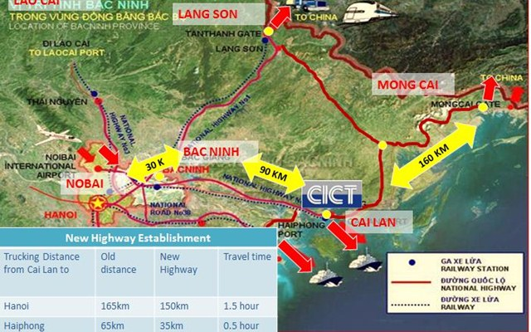
Source: SSA Marine

Development Strategy
37. Mong Cai is an international border gate and there are 5 local border check points in Quang Ninh province that include Ka Long. Mong Cai BEZ is the only BEZ with sea transport potential connected with roads. Mong Cai is across from Dongxing border town in China divided by a river and joined by a bridge. Dongxing is at the center of China-ASEAN free trade zone and connected to the Fangchengang seaport for Pan Beibu Gulf trade lanes.
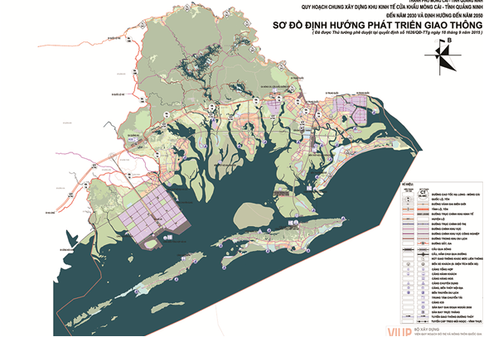
Figure 3 Mong Cai BEZ Plan
38. Meetings with government officials took place in Ha Long on May 14th and in Mong Cai on July 6th to explain the master plans and to visit the BEZ area as well as a meeting with one business leader in Mong Cai. The above map shows the blue areas where development plans are underway with some business investments in textile factories. The plans and current situation is outlined in the Mong Cai BEZ Master Plan to 2030 and 2050. Mong Cai is included in the ADB CTDP #2. The plans are for this BEZ to be a center for commerce, trade, seaport development of the coastal economy and eco and beach tourism.

39. The plan is for a 1,300 hectare area with China at the border connected by a bridge for a CBEZ. Road connectivity is important to connect the industrial zones to the Hai Ha industrial zones to attract investors. The 30 kilometer east-west road as noted in the above map is to connect the two blue areas of Hai Hai (deep seaport to -20 meters) and the Mong Cai international border gate. Area E is to facilitate the important trade of the area small border traders.

40. Industrial, agriculture and seafood clusters are possible. Chinese textile industry is in the Hai Ha seaport area and a Vietnam private sector company invested in infrastructure. The provincial Vice Director of planning and investment (DPI) has a list of investors in the Hai Ha area. Each block is to be for a factory in the Hai Ha blue area of the above map. The border gate IZ has a Chinese textile factory already. Provincial and Mong Cai officials need better coordination with the central government for approvals and communications in order to implement the strategic master plans. Clusters (within Mong Cai and cross border with PRC) and public private partnership (Vietnam Decree #50) case studies are requested, especially about South Korea and Japan examples. Observations from the road travel route noted possible clusters with the following companies established in the area: Aichi Tokei Denki (sensors), Sanmec, LG Electronics, Blue Com, Dong Yang, Hanmi Flexible and Tan Huay Hon.

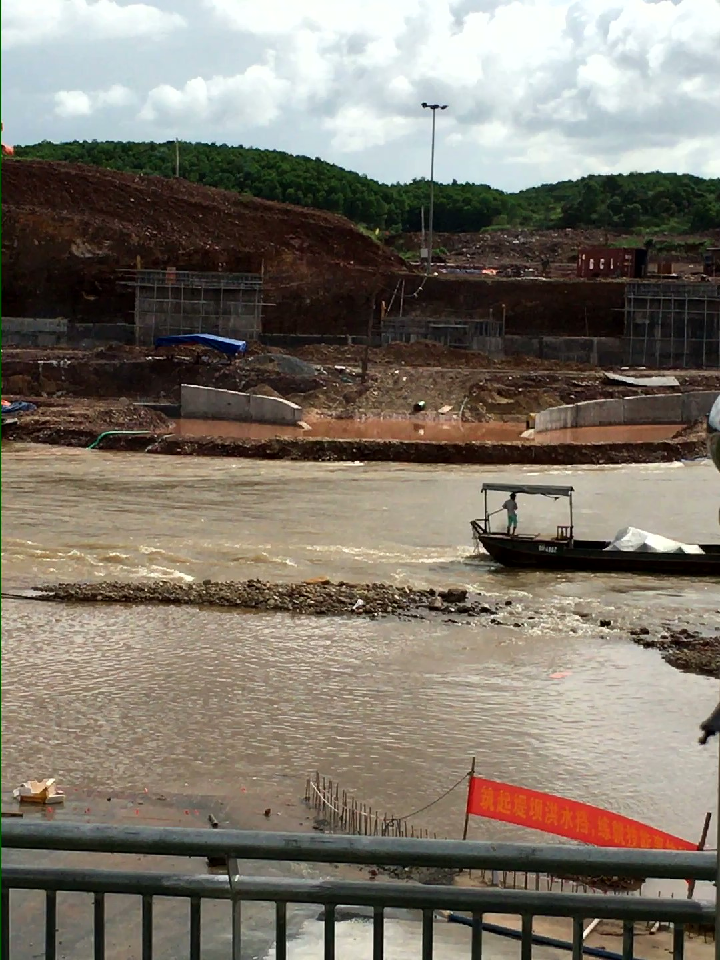
41. The Mong Cai BEZ has numerous infrastructure projects and plans to improve the cross border and regional trade, according to the master plan. One is a harbor project (1.2 billion VND) that is 5 kilometers from the sea that is being dredged by the government and a private company to -8 meters to accommodate container barges from Haiphong instead of trucks from Haiphong for seafood, fruits and Brazilian beef for PRC and other markets. At present, one area is a muddy container yard with 1,000 containers handled per day. Another project is to link Mong Cai to Dongxing across the river for the seafood trades. They have a permit to build a temporary floating dock to connect with the China border trade terminal. It will be a hub for import and export of fruits and seafoods and similar trade. Some other projects started in 2016 are: Bac Luan 2 bridge, expanding the Mong Cai border gate, completing the bridge road on the Mong Cai side that is completed on the Dongxing side, a road from NR18A to a storage site, and other storage and parking in the area wards and communes.
Figure 4 Temporary Floating Dock Project between Mong Cai and Dongxing
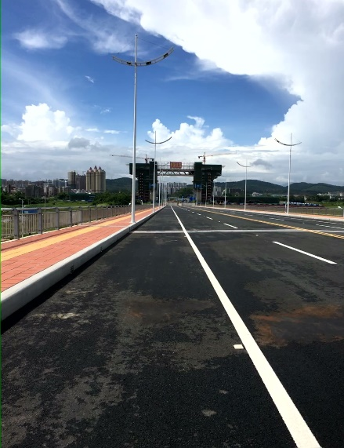
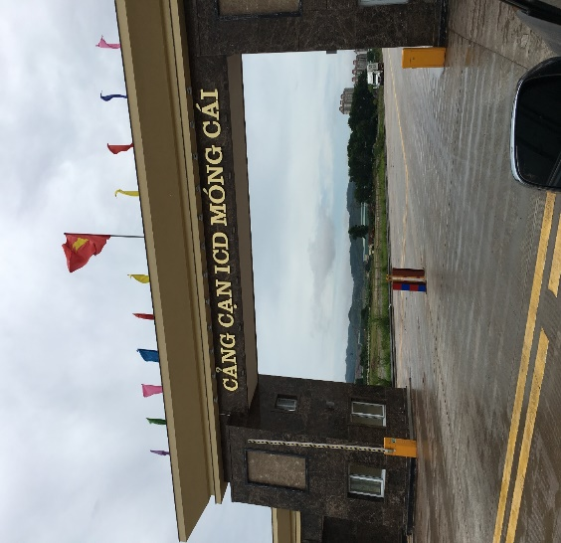
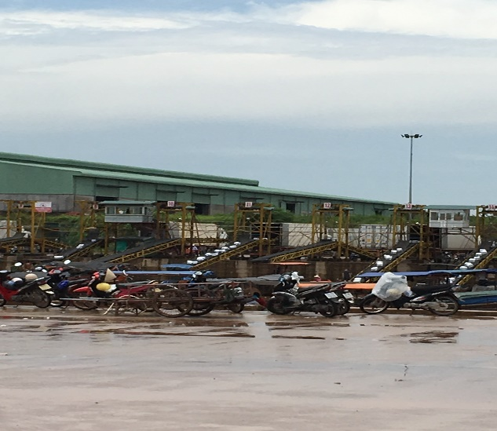
Figure 7 Mong Cai International Border Gate
Figure 6 New Bridge/Gate Mong Cai-Dongxing
Figure 5 Mong Cai Container Yard Seafood Boxes on Conveyors

Cross Border Trade: Mong Cai, Vietnam-Dongxing, PRC Border Crossing Area

42. Mong Cai BEZ trade situation is similar to Lao Cai and Lang Son-Dong Dang, but at a lower level of progress and lower than on the PRC side of Dongxing, GZAR. However, Mong Cai has advantages of proximity to seaports and river ports that needs infrastructure investments for SMEs and for small border traders in order to realize its full potential across diverse economic sectors of industry, aquaculture, agriculture, and tourism. This also includes investments and capacity development for services and facilities in logistics, banking, business market information (business development services-BDS) and better coordination and collaboration between business and government at all levels. As such, in Quang Ninh province, a number of commercial banks set up branches at the border for border trade payments and these include: Agribank, VietinBank, BIDV, Vietncombank and Techcombank of which some have agreements with Chinese partners.

43. The border gate region in Quang Ninh province has over 350 enterprises involved in border trade activities between Vietnam and China including 250 enterprises and traders from different regions of the country. Quang Ninh’s traders account for 30 percent and the remaining are from other provinces across the country and especially from Haiphong city. So far, Mong Cai Border-Gate Economic Zone has attracted only 20 FDI projects with a total registered capital of $1,106 billion and hundreds of other projects. In the coming time, about 40 projects in seven sectors (transport; infrastructure; culture, trade, services; health-care, education; electricity; water supply and drainage, environment; agriculture, industry) will be given priorities to attract investments into Mong Cai Border-Gate Economic Zone, according the Mong Cai reports.

44. Quang Ninh province is a leader in percentage of total border trade value with China from 2006-10 of $4.2 billion or 59 percent compared to Lang Son of 24 percent and Lao Cai of 14 percent, according to the Mong Cai BEZ master plan report. Total value of all border trade in that period was $7.1 billion. In 2011, Mong Cai border gate trade was $1.1 billion exports and $450 million imports with a total of $4.6 billion temporary import and export, according to the Quang Ninh Economic Zone Management Board.

Transport and Logistics

45. Transport and logistics are adequate based on master plan information, but much more needs to be built to handle the growing and diverse volumes and values of trade and to attract investors. The current logistics situation in the Mong Cai area has 17 bonded storage facilities, 13 for refrigeration and 22 normal warehouses. Bonded have a minimum area of 5,000 m2 (including warehouse, ground, support facility), and has a minimum area of 1,000 m2. Some are in the form of solid buildings, meeting all requirements and some are fenced and with all necessary facilities and equipment.

46. The sea port is Van Gia in Vinh Thuc island with a water depth of over -10 meters serving 10,000 tons ships and a capacity of 3-5 million tons per year. The inland container depot mentioned earlier to construct the floating dock for China trade is the Thanh Dat port for export with an area of 49.7 ha, in Hai Yen ward, Mong Cai city. This is sufficiently equipped is operational all day every day. It is mostly for frozen goods, groceries, cars, and plants. Since May 2014, this became a major point for car export to China (temporary import for export). Some other major checkpoints invested by the private sector are: Luc Lam, 300 meter dock along the river, Luc Chan for rubber waste, fruits and other materials, Dai Vai Checkpoint (Bac Son) invested by Kim Tinh Co LTD, area of 8,106 m², and Van Gia Port Border gate, Mong Cai which has a sea front with China. However, there are no docks or warehouses yet, and all loading and unloading happen on the water from ship to ship directly.

47. Recent Prime Minister decision 200 and 1012 (Logistics Center) will bring greater focus to the investment and public-private consultation bodies needed for logistics development in Mong Cai BEZ. These are plans from the master plan report: development of goods and passengers logistics centers: ICD in Hai Ha railway station to transit road-rail; Hai Ha seaport logistics center (rail – waterway – roads); West Ka Long river domestic ports (river – roads); and Border rail station (rail – road). Transportation support facilities: International bordergate: three main road bordergates: Bac Luan I; new Bac Luan II and III; waterway bordergate: upgrade Van Gia port, domestic river port Ka long and new seaport Hai Ha; and railway bordergate: new terminal in Mong Cai city. Finally, plans are for better road connections between Ha Long and Mong Cai expressways by four interchanges with the first to a new entrance to the Hai Ha industrial zone.

Border Economic Zone Potential

48. There are many advantages in Mong Cai bordering Dongxing compared to Lao Cai and Lang Son/Dong Dang. The latter two are landlocked whereas Mong Cai is on the sea with many waterways. Cross border trade is growing in all of these border points. GZAR’s international trade increased rapidly from $17.7 billion in 2010 to $51.3 billion in 2015 and Vietnam is the largest trading partner by 48 percent of this trade. The trade growth is especially evident at the crossing points of Mong Cai-Dongxing, Lang Son-Pingxiang and Cao Bang-Longbang from $3.3 billion in 2010 to $16.3 billion in 2015. Key exports from Vietnam are agriculture products (fresh and dry fruits, vegetables, grains, live animals and animal products, starch and seafood products) and minerals. All requiring some form of refrigeration to prevent spoilage and loss of income. The SME’s and small batch traders are the vast majority of cross border trade accounting for 52 percent of GZAR total trade in 2015, according to ADB reports.

49. Against this backdrop, Mong Cai’s seaport position is critical to cross border trade not just with Dongxing/Fangchengang seaport (Qinzhou and Beihai), but as a possible gateway for landlocked cross border points to markets in the Panbei Bu Gulf and to Guangdong province in the PRC. The ADB “Multitranche Financing Facility” for GZAR will have important spillover effects in regional cooperation and integration for Mong Cai and Vietnam provinces, but much more is needed for infrastructure projects, especially refrigerated capacity for perishable fruits/vegetables/seafoods and for establishing public-private dialogue bodies.

50. At present, there is a planned 1,300 hectare area CBEZ area between Mong Cai and Dongxing. The current cross border area functions are just for immigration purposes wherein individuals from both sides can go 15 kilometers into the other side. Documents provided about Mong Cai BEZ explain that Chinese citizens residing in districts and towns bordering the province are permitted to go through the border-gate economic zone using valid border IDs or border permits issued by China's competent authorities and allowed to stay at the border-gate economic zone in a period not exceeding 15 days (applicable to those who carry foreign passports not subject to visa exemption). Vietnam's citizens are free to go through the border-gate economic zone. Foreigners and Vietnamese settling in foreign countries who are conducting investment and business activities in the economic zone and members of their families are granted with multiple valid exit-entry visas and eligible for temporary residence in the economic zone as well as in Vietnam. Furthermore, goods and services produced and/or consumed in the non-tariff zone or brought into the non-tariff zone from foreign countries and/or exported from the non-tariff zone to foreign countries are not subject to value added tax.

51. Both meetings in Ha Long and in Mong Cai indicated that future plans are to have better cross border trade operations in a joint cross border area, but now are hindered because of approvals required by the PRC side for Vietnam agriculture products and other exports as well as by higher level agreements on the joint cross border area zoning. Industrial, agriculture and seafood clusters are possible with both sides offering their comparative advantages. One possible cluster is with the textile industry where China plants are established in the industrial zone and in the Hai Ha area. The Chinese Mong Cai textile facility is on 300 hectares employing 6,000 Vietnamese workers taking advantage of the low labor costs of $200/month and exporting to China and Hong Kong. Labor issues are common involving cross border worker policies. In Mong Cai, businesses are requesting workers going to the Chinese side. Further research and meetings in Mong Cai will need to gather more details about the companies investing in the Mong Cai BEZ in both the city area and in the Hai Ha area and to align with the Mong Cai master plan for the CBEZ with Dongxing to find exact problem details to make the area functional and operational.

Public Private Consultation Status (Cross Border and National)

52. The Ha Long and the Mong Cai meetings both expressed their dire need of public and private dialogue bodies established at the national and cross border levels. This will need to include an understanding of international practices on how these national and cross border cooperation bodies function to solve problems together (business and government) on a regular basis with agendas and not just for networking and investors. This was also expressed by the Vietnam logistics companies met in Hanoi that have cross border trade operations in Mong Cai (textile and refrigerated produce) and in the other cross border points for regional trade. They are: OTL, Zhen Yang and Gemadept Logistics. These logistics companies meet informally with the government and at present discussing transshipment issues that were once not needed in Pingxiang.

53. The Ha Long meeting explained that two public private consultation mechanisms are functioning:
(1) Border Management Board (promoted by the central government) with working groups in consultation with the Chinese side. This involves daily routine management at the local level between Mong Cai and Dongxing. Also, there are provincial level meetings for the BEZ where the department of planning and investment is invited by the Chinese into the area of the BEZ and IZ. These are regular dialogue meetings.
(2) The second mechanism is a meeting for the whole area EZ as shown in the map in the “Development Strategy” of this report. The Quang Ninh CPC meets with Dongxing one time per year to discuss big investment projects such as the corridors and also meet with Lao Cai, too. However, at present the Ha Long meeting explained that central governments are not coordinating and communicating well with border areas. Issues are tasked under different agencies and are not sharing information with different agencies and with the BEZs. Also, need management of the whole BEZ with investments along with working groups with the other side.

54. So, the two mechanisms described above may not be functioning well at all and are just in name. As such, all master plans and local initiatives to develop the Mong Cai BEZ are not progressing. In addition, the Mong Cai meeting explained that any public private dialogue was informal. In fact, Vietnam government officials cannot go over the border to Dongxing to meet, but businesses can. No mechanism for cross border or national meetings within Mong Cai is happening, according to these officials. This was underscored by the meeting with the local Mong Cai businessman and leader of the Mong Cai business association from Indeco Joint Stock Company. He explained that no regular scheduled meetings take place. Only, every 2-3 months they meet, if companies have problems, then he takes these issues to the government in Mong Cai to discuss and resolve. Mong Cai SMEs meet with the government PPC in Mong Cai to explain issues, but are not very open with businesses and are slow on procedures. This lack of a functioning public private cooperation mechanism is needed because businesses are responsible to solve and finance their border infrastructure and operations issues themselves and government policies are not clear, especially for cross border labor issues.

Hekou, Yunnan, People’s Republic of China

Geographic, Demographic and Trade Profiles

55. Hekou is one of the three border towns in Yunnan province, PRC (the other two are: Mohan, Mengla county, Xishuangbanna Dai Autonomous Prefecture bordering Laos and Ruili, Dehong bordering Myanmar) and part of the GMS North-South Economic Corridor with capital city Kunming as a focal point in the north and Hanoi/Haiphong in the south. Hekou Yao Autonomous county is in the southern part of the province with the largest population of the three of 108,000 in an area of 1,313 square kilometers across from Lao Cai in northern Vietnam. Hekou and Lao Cai are twin cities. Ethnic groups of Yao, Miao, Yi, Dai and Yi are along with the Han. Economic activities are diverse to include: agriculture (various), mining (white marble), cement, rare species of forest resources and agriculture machinery and fertilizers. The two border towns are separated by the Nanxi River (Nam Thi) and is a tributary of the Red River of Yunnan and joined by the 295 meter Red River road-bridge in 2007.

56. Business activities are limited within the Hekou Border Economic Cooperation District (one of 17 established by the State Council in 1992) to petty trade and barter trade. Other business activities, such as processing trade, transit trade, service trade and use of foreign capital, account for only very small proportion. At present, Hekou only has PRC companies, but is opening up to other potential foreign investors. Since 2005, progress is slow on developing their Cross Border Economic Cooperation Zones in Yunnan. However, the PRC Belt & Road Initiative is helping to speed up development with the issuing of a Joint Master Plan for China-Vietnam CBECZs. Vietnam replied with comments on July 24, 2017 to this Master Plan.

Development Strategy

57. The central government has the 13th Five Year Plan with high level development strategies such as the Belt and Road Initiative and Yunnan and Hekou have their own five year plans as well. The local plan is to have urban development for workers and for traders. Some main features of a phased approach are: road network, a new bridge in the Zone since current one is not sufficient, expand the mutual trial area for petty goods
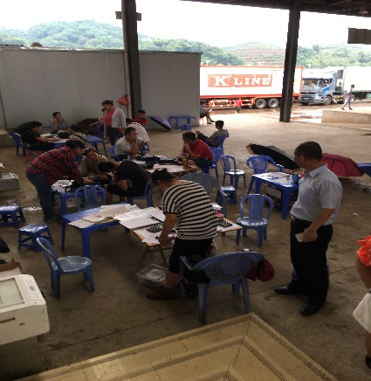
Figure 8 Hekou Border Traders and promote Hekou as a “land port town.” The local government of Hekou expressed their anxieties about the un-coordinated developments of cities on both sides of the border, because all sorts of cross-border economic activities are restricted by the mismatched logistic infrastructure and the customs clearance capacity on the other side (Lao Cai) of the border.

58. The Yunnan provincial Five Year Plan (2015-2020) are ambitious and achievable, especially if national and cross border coordination/consultation bodies are established. These include implementing the Belt & Road Initiative by a Bangladesh-China-India-Myanmar Economic Corridor and a China-Indochina Peninsula Economic Corridor. By 2020, railway and expressway networks will lay routes spreading in all directions to facilitate the access to neighboring provinces and countries. This integrated transportation network will consist of a wide area standard transport network, fast transport network, specialized cargo transport network, border area inter-city railway network and urban public transport network. Railway operation mileage will reach up to 5000 kilometers and expressway network will cover all prefecture-level cities, counties with population of over 500,000. In addition, plans by 2020 include 20 civil airports to bring the total to 50, total length of inland waterways to reach 5,000 kilometers and the construction of large integrated hub cities in Yunnan.

59. The land use area of Hekou is still transforming from agriculture with plans to attract contract manufacturing for electronic devices and reach 10,000 jobs for factory workers as well as scale up processing industries and border trade areas. Also, plans are underway to expand the scope and function of Honghe National Integrated Bonded Area, promote the construction of Hekou, Ruili, and Mohan railway ports, an Internet+ campaign to include among other economic sectors: efficient logistics by using Internet technology to upgrade traditional logistics industry, enhance enterprises’ logistics information standard, build logistics information public service platform, and improve logistics supply-demand info docking and usage efficiency.
60. The Kunming Energy Investment company is a prominent business in the Hekou area. They bought the Kunming Iron and Steel Company which was a 100 percent national company. The Kunming Energy Investment company is more efficient with trading and logistics experience and has 60 percent individual logistics companies among its stakeholders. In 2016, this company transported 3 million tons of goods and from January to June in 2017 transported 2 million tons of goods with a forecast of over 5 million tons and by 2020 plans on 10 million tons per year. This company is upgrading facilities with a $76.6 million (500 million RMB) budget and partnering with the Kunming Railway bureau. Yunnan province has a $3 billion (20 billion RMB) logistics fund for development of logistics, transportation and warehouses.
Figure 9 Hekou refrigerated facility for fruits
and vegetables needing investments
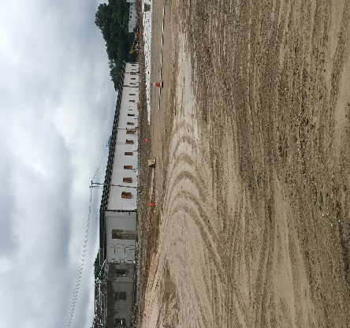
Cross Border Trade: Hekou-Lao Cai Border Crossing Area

61. In 2013, the Department of Commerce, Yunnan signed a memorandum of understanding (MOU) and in 2015 initiated a project for the China-Yunnan, Hekou Economic Cross Border Zone. This area is for 21 square kilometers for 11 square kilometers on the Chinese side in Hekou and 11 square kilometers on the Vietnam side in Lao Cai. Projects are needing central government approvals and include international trade and border logistics, international finance, manufacturing and processing, cross border tourism and infrastructure construction of two bridges. A fund of $383,212, 250 (2.5 billion RMB) is needed and started, according to Hekou field meetings on July 3, 2017.

62. Hekou is the main corridor for seafood and tropical fruits with trade in values and volumes growing in double digits. Trade is growing because of Hekou-Hanoi (224 km.) and Hekou-Kunming (406 km.) highways, better electronic platform to facilitate trade with Customs & Quarantine, the Pan Asia railway and the China-Vietnam economic cooperation. A main contributing factor to the growth is the informal border trading activities.

64. A citizen free trade area is allocated and growing in importance in the Hekou border economic zone. Now, the citizen traders enjoy a tariff free $1,225 (8000 RMB) de minimus and will increase to $3,061 (20,000 RMB) in the future. This policy began in 1993 between the China and Vietnam and the market started in 1998 without any infrastructure and since 2011 has infrastructure that is at present inadequate. One thousand trucks per day pass through the Hekou border area in which individual traders consolidate their de minimus shipments into the trucks for imports. In 2016, container trucks (lychee fruits and iron ore from Vietnam, for example) accounted for 3.8 million tons and expected to grow in 2017 to 5 million tons. Truck exports are limited and mostly empties because of the lack of cross border agreement or implementation for how far trucks can go into each countries’ borders.

65. Hekou Customs provided cross border trade statistics during the field meeting. In 2016, total import and export trade was $640 million for a 29 percent increase over 2015. Imports were $300 million or 42 percent increase and exports were $340 million or 5 percent increase over 2015. Total tonnage of goods imported and exported was 2,252,000 or a 124 percent increase. Road transport accounted for 1,840,000 tons and rail for 294,000 tons. The traders’ area accounted for 118,000 tons and cross border persons increased 14 percent to 1,719,000 and 111,000 vehicles. Main exports were fertilizer, chemical products, electrical equipment, machinery and agriculture products. Imports were mineral ore, wood, agriculture products and seafood from Vietnam in 2016.

66. Seafoods and fruits are dominant trade categories and reliable refrigerated and cold chain infrastructure is required. Hekou Customs calculated imported seafood of $153,284,000 (1 billion RMB) or 25,000 tons and in just January to May, 2017 of the same total value in 30,000 tons. Similarly, Vietnam fruits imported (dragon fruit) from January to May 2017 of $43.5 million (284 million RMB) or 64,000 tons. Yunnan informal trade or citizen petty border trade between January to May 2017 was $245.2 million (1.6 billion RMB) in value of goods of which the most were of seafood (60 percent) and fruits. Fruits were $76.6 million (500 million RMB) or 130,000 tons.

Transport and Logistics

67. In addition to the provincial level transport plans, there are logistics plans. These include coordinating and modernizing logistics, customs and quarantine for cross border trade and furthering the single window, one stop, integrated customs clearance. In establishing Honghe as a logistics hub, accelerate all kinds of logistics services including trade logistics, bulk cargo transition, international procurement, international distribution, and entrepot trade. The details of these broad brushed plans can be achieved through establishing public-private national and cross border consultation bodies. Yunnan international trade growth targets are of $50 billion by 2020 from 2015 of $24.5 billion of which Hekou is a major factor among Mohan and Ruili.

Border Economic Zone Potential

68. The China-Yunnan, Hekou Economic Cross Border Zone with Lao Cai is a start to realize the economic potential and growing trades across agriculture, industry, seafood and informal day trader activities. However, the field visit showed that infrastructure is needed to better facilitate rural linkages and Hekou area border traders as well as funds to complete the refrigerated warehouse facility(s). These include better connected secondary roads and a new bridge to improve border area economic zone businesses and attract more investors for the potential of clusters. Infrastructure improvements also include better housing for workers that will be over 10,000 of which some Chinese factories are already established in the border area.

69. At present, Hekou is connected to the PRC national network for single electronic window Customs, inspection/quarantine and logistics data for shippers. However, the uneven economic development of infrastructure and service offerings on the Vietnam side is a hindrance to smoother cross border cooperation and joint economic zone business operations and could deter potential investors such as contract manufacturers. However, improving cooperation on cross border labor management could attract investors seeking low cost per labor hour comparative advantages. Labor management and proper housing will increase the potential of the designated 11 square kilometers areas on both sides of the border. The ADB multi-tranche financing facility in GZAR is useful to replicate in Hekou, Yunnan since the components address the same issues and will have important spillover effects for Vietnam’s cross border economic zone development.

Public Private Consultation Status (Cross Border and National)

70. Field visit interviews indicated that public-private (government-business) meetings are very informal. These meetings are only workshops with mayors to increase economic and trade activities and some are just ADB sponsored events. The strategic master plans at the national (13th Five Year Plan-2015-2020), provincial and local levels will be difficult to implement without functioning national and cross border cooperation bodies. International practices show that grouping three separate cross border towns together into one consultative body is possible. So, Hekou, Ruili and Mohan could form one public-private national and cross border cooperation institution which is the approach underway according to the field meetings in Hekou on July 3, 2017.

71. The Kunming Energy Investment Company is a strong business entity that could lead the Hekou businesses with the Department of Commerce as co-leaders within national and cross border cooperation bodies. These two mechanisms will be effective in solving problems and harmonizing (within Hekou and cross border with Lao Cai) infrastructures, operations and policies to achieve master plan objectives. Regular meetings with working groups each quarter are proven to categorically and systematically solve cross border problems as demonstrated by international practices. Investment promotion or networking is not the purpose of these meetings. One of the reports from Yunnan stated: “The provincial government calls for communication and cooperation between different levels of government, society, and enterprises; and will improve all-round exchange and dialogue bilaterally and multilaterally”. More details and guidance are needed to assist in reaching the objective.

Pingxiang, GZAR, People’s Republic of China

Geographic, Demographic and Trade Profiles

72. Pingxiang is a county level city on the Nanning-Singapore Economic Corridor and Pan Pearl River Delta Economic Circle and more advanced than Dongxing and Hekou in cross border economic development. The city has a population of 116,000 with majority from the Zhuang ethnic group and per capita income of $7,580 (49,548 RMB) in an area of 650 square kilometers. Pingxiang City is a gateway to the ASEAN, Southwest China and Central South Region in China’s “Belt and Road” Initiative. Currently Pingxiang is the biggest and most convenient land route between China and Vietnam, and is the intersection of Beibu Gulf Economic Zone and the Greater Mekong Subregion. Pingxiang is connecting to three counties of one province in Vietnam, on both west and south sides, with a 97 kilometer border. Since 1980s, the border ports on both sides have been prosperous and stable. Frontier defense, public security, border inspection, customs, inspection and quarantine on both sides have been keeping a good-neighborly and cooperative relationship. The Youyiguan or “Friendship” gateway is important for border trade with Dong Dang/Lang Son in Vietnam and a tourist destination.

73. Pingxiang is focusing on border trade and cultural tourism. The arable land area in Pingxiang is small, and comprises mainly hilly terrain, which is not suitable for large scale agriculture. However, there is a cross border business linkage (value chain) in the Yuexiangyuan dairy processing project which is a China-Vietnam joint commercial business. The main industries are: metallurgy, coal, chemicals, processing, building materials, medicine, food, foreign trade and tourism. Value added to industries was $4.4 billion in 2012, 13.4 percent increase over 2011. Foreign trade was $1.1 billion, a 50 percent increase in 2012 and domestic tourists were 13.9 million.

Development Strategy

74. Pingxiang’s economic development started in 1990. Since 1992, the State Council approved Pingxiang as the open border city and Pingxiang developed its foreign trade in various phases and comparative advantages. To date, enterprises are mainly small-medium sized. Pingxiang needs about $1.5 billion (10 billion RMB) each year for infrastructure construction.

75. Pingxiang is implementing trade and transport infrastructure projects in a phased approach and part of the 13th Five Year Plan. The Commerce Bureau described and showed the border economic zone areas in operation since 2010 and future plans in the field visit of July 4, 2017. Some of these are the integrated bonded area for bonded trade, international trade and Customs functions in operations since September 2010. The China-ASEAN Border Trade pilot project with 6 platforms of which Pingxiang is one. The Youyiguan Port Area bonded logistics processing trading area for free trade zone exports and duty drawback. The Puzhai-Xinqing-Vietnam pilot area which includes a road and tunnel for only goods freight as a short cut. This plan will enable cross border value chains in which Foxconn plans to use Vietnam low labor costs and Pingxiang higher value added assembly for manufacturing Apple products. This is part of phase two with light industry, equipment processing, and an all ASEAN agriculture products area for processing, textiles and information systems with cluster synergies possible.
Figure 10 Pingxiang road and tunnel
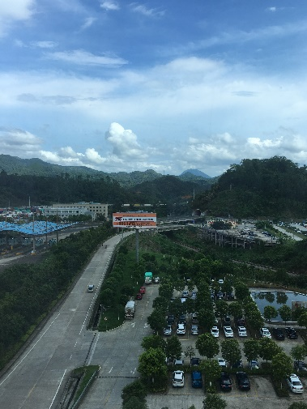
76. In the process of constructing the China-Vietnam (Pingxiang) Cross-border Economic Cooperation Zone, Pingxiang City will explore the management mode and supervision mode during the “13th Five-Year Plan” period, strengthen the cooperation with Vietnam, promote the infrastructure construction before Vietnam takes actions, promote the construction of business zone, tourism zone, logistics zone, financial business zone, specialized market zone, processing zone and port operation zone, and prepare for the cooperation on the mutual recognition of customs clearance standards and industrial chain construction between the two countries, so as to achieve real free trade and closed management inside and outside the territory. The key projects include: the comprehensive development of Pingxiang Park in China-Vietnam Pingxiang-Tongdeng Cross-border Economic Cooperation Zone, and supporting infrastructure construction, the Pingxiang Park Medical Cooperation Center, the power grid upgrading project, the comprehensive development project of Featured Agriculture and Forestry Industry Demonstration Park.

77. Pingxiang has many infrastructure projects in the 13th Five Year Plan in roads, urban facilities, railways, highways, waterways, aviation, dry port, intelligent port, and China-ASEAN Information Port. Notable are: reconstruction project of Pingxiang section of Pingxiang-Hanoi Expressway; Pingxiang- (Vietnam) Hanoi high-speed rail; the construction project of border trade goods logistics center (China-Vietnam cross-border) channel; other road networks in Cross-border Economic Cooperation Zone; a border trade customs information service system that covers Youyiguan Port, Puzhai, Nonghuai, Ping’er, Youai, Jiaoce and other ports will be established, including vehicle automatic scanning system, automatic identification, and information sharing platform. An intelligent and convenient vehicle clearance system will be established. There will be eight featured industries of Pingxiang city mainly including international logistics industry, modern service industry and modern featured agriculture. More details will be needed.
Cross Border Trade: Pingxiang-Lang Son Border Crossing Area
78. Pingxiang and Lang Son/Dong Dang agreed to develop the CBEZ with 8 square kilometers on each side, but needs further government approvals as well as better roads connecting on the Vietnam side. The Puzhai-Xinqing Pilot Area of China-Vietnam Youyiguan International Tourism Cooperation Zone and the E-commerce Park of China-Vietnam (Pingxiang) Cross-border Economic Cooperation Zone will further the integration of the two border towns. On the Pingxiang side this includes warehouse plans, truck parking area for the 800 trucks per day, and import/export area, border trade area in a phased plan. The ultimate goal is the connecting of all areas to one big PRC-Vietnam Free Trade Area: Puzhai, Nongha, Youyiguan with people freely moving from both countries up to a point in the CBEZ area.

79. Pingxiang has business plans to develop the livestock breeding, Chinese herbal medicine processing, fruit and rice processing, China-ASEAN auto parts assembly, Forestry Industrial Park of Pingxiang City, the Rubber Processing Industrial Park of Pingxiang City. These plans offer opportunities for cross border synergies or clusters with Vietnam partners. The realization will depend on improving basic infrastructure on the Vietnam side and better joint government and business cooperation mechanisms. At present, the new Huu Nghi border gate and the multi-tranche financing facility by ADB will prove effective to improve the uneven infrastructure development and trade imbalance of these border towns and towards attracting investors.

Transport and Logistics

80. International logistics industry is prominent in the Pingxiang 13th Five Year Plan. Some key projects are: China-ASEAN logistics hub project, Pingxiang Hangyangchao China-Vietnam International Logistics Base, ASEAN products logistics center project of Pingxiang City. Providing modern facilities and integrated cross border services is important to retain and attract service providers and their shipping customers such as, Shenzhen Overland Total Logistics Co., Samsung and Foxconn. In addition, plans are in the works to build large-scale distribution centers for electronic products, spare parts and finished products. There is also the Land Container Logistics Hub Project conducted by SITC International Holdings to achieve normal operation and carry out container handling, cold chain logistics and other business.

81. Rural business opportunities will improve with better roads to the border and regional markets. Pingxiang has plans for this inclusive growth. The rural infrastructure construction of Pingxiang city mainly focuses on rural road construction, the construction of water conservancy facilities, energy facilities and information infrastructure. The key projects include the modern agricultural infrastructure construction project of Pingxiang, rural drinking water safety project, farmland and forestry water conservancy facilities construction project, the modern forestry demonstration area of Xiashi town, Pingxiang city, and migrant workers’ entrepreneurship park of Pingxiang.

Border Economic Zone Potential

82. The potential on the Pingxiang side of the cross border area is immense because of the plentiful sources of financing of projects. Leveling the benefits of cross border trade will occur with more coordination and harmonizing of Lang Son/Dong Dang master planning and construction with those in Pingxiang. Regular meetings in a defined national consultation committee with working groups will further cross border development and trade. Convenient trade customs clearance environment and improved traffic network are noted issues that need improvements to benefit both sides. In addition, the stalled agreements between the two sides on the border area free trade zone could move forward with a more stable and regular cross border cooperation committee. The construction of the tunnel for goods only freight could also bring equal benefits to these border towns and attract more investments.

Public Private Consultation Status (Cross Border and National)

83. The use of public-private (government-business) mechanisms to solve border problems on a regular basis is not occurring. The Pingxiang meetings in July 2017 asked:
Are there formal institutions (legal basis) or informal meetings with both business (individual companies from: industry, agriculture, logistics, customs brokers) or with their business associations and government officials meeting together at the same time with agendas of problems to solve (border/cross border: operations, infrastructure, policies/laws/regulations) on a regular basis? “There are no regular meetings and working groups are formed ad hoc within Pingxiang, GZAR and at the national levels. Government departments organize workshops and consulting meetings according to the current international trade status. According to the project progress, government departments will gather investors and project owners together and discuss on certain topics.” A similar response was found for the cross border public-private institutions: “According to my knowledge, very few meetings between government and enterprises cross border. More research is needed since there is indication that there is a cross border management committee in Pingxiang, but not enough information at this time.”

Dongxing, GZAR, People’s Republic of China

Geographic, Demographic and Trade Profiles

84. Dongxing is a county level city 25 kilometers from prefectural level seaport city of Fangchengang and establishes Dongxing Border and Economic Cooperation Zone along a 33 kilometer borderline with Mong Cai, Vietnam as an important land and water border town to China and ASEAN markets. The city has a population of 300,000 and per capita income of $8,542 (the largest among Hekou and Pingxiang) with a 50 kilometer coastline and established as a BEZ in 1992 in 4.1 square kilometers. In 2015, the economic output was $1.3 billion from services, industry and agriculture with total foreign trade value of $2.8 billion (Pingxiang was $10.4 billion). The main business activities in the Dongxing BEZ area are border trade, tourism and processing, especially seafood/marine as seen in the July 5, 2017 field visit.

Strategic Development

85. Dongxing leaders have ambitious plans to capitalize on their unique land and water transport location for border and regional trade and are developing much more than cross border town Mong Cai, Vietnam. The city spent $7.6 billion (50 billion RMB) on infrastructure from 2007-2017 and will need $762.7 million (5 billion RMB) to 2020. Long range plans over 35 years are for $9.1 billion (60 billion RMB). Master planning indicates that Dongxing Border Economic Cooperation Zone will transform into the Beibu Gulf Free Trade Experimental Zone Fangchenggang Area. Details are to build the CBECZ into “1+7” supporting zones.

86. Of the seven, only the first listed below is in operations with 20 companies:
- Chonglan Eco Industrial Park (IP). This area aims to develop for ASEAN markets with export-oriented processing manufacturing. The industrial types are dominated by food manufacturing, agricultural and non-staple food processing, pharmaceutical manufacturing, furniture manufacturing and handicraft product manufacturing, electric machinery and equipment manufacturing, telecommunication equipment, computer and other electronic equipment. After phase one, companies are estimating annual output value of $1.52 billion (10 billion RMB).
- Border Trade Center;
- Jiangping IP for marine processing;
- Songbai IP for emerging industries such as energy saving and new energy vehicle, electronic component, new material, bio-pharmaceutical, marine engineering equipment, 3D printing and high-end mahogany processing industry
- Changshan New Town
- Huangshashui Logistics Processing Park for import & export resource product packaging, processing and warehousing. It will develop manufacturing with imported resources and focus on processing industries such as rubber, building material, metallurgical processing, renewable resources, and plastic products.
- Jialang Logistics Park
To further integrate with the ASEAN economies, the plan is for Guangxi Dongxing Baiheling Tourism Culture Industrial Park, Mahogany Specialized Market, China-ASEAN small commodity cross-border trading center. Also plans are to implement policies for domestic and foreign tourists for duty free shopping in the border area.
87. The Dongxing meetings also outlined key infrastructure projects to link the border area industrial parks and tourism to the wider region. These include:
- Second Beilun Bridge Project with office building, inspection area, Customs area for $30.6 million (201 million RMB)
- Dongxing-Mong Cai-Ha Long-Hanoi High-speed Railway and Fourth Beilun Bridge Project for $83.9 million (550 million RMB)/$40 million application to ADB. Also, planning for a Dongxing-Fangchengang Railway project
- Dongxing-Mong Cai-Ha Long-Hanoi Expressway and Second and Third Beilun Bridge Project for $76.2 million (500 million RMB)
- Dongxing-Pingxiang Expressway
- Dongxing Airport and Railway Station

Cross Border Trade: Dongxing-Mong Cai Border Crossing Area
88. Most business and trade activities in the Dongxing Border Economic Zone Districts are limited and characterized by petty trade and barter trade. One discussion with the Wantong Logistics Company remarked that since 2009 most cross border trade was petty goods and not for containers. By comparison, Pingxiang truck traffic is 1,000 per day whereas Dongxing is 200 trucks per day, according to Wantong Dongxing Logistics Company. Tourist trade is forming with a new free trade shopping facility at the Dongxing border gate.
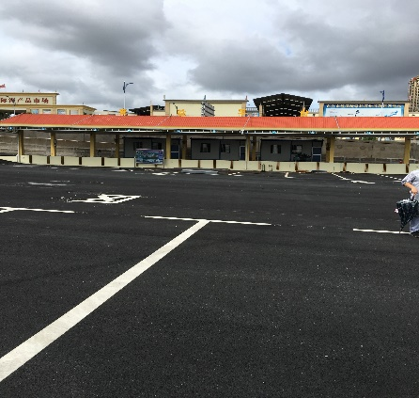
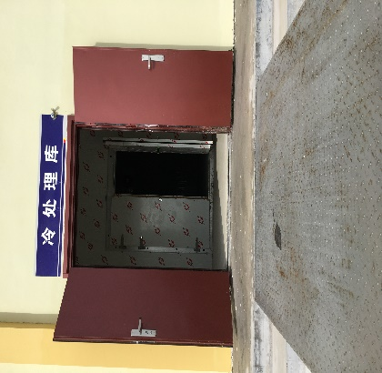
89. There is great potential for Dongxing-Mong Cai cross border business synergies and clustering in the seafood and fruits or perishables trade. In addition to the floating bridge project depicted in Mong Cai, Figure 4, Dongxing is opening fruit processing facilities. The platform in figure 11 inspects
Figure 11 Fruit Processing Figure 12 Fruit Cool Storage
fruits from Vietnam with one warehouse to separate problem fruits and one for cool strorage. Market facilities are under construction for Border Citizens Trade where they will enjoy tax free de minimus (8,000 RMB/person) benefits as in Hekou. The business and investment model here is a pubic private venture.

90. The Dongxing Cross Border Area is part of a larger Dongxing demonstration project. Dongxing has a 10 square kilometer area and Mong Cai, Vietnam has a 13 square kilometer area. The central governments are deciding on their requests for preferential tax policies or no tax zone and to harmonize taxes on the Vietnam side. At present, Customs procedures are separate and are trying to promote a common area and system. Dongxing does not have the single window platform until the end of 2017, but there is a unified national system network that is connected to Dongxing. There is limited connection to the Vietnam Customs system and no access to data. Customs clearance times for cross border trading are 1 hour for imports and 30 minutes for exports on average.

Transport and Logistics

91. In order to facilitate the fruit trade between Dongxing and Mong Cai, a project plan is for a rail spur connecting to the railway to Fangchengang. Dongxing will also have buildings for packaging of fruits, then rail to Fangchengang for wider market distribution. The floating bridge project across to Mong Cai is 144 meters by 12 meters wide in a $1.98 million (13 million RMB) investment and $3.3 million (22 million RMB) for the fruit inspection facilities. In addition to the projects in the “strategic development” section of this report, the ADB Guangxi Multi-tranche financing facility will improve border SMEs, financial services, e-commerce, BEZ development (refrigerated warehousing) and connectivity to markets.

Border Economic Zone Potential

92. Government plans are for a multi-sector production and services cross border economic zone area in agriculture, seafood, light industry, citizen’s trade, logistics, eco-tourism and beaches.
Figure 13 BEZ & Fruit Processing
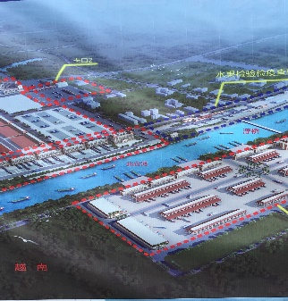
Mong Cai is at a lower level of border development. The moving water bridge project between the two border towns could eventually prove effective in forming clusters in the seafood and fruit trades, yet more road infrastructure and modern last mile infrastructures (warehouses) are needed in Mong Cai/Hai Ha. Some Dongxing logistics infrastructure projects also offers possible demonstration effects as to public and private investment partnerships. The “1+7” supporting zones of industrial parks and connecting infrastructure is a work in progress. At present, citizen traders lack facilities on both sides of the borders and are scurrying across the connecting bridge with bags of goods in hands or on carts. The opening of the new bridge/road, administration building and gate will go far in improving the cross border trade zone conditions at least for the Dongxing side. The lower labor costs in Mong Cai can be the comparative advantage for the Chinese invested textile factory and for the seafood/fruit trades. Moreover, once infrastructure is in place of both hard (roads, ports) and soft (last mile warehouses), then more investors will come for the numerous business opportunities and market access that this CBEZ offers by dry ports and sea/river ports.

93. The spatial location is for a 1,300 hectare cross border economic zone, yet only immigration rights are allowed by citizens 15 kilometers into each border area for 15 days maximum. A common customs area and free trade area still need central government approvals that will require agreements on inspection (facilities in Mong Cai/Hai Ha shrimp farms) and quarantine for the large volumes and values of fruits and seafood from Vietnam. Agreements on these issues will lead to single stop inspection and single window construction and pave the way for more investors in fruit, seafood, light industry, eco-tourism/beaches and logistics. Established and functioning public and private collaboration and cooperation bodies at the local, provincial and cross border levels are proven to improve CBEZ prospects for jointly developing the BEZ areas.

Public Private Consultation Status (Cross Border and National)

94. Dongxing does not have any formal mechanism for public and private cooperation of the BEZ. Each month, Dongxing government goes to the industrial parks for discussions about business license applications and about new fruit policies for companies’ imports. Transport and logistics operation issues are resolved by the mayor and by the many individual deputy mayors in government offices according to their areas of responsibility. As a group, businesses and government do not meet on a regular basis. Wantong Dongxing Logistics Company meets once or twice per month with the Department of Commerce, Dongxing about operations, environment and training workshops informally, and meets in formal meetings about policy changes or reforms. An investment promotion bureau committee is active to inform companies about opportunities. Also, the mayor and six deputy mayors receive problems from businesses by an on-line website platform and reply to them by e-mails.

95. At the cross border (CBEZ) level, there is also no formal mechanism for cooperation with business and government together meeting. According to Nanning officials, both sides are active and eager to implement cooperation, yet Vietnam central government does not have policies (funds) to improve provincial and local cooperation for border economic zone development. However, four Vietnam provinces and local districts are active. More details are required to flesh out these mechanisms for institutional reforms, especially since local and provincial levels (Haiphong for example) can be more effective and successful in moving cross border agendas forward based on international good practices.

96. Phase one of public private consultation mechanisms reforms are in the national BEZ (local/provincial) levels. The success of this body will pave the way for opening up cross border (CBEZ) dialogue in phase two with both business and governments in attendance. More information is requested by Nanning officials about international practices as far as issues of sovereignty, trust building, third party “honest broker” assistance and business involvement. These concerns are covered in the other section of this progress report. The ministries of commerce on both sides are planning together starting in 2017 based on the GZAR “2015 Master Plan Construction of the Cross Border” document submitted to Vietnam with their comments received in July 2017.

