Pacific Northwest seaports prepared for wind energy shipments
By: Robert L. Wallack | Issue #638 | Nov 20 2016 at 06:49 AM | Channel(s): Breakbulk & Projects Breakbulk Energy Alternative
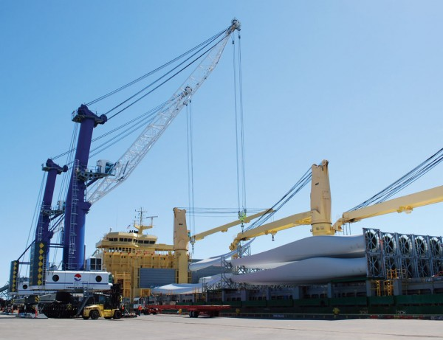Imported wind energy components are a growing opportunity for the Port of Vancouver USA

The Pacific Northwest seaports are vying for new project cargo business from their specialized labor, new heavy lift equipment and seamless transport connections. Imported wind energy components are a growing opportunity for the Port of Vancouver USA and Port of Longview on the Columbia River and for Port of Olympia on the Salish Sea. The United States Congress extended the Production Tax Credit, which will propel the wind farm industry for years. Transportation and logistics companies will find new business from the construction of new wind farms and by refurbishing capacity of existing sites across the United States.
Port of Vancouver USA is located 106 river miles from the Pacific Ocean on the Columbia River and stretches across 2,100 acres of marine and industrial development. Through the first six months of this year, windmill project cargo was a top category accounting for 11 million metric tons after steel, 290 tons and automobiles, 66.5 tons according from industry reports. The port has over fifteen years experience handling wind energy project cargo and each project is unique. “The port has maintained our status as one of the highest volume and most productive deep water ports on the United States West Coast for wind energy handling,” said Alistair Smith, chief marketing/sales officer, for the Port of Vancouver USA in a recent interview with the American Journal of Transportation.
Project volumes range from a few wind turbine generators to over one hundred. Components imported are the towers that range from 3 to 5 sections, the 213 feet (65 meters) blades and nacelles. Blades arrive from Korea, Indonesia, Vietnam and China and nacelles are manufactured in Europe.
Advanced planning is involved as the wind energy components become larger from manufacturers. Destinations and clearance issues through the terminal and inland modes are resolved before the shipment arrives. “Details are often coordinated with third party freight forwarders and sometimes directly with the original equipment manufacturers (OEM). Strong communications with the OEM, stevedores, labor and inland transportation providers is a must,” said Smith.
The efficient and safe handling of wind energy project cargo is essential to meet customer destinations in the Pacific Northwest, Montana, Kansas, Illinois and western Canada. Both the port and stevedores, Jones Stevedoring and Ports America invested in equipment and specialized training to make smooth shipments possible. The port has two Liebherr mobile harbor cranes with 140-metric ton lifting capacity or 210-metric tons in tandem. Other specialized equipment for wind projects includes: onsite expandable trailers and yard equipment along with 100 acres of laydown space for shippers to perform inspections. Both stevedore companies invested in extended yard trailers, reach-stackers, Schnabel trucks and other project specific equipment to efficiently move project cargo off the docks to waiting trucks or railcars.
The massive equipment and wind farm cargo require specialized training in tandem and engineered lifts by the port, Jones Stevedoring and the local longshore union. “We formed a partnership among these three on a new crane operator training program to certify every Port of Vancouver crane operator and ensure they were fully certified. Today, we have a pool of qualified operators,” said Smith.
Port of Longview and Industrial Rail Corridor
The Port of Longview has almost a century as a premiere West Coast breakbulk cargo handling port. The port is 66 Columbia River miles from the Pacific Ocean in southwest Washington State and across 856 acres of waterfront industrial property. The port makes strategic investments in both infrastructure and equipment. Fifteen years ago, the port invested $21 million to construct its Industrial Rail Corridor (IRC) for direct access to the port’s marine terminals of the Burlington Northern Santa Fe (BNSF) mainline and for Union Pacific. “At present, the port is planning a phased expansion of the IRC over several years to increase unit train capacity and railcar storage,” according to Laurie Nelson-Cooley, Business Development Manager, Port of Longview.
The port’s breakbulk expertise was evident in a recent import from China by OEM, Vestas of 270 wind energy blades destined for wind farms in both Illinois and North Dakota. The International Longshore and Warehouse Union (ILWU) secured the blades to the railcars. The port’s on-dock double tracked rail spanning 1,200 feet and the two Liebherr mobile harbor cranes for lifting 140 tons made this project possible.
Each blade was 49 meters (160 feet) long to reach the port by Saga and Chipolbrok ocean liners. “Most of the blades were discharged from vessel directly to rail. These blades were secured to the on-dock rail cars using specialized platforms engineered by Transportation Technology Services (TTS) that allow the blade to ‘float’ across two flat deck rail cars. Blades were secured by twist locks on the roof and tip frames,” said Nelson-Cooley.
Directly north of these two river ports is Port of Olympia on the Salish Sea which is one of Washington State’s eleven deep draft ports capable of handling ocean going vessels. A newly acquired 140 metric ton Gottwald mobile harbor crane, on-dock and dual rail access to Union Pacific and BNSF and an “impeccable reputation of our longshore labor at local 47” enable the port to satisfy customers across many trades, explained Len Faucher, the Marine Terminal Director, Port of Olympia in a recent interview with the AJOT.
The new crane is pivotal in moving various wind cargo, organic grains and for the export of livestock. The port and the United States Department of Agriculture (USDA) quarantine facility shipped 1,400 head of dairy heifers to Vietnam to fill their policy needs in feeding their children. “This operation moved entirely by truck to the vessel. We did use the Gottwald to transfer feed and hay for the operation based on USDA detailed process in humane livestock treatment…,” said Faucher.
Production Tax Credit
All three Pacific Northwest ports are prepared to benefit from the Production Tax Credit renewed by U.S. Congress last December. This green energy tax credit allows qualified wind farms to reap tax benefits based on their output for a 10-year period to reduce federal tax bills, according to the Wall Street Journal article of October 8, 2016. Most of the business through these three ports is for new wind projects, but they expect retrofit or repower wind turbine projects from the aging and reduced performance on the older wind turbines.
The American Wind Energy Association (AWEA) informs that more focus is towards safety and for road infrastructure to desolate rural wind farms for moving domestically produced wind energy components since imports are becoming onerous for the transportation and logistics sector. OEMs have 500 plants in the United States to serve the over 20,000 megawatts (MW) of new wind capacity under construction. However, imports are still important to new construction and refurbishing and for offshore wind farms. The first is on Block Island in Rhode Island.
Wind Energy Construction
More wind energy construction is expected to continue in the double digits for decades. The Department of Energy’s ‘Wind Vision’ report forecasts that U.S. wind power supplies 10% of electrical demand by 2020 from 5-7% in 2016, 20% in 2030 and 35% in 2050. “Recognizing that transport and logistics are a key part of wind industry’s future growth, we’re engaged in proactive efforts including the AWEA Safety Awareness Campaign for 2016, ‘Arrive Alive: Driving a Vehicle Safely’ and our AWEA Safety Data Collection Report to get ahead of the curve,” said Michele Myers-Mihelic, Director of Health, Safety and Standards, American Wind Energy Association in a recent talk with the AJOT. AWEA has a networking group for transportation and logistics at events to discuss major issues. The next event is in San Diego, February 28-March 1, AWEA Wind Project O & M and Safety Conference 2017.
The Ports of Vancouver and Port of Longview on the Columbia River and the Port of Olympia on the Salish Sea in Washington State are all poised to benefit from the tax credits for wind farm construction and upgrades and from decades of wind energy growth in the U.S.A.
Their massive mobile harbor cranes, rail services and highly skilled labor forces are prepared to handle imports from overseas for wind energy producers across the United States. “The recent passage of the five year Production Tax Credit is reinvigorating the wind industry and will help it move to a position of stability. We expect the cascading credit will nudge the industry into a new era,” said Smith.

