Port Milwaukee rehabilitating infrastructure to better serve customers
by Robert L. Wallack | Published in Issue 698, St. Lawrence Seaway Great Lakes Ports, November 25, 2019
Page 1: Port Grant
Page 2: Two Potential Projects
Port Milwaukee is increasing its competitiveness among the 33 inland waterway ports that account for The Great Lakes St. Lawrence Seaway system (GLSLS). The $3.7 million rail rehabilitation project is underway to bring back intermodal container flows to the region. In addition, the Port applied for a Harbor Assistance Program (HAP) grant of $3.969 million to enhance logistics operations as well as applying for the United States Department of Transportation’s Port Infrastructure Development Program (PIDP) grant to build the first agriculture facility for exporting of Distiller’s Dried Grains and Solubles (DDGs).
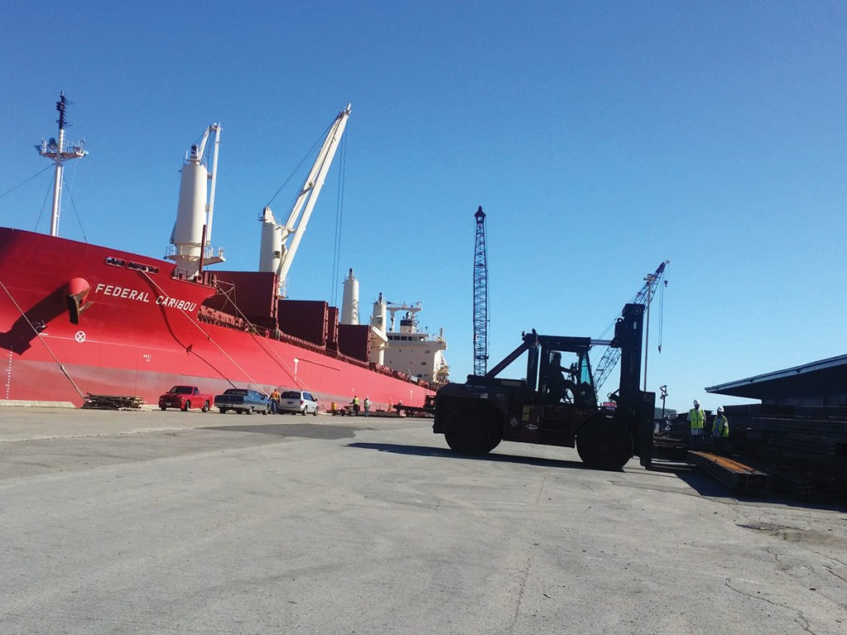Steel beams being discharged from the Federal Caribou at the Port of Milwaukee

Port Milwaukee is situated between Port of Chicago to the south and Port of Green Bay to the north on the west bank of Lake Michigan and is designated Foreign Trade Zone (FTZ) Number 41. Since 2012, Canadian Pacific (CP) Rail cut service to the Port, yet demand continued to rise. Now, importers and exporters of southeast Wisconsin haul intermodal containers through Chicago suburbs which takes a full day. These inefficiencies, poor transit times, higher costs, road congestion and environmental concerns all came to the fore on November 5th at the “Milwaukee Regional Intermodal Freight Summit” sponsored by the Metropolitan Milwaukee Association of Commerce (MMAC). Business and government leaders discussed the Port’s role in the future as an intermodal hub in southeast Wisconsin.

Port Milwaukee is a premium deep-water inland waterway seaport. Its 20 plus tenants shipped 2.4 tons of cargo in 2018. Recent surveys indicate demand increases for international container exports of 121% and for imports of 15.6% over the next 5 years. The Port contributes more than 100 million in regional economic activity, annually and is a designate of the Maritime Administration (MARAD) Marine Highway Program.
Adam Schlicht became director, Port Milwaukee in August 2018.The Port is part of the City government and has a seven-member Board of Harbor Commissioners to oversee operations on 467 acres. “As of November 1, 2019 overall tonnage at the Port Milwaukee is up 22% compared to this time in 2018. Traditional Port commodities are respectively experiencing double digit increase, including salt, cement, limestone and steel shipments. The Port attributes this growth to both increasing awareness and strategic marketing of its logistics capabilities to domestic and world markets as well as its world-class stevedoring partners,” said Director Schlicht in a recent interview with the American Journal of Transportation.
Port Grant
In November 2018, the Wisconsin Department of Transportation’s (WisDOT) Freight Rail Preservation Program (FRPP) awarded the Port a grant of $2.99 million to modernize 8,000 feet of rail track, including new ballast, ties, turnouts and 115-pound rail. Enhanced Port property includes the Intermodal Yard as well as the West Classification Yard in the South Harbor Tract of the Port. This will improve container service and establish an intermodal hub. This rehabilitation project will benefit regional manufacturers, growers and international shippers needing rail to water, water to rail and rail to truck connections. The Port matched funds with $748,480 for a total project amounting to $3.7 million. “The Port intends to pursue an aggressive project schedule. Ideally, all work will complete in mid-2020,” said Director Schlicht.
Adam Schlicht – port director, Port Milwaukee

No decision is made yet on whether Union Pacific (UP) or Canadian Pacific (CP) will use the rehabilitated facility. “The Port is equally invested in offering the opportunity to both Union Pacific and Canadian Pacific, as the two Class 1 rail lines currently servicing the Port, daily. The endeavoring rail lines in partnership with the Port, would select the logistics operator for the site,” said Director Schlicht. At this time, there is not any implementation or installation of new information systems/technologies. “This will be subject to a lease negotiation with the container yard operator at the Port,” he said.
The efficiencies, reduction of road congestion from trucks and environmental advantages of inland water transportation for project cargoes are found on the Great Lake Ports. “Shipments of project cargo are particularly noteworthy, a number of U.S. Great Lakes ports are reporting an outlook for continued movement,” said Craig H. Middlebrook, Deputy Administrator of the U.S. Saint Lawrence Seaway Development Corporation. These project cargoes include high value windmill components, cranes and heavy machinery. Port Milwaukee has seen a 220 percent increase in project cargo. “The Port continues to seek new commodity diversification opportunities, including fuller utilization of our outdoor laydown capabilities. For the first time in recent history, the Port received new project cargoes, including international lumber via import in Milwaukee,” said Director Schlicht.
The MMAC November Intermodal Summit showed a strong customer base for international container service in southeast Wisconsin and beyond. Some of those 150 attending were existing Port tenants and stevedores such as Federal Marine Terminals (FMT) and Kinder Morgan/Milwaukee Bulk Terminals (MBT). Future customers of the Port’s intermodal container service include the AIM Group of Companies, Berco of America, C.H. Robinson, GKM WI Global Supply Chain, JUSDA (the freight forwarder of Foxconn), Lake States Lumber Association, PAK Technologies, Via Rail Engineering and WATCO among many others.
Two Potential Projects
A further bolstering of the Port’s competitive position in the region comes from two potential Port projects. The Port is awaiting approval by the WisDOT to the Port’s Harbor Assistance Program (HAP) grant application. The proposed $3.969 million project includes logistics improvements, facilities and equipment upgrades beyond the rail work identified in the FRPP. This includes entrance gates, rail crossings, paving, inspection racks, fencing, lighting and other rail equipment. “An announcement could be made by WisDOT anytime from November 2019 to March 2020,” said Director Schlicht.
The PIDP grant application is for DeLong Co., Inc., an agriculture products wholesaler, to lease a parcel of property at the Port Milwaukee, Jones Island facility. The Port grantee will develop an agriculture commodity transload facility for bulk shipments in Milwaukee inner harbor. This will be the first on the GLSLS system specifically for the transload and export of Dry Distiller’s

Grain with Solubles (DDGs). Supplemental service is also envisioned for the export of soybeans, corn and grain via deep-draft, Seawaymax vessels. Port Milwaukee transportation infrastructure will need to be modernized which includes demolition work and construction of upgraded moorings, fabric building, transload facility and equipment for rail and truck bulk loading into deep-draft bulk cargo vessels. The project cost estimates are budgeted into the Port’s grant application totaling $31,366,928, according to the Port Milwaukee website report on the PIDP grant application.

