Cold Chain Logistics Management - Data Points to Measure the Effectiveness of Innovation, Robert L. Wallack, 2019-2020
.

The economic and social benefits of cold chain logistics infrastructure and service management to improve food security and reduce carbon emissions depend on reliable logistics information technology systems to be incorporated into the design of the Shaanxi Transport and Logistics Port project.
International best practices demonstrate the importance of cooperation, collaboration, competition and building trust among shippers, customers and logistics service providers (LSP) in real-time data by using platforms or portals. The platforms that share data are Warehouse Management Systems (WMS), Transportation Management Systems (TMS), Enterprise Resource Planning (ERP) and radio frequency identification (RFID) with computer chip tags and hand-held reader devices. Limiting the benefits of the numerous planned logistics parks in Shaanxi province for their consolidation functions will be their lack of information technologies in both hardware and software.
The Fifth National Logistics Parks Survey Report (2018) stated that “the average value of investment for information and equipment systems in the People’s Republic of China (PRC) logistics parks is only 8.2 percent of the total and that in 51 percent of logistics parks information systems accounts for less than 5 percent of the total logistics parks’ investments as opposed to JD.com, SF Express and Suning logistics parks investments for information technology is 25 percent or more.”
The WMS, TMS, ERP and RFID systems can capture and transmit data to a desktop computer or mobile devices showing dashboards of key performance indicators (KPIs) and visibility of temperature controlled inventory throughout the supply chain to monitor storage and moves for customers, LSPs and government officials. These KPIs or metrics and event management are viewed through the portals in the enterprise and/or logistics parks to quantify business, economic and environmental issues to be monitored and improved by decision makers over time.
This data in the KPIs can form a scorecard report for warehouse labor as well to improve labor productivity such as metrics on load/unload time and stocking order fulfillment accuracy. Furthermore, a suite of KPIs can be actionable to improve workers by incentives and gamification among workers by their dashboards and a catalyst for refrigerated and transport logistics changes. Also, limiting the full benefits of logistics parks in both their ambient and refrigerated storage will be the lack of pallets, dry containers and refrigerated containers or reefers in operations at logistics parks in Shaanxi province.

At present, there are not any information technology platforms that foster cooperation, collaboration, lower costs and improve economic and environmental efficiencies. Information systems can capture data and form baseline and benchmark metrics to show the full benefits of the Shaanxi Transport and Logistics Port project to 2027 and beyond. Shaanxi macroeconomic data and KPIs from international practices can offer some guidance until reliable information technology systems are in place.
In order to quantify the benefits of the parks to 2027, there is a need to establish business, government and customer culture of capturing the logistics parks’ warehouse and transportation data daily from the information technology systems to manage by metrics. Initial baseline data can show that overtime in a weekly, monthly, semi-annual and annual reporting mechanism of how and where cold chain logistics management can be improved to lower costs; improve services (route optimization/planning; load factors (less than truck load, LTL/full truck load, FTL); transit times, on-time delivery, empty backhauls, scheduling, landed cost analysis (duty, tax, transport costs, overhead costs); inventory turns and planning; utilization rates; reduced congestion, lower emissions, increase private sector opportunities and grow the economy in an eco-friendly method.
The immediate overarching limiting factor is the gradual increase of Shaanxi per capita and disposable incomes. Higher incomes are needed to afford the price premiums from the high fixed costs of refrigerated infrastructure and attendant value-added services offered by the LSPs as discussed and presented in the workshop of July 25, 2019 in Xi’an. Another factor to consider in the transition to a modern data dependent Shaanxi Transport and Logistics Port project is that of the PRC command economy where local decisions rely on the central government. In that view, PRC and Shaanxi logistics costs as a percentage of gross domestic product (GDP) were 16.6 percent in 2014 and 14.8 percent in 2018, according to the PRC National Development and Reform Commission (NDRC). This indicator is higher than the most competitive developed economies of 8 to 10 percent. This indicator could also be a useful baseline to measuring the benefits to the logistics parks from information systems.
The Shaanxi Transport and Logistics Port project could establish goals to 2027 accompanied by useful KPI metrics and targets to reach over the intervening years. One important goal could be determining at what price levels customers can afford the services of the LSPs in temperature-controlled logistics for fruits, vegetables, dairy, and beverages. The Xi’an supermarket chains could be a useful pilot project to test pricing.

China Gross Domestic Product: per Capita: Shaanxi

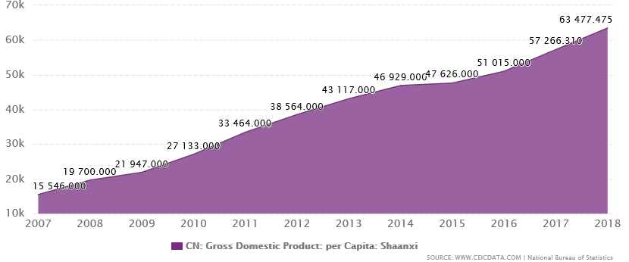
December 1, 2007 to December 1, 2018
This graph shows a per capita compounded annual growth rate (CAGR) from 2007 to 2018 of 13.49 percent for Shaanxi. ($2,220 to $9,068 of 11 years @ 7RMB:$1.)

China's Disposable Income per Capita: Urban: Shaanxi: Xian

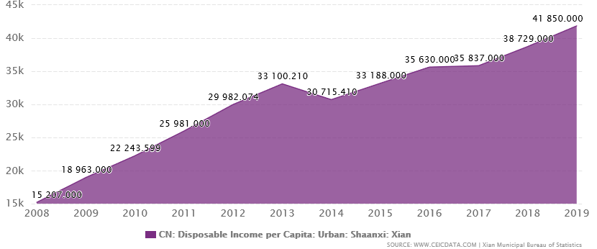
December 1, 2008 to December 1, 2019

This graph shows a disposable income per capita compounded annual growth rate (CAGR) from 2008 to 2019 of 9.53 percent for Shaanxi ($2,172 to $5,978 of 11 years @ 7RMB:$1)

Logistics parks and cold chain logistics management enterprises consider their KPIs as competitive advantage in more advanced economies. Internally, these parks and enterprises set goals to achieve over time from their baseline data and use the data to benchmark their progress. In general, the data is used to capture markets and improve services to customers. In addition at the microeconomic or firm level, LSPs and customers sign service level agreements (SLA) or contracts which also have performance metrics and incentives that are monitored and evaluated from information technology systems.
So, it is difficult for companies to share operational KPIs. However, there are commonly accepted KPIs used by companies aligned with international standard practices. The following are possible for the Shaanxi Transport and Logistics Port project to consider. There are numerous KPIs used in business and it is recommended to only use those that are needed to achieve the goals of the logistics parks and or set by the LSPs and their customers (supermarkets, wet markets) in SLAs.
KPIs can be grouped into various categories:

Occupational Health and Safety (OHS) is the number one focus. Every incident should be reported and examined by a committee monthly.

Financial - they would not be unlike the usual financial indicators one would use for warehouse and transport operations.

Operational - they would involve efficiency measurements and the integrity of the cold chain. Such as,

- turnaround time in less than 4 hours in refrigerated docks.
- picking and putting away: time per turnaround
- hygiene and cleanliness
- staff statistics
- resources utilization/breakdown
- utility usage
- outsource labor efficiency
- adherence to SOP (standard operating procedures)
- others as negotiated with customers

Engineering KPI

- compliance
- service frequency
- maintenance intervals (use proactive maintenance as guiding principle)
- building integrity
- procurement
- adherence to code of conduct and procurement process

Information Technology

- system serviceability
- IT security reports

Environmental

- electricity and water savings
- savings in paper
- percentage recycling of packaging material
- integrity of ammonia/carbon dioxide systems
- solid waste management
- effluent management

Customer service

- Compliments and service failures

Some other KPIs to consider to incorporate into the information systems planning:

Business/Economic

- On Time delivery-montitor customer required delivery date per purchase order (contract) planned/promised versus actual and transit times
- Warehouse capacity- manual inventory tracking transition to RFID in warehouses
- Accurate Order Fulfillment-order picking process by pallets-speed, accuracy (lost, damaged)
- Store Incoming Product-Accuracy: correct freezer, cooler, ambient temperature
- Peak Warehouse Capacity-demand fluctuations and replenishments
- Total Cycle Times-dock to load time, carrying cost of inventory, inventory turnover with WMS visibility
- Employee turnover rate
- Recording of temperatures-temperature monitoring system. Shelf life of food

Environmental

- Renewable energy utilization rate
- New energy vehicle utilization rate-total vehicles?
- Green building coverage-type? Floor area?
- Power consumption to total renewable kilowat to hour, yuan (ton)
- Renewable energy rate: solar, wind

The development of the cold chain logistics industry in the PRC is forecast to grow at a CAGR of 15.6 percent over the next five years. Shaanxi’s economic development with the construction of the Transport and Logistics Port will enable 3PLs, customers and the numerous logistics parks to satisfy demand by temperature controlled logistics for natural, fresh and organic agriculture products whether in supermarkets or by e-commerce. The cold chain logistics management will need to implement WMS, TMS, ERP and RFID innovations so that KPIs can be used to manage by measuring progress over the next ten years according to the goals set by the managers of the Shaanxi logistics parks. Rising incomes show that a gradual price premium charged by 3PLs will be affordable to consumers as shown by the per capita disposable income CAGR of 9.53 percent since 2008 in Shaanxi.

Samples of Dashboards and Graphs from WMS,TMS, ERP into Excel pivot tables

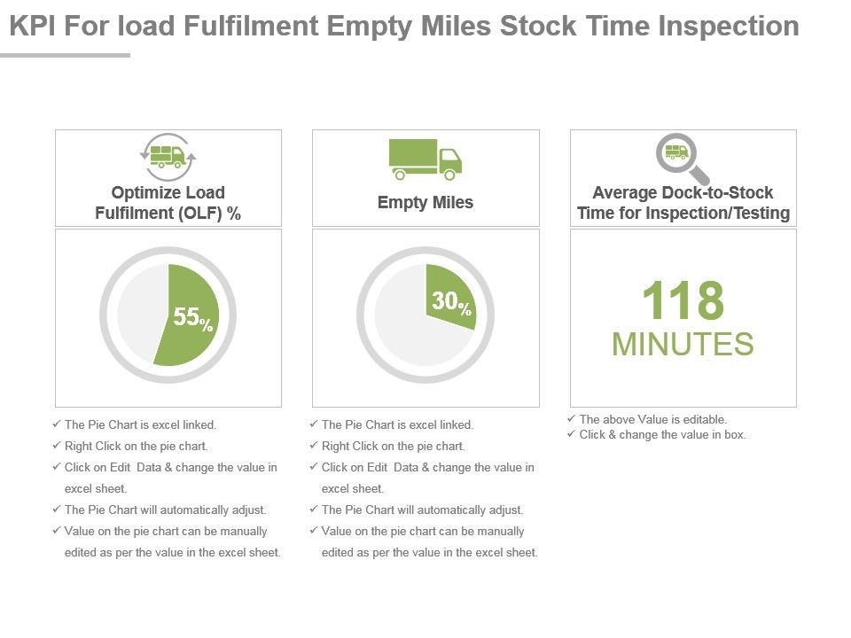
(source: www.slideteam.net)

1-
NA CPG Manufacturer Lean KPI Measures
⁴
0
%
20
%
40
%
60
%
80
%
On-time delivery
Inventory Turns
Cost per unit
Manufacturing Cycle Time

17-
High Velocity Retailers
¹⁰
5
10
15
20
Gasoline Stations with Convenience Stores
Fish and Seafood Markets
Fruit and Vegetable Markets
Meat Markets
Grocery (except Convenience) Stores
Convenience Stores
Computer and Software Stores
Beer, Wine and Liquor Stores
Florists
Pharmacies and Drug Stores
Inventory Turns per Year
(source: Logistics and Supply Chain Management (SCM) Key Performance Indicators (KPI) Analysis
A Canada/United States Retail and Consumer Product Goods (CPG) Supply Chain Perspective, Retail
Council of Canada, November 2006, pgs. 6 and 14)

