Strengthening International Trade and Logistics through Private Sector Participation in Mongolia and Pre-feasibility study for a Dry Port in Zamiin Uud

January 26, 2023

Demand Assessment and Logistics Mapping
Prepared by: Robert L. Wallack, Logistics Expert, U.S.A.
Assisted by: Dr. Munkhbold Adiya, Logistics Expert, Mongolia

January 26, 2023

Prepared for: World Bank
with Mongolia
Ministry of Road Transport Development (MRTD), Mongolia

David Lupton & Associates Ltd. (DLA)

TABLE OF CONTENTS

Executive Summary- Introduction………………………………………………………..4

Chapter I

A. Mining Trade Data Analysis-Exports-2019 and 2020………………………………6
B. Livestock-Agribusiness Trade Data Analysis-Exports-2019-2020……………….10 C. Imports Trade Data Analysis and Transit Trade…………………………………...16

Chapter II Logistics Mapping……………………………………………………………19

Chapter III Logistics Chains and Level of Services…………………………………..25

Chapter IV Conclusion…………………………………………………………………..33

ABBREVIATIONS

ADB Asian Development Bank
API Application Program Interface
CATS Central Asia Regional Economic Corridor Advanced Transit System
COSCO China Overseas Shipping Company
CAGR Compounded Annual Growth Rate
DRI Direct Reduction Iron
EDI Electronic Data Interchange
FMFF Federation of Mongolia Freight Forwarders
4G Fourth Generation
GDP Gross Domestic Product
InfraSAP Infrastructure Sector Assessment Program
MRTD Ministry of Road and Transport Development
OTD On Time Delivery
PRC People’s Republic of China
RFID Radio Frequency Identification Data
SEW Single Electronic Window
SOE State Owned Entrerprise
3PL Third Party Logistics
TIR Transport Internationaux Routiers
TMS Transportation Management System
TEU Twenty-foot Equivalent Units
UNESCAP United Nations Economic and Social Commission for Asia-Pacific
WMS Warehouse Management System

Executive Summary

1. The demand assessment of Mongolia’s trade logistics on the export side focuses on nine main commodities. Five from the mineral sector comprised 92.4 percent of total exports in 2021, while four commodities from the livestock or agribusiness sector comprised the remaining 7.6 percent of the total. Road transport was the principal mode of transport, carrying 53 percent of all exports, while 35 percent were carried by rail and 12 percent by air. There is gradual use of standard shipping containers in exporting mining products which will reduce costs in both road and rail transport.

2. Imports are also examined of which 86 percent of the 2021 total were non-food products. Imports of consumables and perishable products were 14 percent of cargo traffic. Seventy percent of Mongolia’s consumer goods were transported in containers by rail of which 90 percent are from the People’s Republic of China (PRC), Tianjin seaport. It is estimated that that average turnover of containers used by Mongolia is 60-70,000 TEUs per year. Transit traffic by rail is increasing due to growing demand from China; 84 percent of transit cargo was transported from Russia to China and 15.9 percent of transit cargo was transported from China to Russia in 2018. Transit traffic is through the North-South Central Economic Corridor in Mongolia via Zamiin Uud in the south and through Altanbulag in the north.

3. The sites of origin for exports of mining, agriculture and manufacturing goods are located throughout Mongolia. As a result, transport and logistics costs are very high as a percentage of gross domestic product (GDP), reaching 30 percent in Mongolia in 2021. The main export destination market is China, receiving over 70 percent of all commodities. However, global customers are various, especially for the livestock-agribusiness markets, with opportunities to increase exports across all commodities from improved transport and logistics value-added infrastructures and services focused on consolidation centers, reliable roads and railway systems as well as end to end supply chain visibility and real-time data from software applications.

4. Export demand is forecast to increase by diversifying to value additions of commodities across all categories to meet stricter demand requirements in more countries. These demand requirements will need more logistics services such as packaging, labeling and tracing. In addition, commodity value additions will depend on improved transport infrastructure and opening more export markets. At present, most export commodities are high volume raw materials or intermediate products. Forecasts of demand are based on the Government of Mongolia’s, “New Recovery Policy” for proposed action planning and possible results and in the World Bank’s Infrastructure Sector Assessment Program (InfraSAP) and highlighted in this report.

5. This report is divided into three chapters. The first is to quantify the current volumes of the main exports and imports and their forecasted demand. The second will be logistics mapping by trade type and by origin-destination. The third describes the logistics chains and qualifies the level of logistics services needed versus the actual current situation at the key nodes within Mongolia, PRC and Russia by road, rail and ports.

6. There are many factors that contribute to Mongolia’s high logistics costs that impede current and forecasted export demand. Among them are improved infrastructures for road and rail connectivity for year-round use, lack of storage facilities for logistics consolidation of shipments (containerization) and with value added cold chain (refrigerated containers) and lack of information systems with real-time data and paperless documents on a shared platform and related software applications. Chapter Three, “Logistics Chains and Level of Services” of this report found the following key points and related recommendations:

- Lack of digital infrastructure on the main road/rail North-South corridor and at main dry ports of entry and exit. Information systems with real-time data are needed to manage delays and costs in terms of on time delivery (OTD) based on export customer required delivery dates (CRDD) and transit times (TT) from end to end. Added end to end supply chain visibility will enable freight forwarders to manage delays, landed costs such as container fees and truck weights at the border ports.

- Recommended information systems are better use of electronic data interchange (EDI) transaction sets such as advanced shipping (ASN) notices which are status messages for truckers, freight forwarders and traders as well as transportation management systems (TMS) and warehouse management systems (WMS) applications.

- Scheduling system applications to manage truckers and shipping containers both loaded and empty for import and export in cooperation with Russia and China.

- Complete use of paperless documents with the single electronic window (SEW) shared platform to speed flows of inspections and Customs documents used by freight forwarders, customs brokerages and traders.

- Cold chain logistics infrastructures and temperature monitoring software applications for meat exporters and consumer goods’ imports from end to end.

- Better use of Transport Internationaux Routiers (TIR) transit documents to increase to export markets and along the 6 corridors of the Central Asia Regional Economic Corridor (CAREC) program. Recommended that Mongolia actively participate in the CAREC Advanced Transit System (CATS) program. Also, provide more training to the 18 Mongolian transport companies that have 160 refrigerated trucks and their TIR certifications.

- Better use of the “Tianjin-Dongjiang Mongolia Area” which is designated for Mongolian international trade logistics to resolve corridor congestion with real-time data and storage facilities with refrigerated logistics

- Increase opportunities for freight forwarders to add value, income and profits to their businesses for their export customers with packaging, labeling, bar coding with RFID systems and information systems applications by use of EDI, SEW shared platforms and TMS and WMS applications.

- In addition, to these findings and recommendations there is the key finding and recommendation in Chapter Two, “Logistics Mapping” with the proposed eight agro-processing freight logistics hubs. These are geared towards the meat industry, but will also benefit other agribusinesses in cashmere, wool and leather. These freight hubs will especially benefit the logistics services providers to consolidate shipments from less than truck loads (LTL) to full truck loads (FTL) and increase opportunities for containerization as well as opportunities to add value from IT systems which will all work towards lowering Mongolia’s high logistics costs.

I. A. Mining Trade Data Analysis-Exports-2019 and 2021

7. Mining was 92.4 percent of total exports in 2021 with 77 percent of mining exports to the PRC. Of these Mongolia exports, 66.5 percent of the total are through Gashuun Sukhait andShivee Khuren from the several south Gobi mines as well as exports to the main north-south corridor from area mines nearOrkhon and Sainshand. There are many existing mines and mines awaiting connecting road and rail infrastructures such as the Ovoot coking coal mine by a private sector company in Khovsgol aimag with 255 million metric tons of coking coal reserves for 4 million metric tons per year as depicted in Map 1. This map’s blue pins indicate the steel mill markets in China. This map also shows the added demand on the “major rail line” from the mining sector. . In terms of mining values, exports increased over 2020 by US$1.5 billion for a total of US$8.5 billion. Road transport is mainly used in exporting mining commodities, especially for the highest export commodity of coal (thermal and coking) by 85 percent and then by rail 15 percent to the China rail network across the borders. However, there is a transition to exporting coal by rail containers due to the construction of new rail lines from Tavantolgoi coal mine to the Gashuun Sukhait border port and from Zuun Bayan to the Khangi border port.
Map 1. Mining Exports
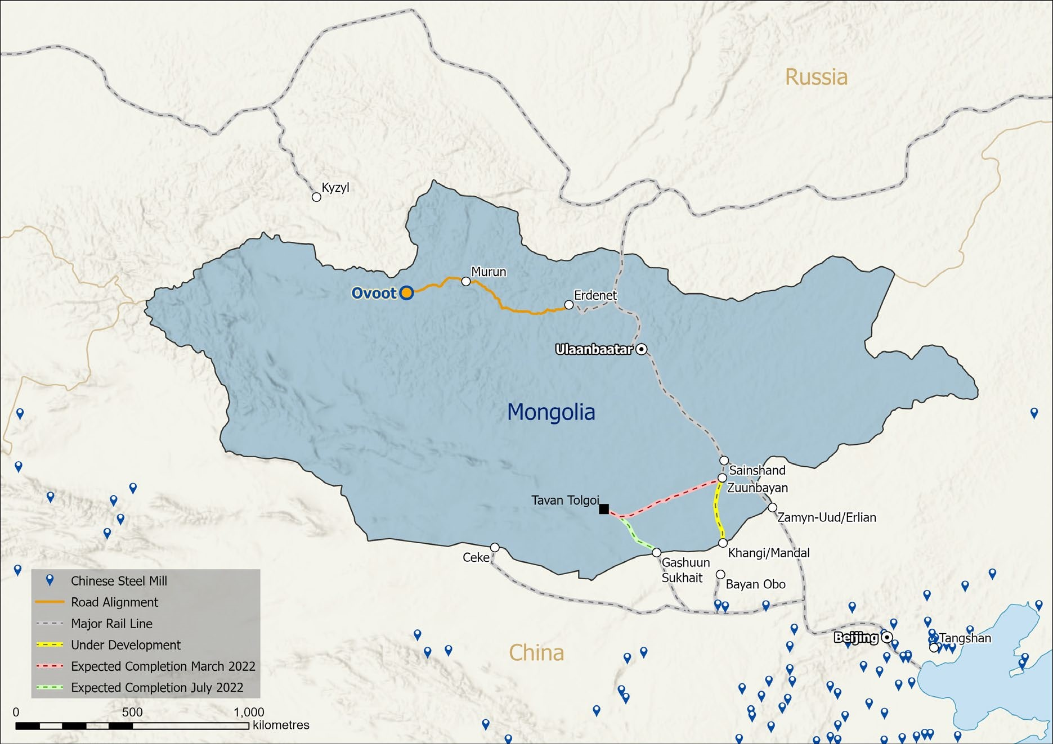
(source: private sector coking coal mining company)

8. Coal is the dominant commodity in terms of transport volumes exported by Mongolia among five major commodities. The economic fallout in 2020 from the pandemic drastically reduced the exports of four mining commodities except for gold from 2019 to 2021 as shown in Table 1. Coal exports dropped by over one half in 2021 to 16.1 million tons compared to 36.6 million tons in 2019. Iron and copper exports experienced similar export reductions in 2021 from pre-pandemic 2019 exports. Crude oil experienced a drop in exports from 65.5 million barrels in 2019 to only 4.3 million barrels caused by China closing borders. Crude oil exports are by both rail and road transport in special purpose tanks. Lastly, gold is the only main export commodity to increase in both total volume and value between 2019 and 2021 from 9.1 tons in 2019 to 17.2 tons in 2021 for US$418.4 million and US$1.0 billion, respectively. Gold exports are shipped to Switzerland and South Korea in addition to China.

Table 1. Five Main Mining Commodities, 2019 and 2021 Exports
Commodity | Volume | Value | Mode | Customers
Coal  2021  2019 | (thermal and coking)  16.1 million tons  36.6 million tons | US$ 2.8 billion  US$ 3.1 billion | Road-85% and Rail-15% to PRC-Rail | PRC
Iron ore  2021  2019 | 7.1 million tons  8.4 million tons | US$ 952.2 million  US$ 576.4 million | Road | PRC
Copper  2021  2019 | 1.3 million tons  1.4 million tons | US$ 2.9 billion  US$ 1.8 billion | Road | PRC
Gold  2021  2019 | 17.2 tons  9.1 tons | US$ 1.0 billion  US$ 418.4 million | Road | Switzerland South Korea
Crude oil  2021  2019 | 4.3 million barrels  65.5 million barrels | US$ 273.4  US$ 366.7 | Road and Rail | PRC
(source: Mongolia, National Statistics Office,2019,2021)

9. Demand for mining exports is forecast to increase. Many sources both public and private predict an increase in mining exports to the end of the decade in tens of millions of tons and in billions of dollars of coal and copper. These forecasts could be offset by predicted slowing economic growth from China. Here are some of the forecasts in details:

- Tavan Tolgoi - Zuunbayan’s 416.1 km railway, which has the capacity for transporting an incremental 15 million tons of freight is expected to be completed by October 2022.

- Tavan Tolgoi - Gashuunsukhait will provide 30 million tons

- Zuunbayan-Khangi line would be 226 km and would reach Port of Mandal in China. That line has already broken ground in March with an aim to export 20 million tons

- The railroads are intended to solve these logistical challenges, increasing exports to between US$14 billion to US$17 billion in 2025-2028, and US$20 billion by 2029.

- Assuming a coal price of US$200 per ton, this translates to an incremental 65 million tons of exports and US$13bn of exports for coking coal alone in a country whose total goods exports in 2020 were just US$8.47 billion.

- The prolonged pandemic and China’s restrictive covid-19 policies are a major challenge for Mongolia to increase its exports. In the beginning of 2022, only five trade ports were operational. According to the Ministry of Mining and Heavy Industry, between April 15-21, Mongolia exported 300 containers of coal, adding up to the total of 3,342.000 tons of coal export to China.

10. In addition, there are assumptions from mining projects envisioned by the World Bank’s, InfraSAP and the Government of Mongolia’s, “New Recovery Policy” reports that will increase demand on road and rail infrastructures, the main corridor, dry ports and attendant logistics services for mining exports. Some of these are as follows:

World Bank, InfraSAP

Value addition exports such as steel products assume Darkhan and Sainshand factories have adequate resources to produce exportable products. The 226-kilometer section of railway track between Sainshand and the Zamiin-Uud/Erlian border with China would experience the highest increase in traffic density mineral products such as direct reduction iron (DRI), refined copper, and coking coal flow to that border crossing. An additional 1–2 million tons per year of capacity need to be created on the railway line in order to facilitate DRI exports if the Darkhan expansion goes ahead and an additional DRI plant is constructed in Sainshand on the railway line. Sainshand is located closer to high-quality coking coal than Darkhan. The production of 2 million tons of DRI has an annual potential export value of $800 million. The DRI could be used to feed arc furnaces to produce steel in Mongolia.

Government of Mongolia, “New Recovery Policy”

The “Industrial Recovery” section assume certain results from the following “value adding heavy industry” projects that will increase exports:

- A project to increase the efficiency of the Erdenet Mining Corporation’s production, construct a mining-metallurgical and chemical value-added production complex (producing copper concentrate processing plant, cathode copper production from oxidized ore). This project assumes: The industrial park's plants will produce 135,000 tons of pure cathode copper per year, increasing export earnings and creating 1,050 new jobs. A cluster of small and medium-sized enterprises for the production of various copper products will be established.

- A project to establish a copper concentrate processing plant based on the Oyu Tolgoi deposit and increase the production of value-added products such as cathode copper, gold and silver. This project assumes: Facilities will be put into operation, producing an average of 257,000 tons of pure cathode copper, 5.7 tons of gold and 57 tons of silver per year resulting in increase of export earnings.

- This project assumes there will be adequate resources (iron ore, power, water, transport) to develop the metallurgical industry together with auxiliary plants to meet the domestic demand for steel products. This project assumes these results: The project of “Mongol Steel Complex I” contemplating domestic processing of iron ore and production of value-added end products such as 350 thousand tons of steel products, the Altanshireet Industrial Park project aiming at production of 500 thousand tons of cast iron and 1 million tons of coke, and the Erdenet Metallurgical Plant project for production of 200 thousand tons of steel products will be completed. By the end of 2025, the country will have met 80 percent of its domestic demand for key steel products (such as rebars) and have increased its exports of such products.

I. B. Livestock-Agribusiness Trade Data Analysis-Exports-2019-2021
11. Livestock or agribusiness (non-mining exports) were only 7.6 percent of total exports for US$ 705.3 million in 2021. These exports increased US$175 million over 2020 or 33 percent in 2021. In 2000, these exports totaled 274 million and accounted for 51 percent with 30.2 million livestock. Their much lower share reflects the fact that mineral exports were much lower then, not a decline in non-mineral exports in absolute terms.

12. At present, there are 70 million livestock available throughout Mongolia for domestic and export agribusinesses. Washed and combed cashmere is the main export of the livestock sector in terms of value. The other main exports are wool, meat (horsemeat, lamb, goat, frozen, canned, beef), and leather as shown in the following tables.

Table 2. Cashmere Agribusiness, 2019-2021 Export (thousand tons)
Commodity | Volume | Value | Road/Rail | Customers
Cashmere:  Washed  Combed | 2019 5, 688.7  2020 6, 339.8  2021 6, 026.9  2019 507.2  2020 260.0  2021 424.0 (up 63.1%) | 2019 US$ 283, 289.7  2020 US$ 185, 313.1  2021 US$ 253, 646.4  2019 US$ 45, 319.3  2020 US$ 16, 8770.0  2021 US$ 39, 923.0 (up 23%) | Road | 100% to PRC  Italy-73.4%  UK-15%  S. Korea-4.6%  India-0.4%  Others-6.3%
(source: Foreign Trade 2021, NSO, Mongolia, p. 19)

Table 3. Wool Agribusiness, 2019-2021 Export (thousand tons)
Commodity | Volume | Value | Road/Rail | Customers
Wool | 2019 14 757.7  2020 8 510.4  2021 5 331.6 | 2019 US$ 20 352.4  2020 US$ 8 983.2  2021 US$ 5 369.9 | Road | Almost all to PRC, some to India, others
(source: Foreign Trade, 2021, NSO, Table 7, p. 19)

Table 4. Meat Agribusiness, 2019-2021 Export (thousand tons)
Commodity | Volume | Value | Road/Rail | Customers
Meat Totals | 2019 37.9  2021 8.6 | US$ 83.7 million  US$ 18.7 million | Road | PRC, Korea, Russia, Japan  Vietnam
Horsemeat | 2019 30, 834.9  2020 17 ,567.8  2021 6. 950.0 | 2019 US$ 57, 688.6  2020 US$ 33, 047.5  2021 US$ 14, 443.5 | Road | PRC, Kazakhstan, Russia, Japan, Vietnam
Lamb and Goat Meat | 2019 7, 041.9  2020 1, 802.2  2021 1, 692.1 | 2019 US$ 24, 164.6  2020 US$ 4, 828.3  2021 US$ 4, 334.8 | Road | PRC, Vietnam, Iran, N. Korea, Other
Frozen Meat* | 2017 600.0  2018 1 054.6 2019/2020 none* | 2017 US$ 1, 643.3  2018 US$ 3, 175.8  2019,2020 none* | Road | Russia, Uzbekistan, Vietnam, Kazakhstan, North Korea
Canned Meat | 2019 18, 501.1  2020 21, 181.4  2021 13, 477.5 | 2019 US$ 50, 311.9  2020 US$ 60, 242.4  2021 US$ 38, 427.9 | Road | PRC
(source: Foreign Trade 2021, NSO, Mongolia, p.18)

Table 5. Fresh and Frozen Beef Exports, 2006-2021
Product Name/Code | 2006 | 2007 | 2008 | 2009 | 2011 | 2018 | 2019-2021
Fresh Beef  HS 0201  Kilograms  US$ thousands | 194,628.0  309.1 | No exports | No exports | No exports | No exports | 59,500.0  130.4 | Export ban
Frozen Beef  HS 0202  Kilograms  USD$ thousands | 2,689,776.0  4,425.0 | 3,879,344.0  6,263.3 | 4,210.403.0  8,497.8 | 8,818,488.0  17,789.1 | 5,795,889.0  13,926.1 | 1,054,582.5  3,175.8 | Export ban

13. Beef exports are uneven from 2006 to 2021 for both fresh and frozen. Fresh beef exports had zero and insignificant exports after 2006 until 2018 with 59,500.0 kilograms. Frozen beef exports increased steadily in amounts of annual shipments from 2006 to 2009 from 2,689,776.0 kilograms to a peak of 8,818,488.0 kilograms, then decreased. Exports of all beef were banned from 2019-2021. Improved transport and logistics infrastructure and services especially refrigerated logistics to modern standards are among many improvements in the meat industry that could result in annual increases of meat exports.

14. The meat export sector has much potential and has been studied extensively in recent years. Beef cattle and horsemeat have positive export demand forecasts as many countries increase to middle incomes and demand for more protein and specialized products grows. Halal is a specialized market found globally as is organic meat both of which will require specialized branding and logistics value added services. Graph 1 shows the gradual upward slope from 2013 to 2024 in the number of heads of cattle available and beef production in thousand of tons in Mongolia. Table 6 presents forecasts for meat consumption in the five main export markets to 2028.

Graph 1. Potential Beef Export to Global Markets

Table 6. Meat Consumption Forecast in Key Export Markets (kg per capita)

Country | 2018 | 2019 | 2020 | 2021 | 2022 | 2023 | 2024 | 2025 | 2026 | 2027 | 2028
China  Japan | 48.9  40.7 | 48.4  40.7 | 49.8  41 | 50.2  41.2 | 50.5  41.4 | 50.9  41.6 | 51.2  41.8 | 51.6  42 | 52  42.3 | 52.4  42.5 | 52.9  42.8
Korea | 59.3 | 60.4 | 60.9 | 61.2 | 61.5 | 61.9 | 62.3 | 62.6 | 63 | 63.4 | 63.8
Russia | 62.8 | 63.6 | 64.3 | 64.7 | 65 | 65.3 | 65.6 | 65.9 | 66.2 | 66.6 | 66.9
Vietnam | 52.5 | 53.1 | 53.9 | 54.5 | 55.2 | 56 | 56.7 | 57.4 | 58.2 | 59 | 59.8
Total | 264 | 266 | 270 | 272 | 274 | 276 | 278 | 280 | 282 | 284 | 286

15. Leather products are mainly exported as raw materials and semi-finished products not finished goods. Leather exports are hindered by lack of international standards for processing, local storage, grading and transport. Input chemicals also pose a challenge and are imported from Germany, Holland and Italy. Tables 7 shows the leather exports. The main export markets for these intermediate products are: Italy, Turkey, Czech Republic, Ethiopia, Thailand, Netherland, Korea, Spain, USA and China.

Table 7. Mongolian Leather Exports by HS Code (2019-2021)
Product name/HS Code | 2019 | 2020 | 2021
Cow & horse leather  4104  (square decimeter) dm2  US$ thousands | 68,618,118.6  6,376.2 | 23,423,758.2  2,274.3 | 7,583,124.5  846.4
Sheep & lamb skin leather  4105  (square decimeter) dm2  US$ thousands | 54,021,120.0  1,185.9 | 49,208,360.0  1,007.7 | 66,274,825.0  1,328.2
Goat or kid skin leather  4106  (square decimeter) dm2  US$ thousands | 120,891,870.0  4,031.2 | 85,185,905.0  3,120.4 | 76,991,501.0  2,435.4

16. Mongolian leather exports had a mixed record from 2019 to 2021. For cow and horse leather there was a decline from 68,618,116.6 to 7,583,124.5 square decimeters (dm2) with a peak year in 2017 of 102,025,382.0 dm2 in the analysis from 2006 to 2021. Sheep and lamb skin leather exports dropped after 2015 of 147,747,225.0 dm2 with a peak of 331,512,365.0 dm2 in 2011 from the 2006-2021 analysis. Goat and kid skin leather showed a decrease from 120,891,870.0 dm2 in 2019 to 76,991,501.0 dm2 in 2021 with a peak year in 2018 of 145,527,385.0 dm2 from the 2006-2021 analysis. There are many factors contributing to the uneven and inconsistent export totals which include animal disease, weather, quality control and insects. Some of these are hard to control, but could be mitigated with investments in connectivity of roads, information systems and local storage facilities for consolidating to full truck and container loads.

17. The highlight in the livestock exports in volumes and values is that from 2019 to 2021 there was a lower export demand due to the pandemic which caused China to institute stricter border control policies across all categories except cashmere. Of note are the meats and frozen meat category which stopped due to the pandemic, but from November 15, 2022, China accredited Mongolia factories can transport by road via Zamiin Uud in refrigerated trucks. The meat category is a major focus of the next chapter for the need to increase overall storage facilities for all products in the agriculture/herder economy and in particular end to end cold chain and refrigerated logistics.

18. The diversification of exports from mining to more agribusiness markets, globally, will become important since China’s economy is expected to slow in the future. China’s annual growth rate is expected to average 4.4 percent through the decade and dropping to 3.1 percent in the 2030 decade. The Mongolian agriculture economy is forecast to improve due to several inclusive projects as defined by the Ministry of Food, Agriculture and Light Industry, Policy and Planning Department. These projects will depend, among other factors, on reliable on time deliveries (OTD) from transport and logistics infrastructure and services. These projects are listed below and in Map 3.

1, Enhanced Meat and Dairy Cattle Farming Project: Meat exports increase by 350 tons per year from 4,000 beef cattle. 5,000 dairy cattle available for production and export potential. (Belarus funding, 2020-2027)

2. Kulemji Complex Agriculture Project: Vegetable increases by 9500 tons per year in greenhouses on 20 hectares for all year crops. (USA and Korea funds, 2021-2024)

3. Irrigated Crop Development Project: Increase vegetable production per year by 15,000 tons, 50,000 to 60,000 tons of fodder and 80,000 tons of grains. (ADB, 2020-24)

4. Potatoes and Vegetable Storage Network: Refrigerated warehouses total capacity of 24.5 thousand tons for six provinces. Reduces spoilage by 26 percent (BNPU. 2020-24)

5. New Hovd Industrial Park Project: 19 factories for western aimags. 1 million skins, 3.0 thousand tons of wool, 300 tons of cashmere, 200 cows for 5000 liters/day of milk
(State budget and private sector funds, 2021-2024)

6. Meat Industry and Quarantine Zone: 640,000 small and 101,000 heavy animals increase export volumes 21.0 thousand tons meat and for leather products (2021-24)

7. Darkhan Leather Complex Project: Five factories processing 4.4 million pieces of leather for increased exports. (Erdenet SOE funds, 2020-2024)

Map 3. Forecasted Export Demand for Agribusiness Projects by 2024 and 2027
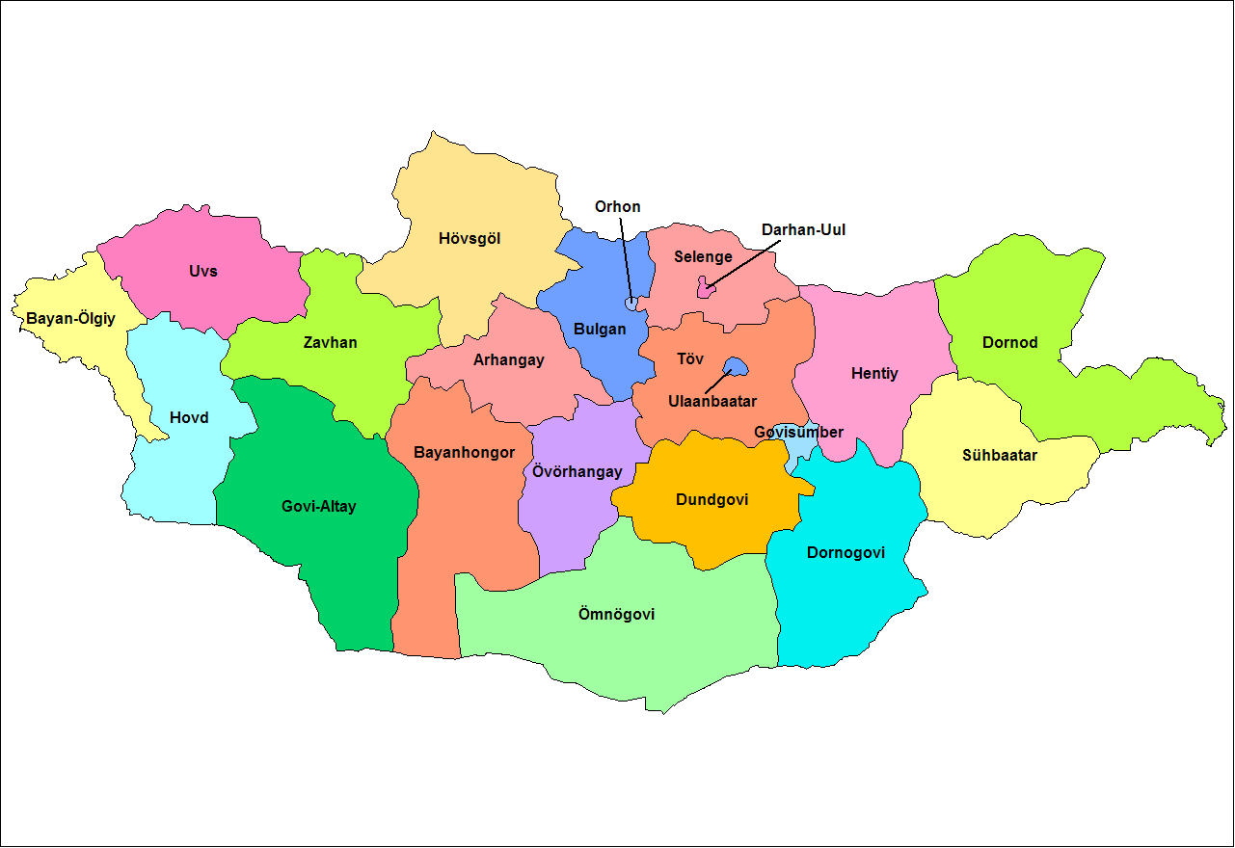
6.) Meat Industry & Quarantine Zone in Arkhangai, Bulgan, Dornod, Hovd
5.) New Hovd Industrial Park Project in Hovd, Jargalant
1.) Enhanced Meat & Dairy Cattle Farming Project in high density areas
2.) Kulemji Complex in UB
7.) Drahan Leather Project in Arkhangai, Darkhan
4.) Vegetable Storage Network in UB, Selenge, Hovd, Khentii, Omnogovi, Govi-Altai
3.) Irrigated Crop Development Project in Selenge, Darkhan, Bayan-Olgii, Hovd, Zavhan, Gobi Altai, Uvs
(source: Internet Map and boxes by Wallack, consultant)

I. C. Import Trade Data Analysis and Transit Trade

19. Mongolian imports can be divided into non-food and food products or consumable goods. In 2021, total imports were US$ 6.8 billion of which non-food such as investment products and industrial inputs were 86 percent of the total and food products or consumables that include perishables were 14 percent of the total, according to Mongolia foreign trade statistics report of 2021. Seventy percent of imports are transported in containers with 90 percent of the containers arriving through Tianjin seaport via the Zamiin Uud corridor.

20. On a transactional basis, the average turnover of containers is 4,000-5,000 per month or 60,000 to 70,000 twenty-foot equivalent units (TEUs) per year. This is a tiny fraction of the annual throughput of 14-15 million TEUs handled in Tianjin, Xingang, PRC seaport per year. In 2021, imports by main partner country as a percentage of output were China accounting for 37 percent, Russia for 29 percent, South Korea 4 percent, Germany 3 percent and the United States for 3 percent. These main countries will account for 83 percent of total imports. In addition, 87 percent of European countries’ imports will go through Russia.

21. The largest increases of total imports over 2020 were diesel, gasoline, trucks and cars. Imports increased US$ 1.5 billion or 29.2 percent over 2020, mainly due to the increase in the import of diesel fuel by US$ 157.7 million, gasoline by US$ 146.4 million, trucks by US$ 116.2 million and passenger cars by US$ 87.9 million. Table 8 provides details. Russia accounted for 86.6 percent of imported petroleum products. Cars and trucks mainly are from Japan and South Korea with 92 percent of passenger cars or 52,014 imported from Japan and 1.6 percent from South Korea; trucks imported from South Korea were 20.6 percent or 10,661 and trucks imported from Japan were 5,463 while trucks imported from China were 7,904 in 2021.

Table 8. Main Imported Non-Food Products, 2020-2021
Product name | 2020  Quantity  (thousand tons) | 2021  Quantity | Percentage Change | 2020  Amount  (millions of USD) | 2021  Amount | Percentage Change
Diesel Fuel | 1 026.9 | 988.9 | -3.7 | 432.4 | 590.1 | 36.5
Gasoline | 586.1 | 572.7 | -2.3 | 244.7 | 391.1 | 59.8
Passenger Car | 53.1 | 55.2 | 4.1 | 297.3 | 385.2 | 29.5
Truck | 21.0 | 26.5 | 26.4 | 269.0 | 385.2 | 43.2

22. Non-food import shipments were US$ 5.9 billion or 86 percent of total imports. These are categorized by the Mongolia Foreign Trade 2021 report as investment products accounting for US$ 2.8 billion which is a 20 percent increase; industrial inputs for US$ 762 million, a 29 percent increase; and petroleum products of US$ 1.1 billion, up 39 percent over 2020. European countries were 38.4 percent of these shipments. Russia was 27.5 percent of these shipments by 100 percent of railway locomotives, 98.5 percent of nitrogen fertilizers, 96.7 percent of wagon trailers and 88.6 percent of petroleum products and 62.2 percent of rebar. Russia shipments of petroleum products accounted for 51.1 percent.

23. Consumables (perishables) were US$ 962.7 million or 14 percent of total imports. Consumer products increased 42 percent to US$ 2.2 billion of which 57.3 percent from Europe and 35.8 percent from Russia. The Foreign Trade 2021 report attributes Russia accounting for 92 percent of imports of products such as wheat, eggs, vegetable oil, margarine and pork. The report distinguishes “countries except Russia” and “other countries” for the following imports:
- Bread and sweet baked goods-51.2 percent
- Cigars and cigarettes-66.8 percent
- Alcoholic beverages-96.3 percent
- Fruits and berries-96.4 percent
- Condensed milk, dry milk, cream-98.2 percent

24. Transit trade increased from 2015 to 2021 between Europe and the PRC. In 2021, a total of 2,513 trains or 283,776 TEUs transported by rail through Mongolia. The corridor from Tianjin to Europe via Erlian and Zamiin Uud is one of three logistics channels of the CR Express, and is known as the ‘Middle Channel’ in China. In 2021, a total of 497 freight trains and 53,132 TEUs of CR Express were shipped at Tianjin Port, up 25.5% and 24.4% year-on-year, respectively. The Middle Channel will save time and cost for goods from Japan and South Korea to Europe via Tianjin Port. From January to December 2021, there were 2,739 inbound and outbound China Europe trains at Erlian Port, up 15.1% year on year. Among them, there were 1,225 inbound and 1,514 outbound China-EU trains. in 2021.
25. The World Bank InfraSAP report indicated that Mongolian transit trade is one potential source of growth in trade. However, there is competition for this business from other trade routes between the PRC-Russia-Europe, but there are benefits to participate in this trade. According to the data of Erlian Port, by the end of 2018, there were 1,052 China-Europe trains running at Erlian Port. Among them, the China-Europe trains that realized two-way operation were Zhengzhou—— Hamburg; Changsha——Moscow; Chongqing—— Malashevich; Ulanchap——Russia Volsino; Xiamen——Russia Volsino; Tianjin—— Russia Hovrino; Chengdu ——Poland Lodz, and the one-way trains run from Suzhou, Wuhan, Zhongwei, Hefei, Weihai, Shanghai and Wuhai. The content of these shipments are as follows exporting from the PRC and importing to the PRC: The export goods mainly include tires, sports goods, handicraft machinery parts, laptops and accessories, mechanical equipment, daily necessities and small household appliances, while the import goods mainly include auto parts, tires, mechanical equipment, steel plates, plates, furniture daily necessities. There are also the Manzhouli-Russia and Xinjiang-Kazakhstan routes. Table 9 indicates transit trade with the highest compounded annual growth rate (CAGR) in 2015-2021 with potential to increase year over year.
26. The benefits of transit trade are possible for Mongolia’s dry port
development. At present, most countries do not levy transit taxes on transit goods but,
they can obtain income such as service fees, storage fees, and transshipment of goods.
Transit trade can promote the development of regional ports, related industries, financial
credit such as in Hong Kong which can apply to cross border with Erlian-Zamiin
Uud. The Ministry of Foreign Affairs and UNESCAP report made useful observations
on the overall shifts in mode of transport that impacted dry ports. The pandemic
caused a shift in modal patterns from pre-pandemic 2019 in which 40.8 percent of cargo
moved by rail and 59.2 percent by road, yet in 2021 rail cargo was by 63.5 percent and
road by 36.5 percent.

Table 9. Mongolia Railway Cargo 2015-2021 (thousand tons)
Indicator | 2015 | 2016 | 2017 | 2018 | 2019 | 2020 | 2021 | CAGR
Transported  Cargo | 19150,8 | 19989,1 | 22765,1 | 25763,3 | 28143,0 | 29840,0 | 31261,3 | 8.1%
Domestic | 9231,2 | 8537,6 | 9484,6 | 10326,8 | 11091,1 | 11023,1 | 12669,9 | 5.39%
Export | 5637,7 | 7095,2 | 7886,8 | 9272,3 | 10218,5 | 11515,6 | 10992,3 | 11.72%
Import | 2188,2 | 1993,9 | 2302,7 | 2798,4 | 2937,8 | 3023,1 | 3358,0 | 7.36%
Transit | 2093,6 | 2362,29 | 3091 | 3365,7 | 3895,6 | 4278,1 | 4241,0 | 12.4%

27. The new Bogdkhan Railway Bypass project will increase rail freight turnover by 5 to 6 million tons per year. After completing this 144.6 kilometer project in the near future, the railway transit, import and export cargo will go around the front of Bogdkhan mountain without going through Ulaanbaatar city. This project branches off the Maanit station of the Ulaanbaatar Railway JVC line and connects to the Rashaant station by bypassing the mountain. The feasibility report completed in 2021 and has the government support as of January 2022. This project has benefits to both cargo and passenger traffic and should improve cargo transit times and on time deliveries along the corridor. “The analysis starts with construction in 2023-26, project opening in January 2027 and operations tallied as far as 2050”.

II. Logistics Mapping for Mining and Livestock-Agribusiness

28. Central to the logistics mapping for mining and livestock exports as well as imports demand is the upstream need to provide the road and rail infrastructures and strategically located storage facilities throughout Mongolia to perform modern logistics warehouse functions of consolidation services. Without storage facilities located in key regions of Mongolia it is difficult to lower transport and logistics costs as a percentage of GDP which are currently very high at 30 percent. At present, Mongolia exports 90 percent of mining and livestock shipments to its two neighboring countries, China and Russia. Lowering the upstream logistics costs and adding value to both products and logistics services could capture more exports markets through more competitive pricing and higher quality products in the global marketplace. This chapter will identify those opportunities in the logistics chains based on the demand assessment chapter.

29. The main mining sites for coal, copper and gold use the South Gobi’s Gashin Sukhait dry port for exporting in bulk by road, then to rail connecting to the PRC markets. Iron ore and crude oil sites are aligned with the main north-south corridor to access the rail network for export markets. Road is still the dominant mode from the mouth of the mines to the rail networks for both public and private enterprises. The completed local rail lines and the processing plants in the South Gobi, Darkhan and Sainshand could realize more revenues to neighboring and longer distance markets. However, these new processing plants for adding value to mining assets also depend on reliable sources of energy and water which could take longer to construct and impact demand for exports. Despite accounting for 80 percent of export revenues and a quarter of GDP, however, mining contributes only 20 percent on average to domestic government revenues.” Transport and logistics costs remain high in moving mining materials long distances in such a vast country until more road and rail connections are made. The average transport distance for freight movement in Mongolia is 602 kilometers. The total annual transport cost is estimated at US$ 2 billion and the logistics costs is estimated at US$ 3 billion to support the 30 percent logistics costs as a percentage of GDP. Table 10 shows comparisons to other countries logistics costs as a percentage of GDP.

Table 10. Country Logistics Costs as Percentage of GDP
Country | Logistics (GDP%)
China | 14.4%
Russia | 16.1
Hong Kong | 8.5
Lao | 17.7
Indonesia | 22
Vietnam | 20
Asia-Pacific, Others | 17.3
Uzbekistan* (World Bank, p. 77) | 17
USA | 8
(source: “Global 3PL Market Size Estimates,” Armstrong & Associates, USA, 2020)

30. The livestock and agribusiness sector are characterized by inefficient logistics and unreliable transport infrastructure. There is an opportunity to realize short to medium term benefits to this sector while diversifying the economy away from dependence on the mining sector. This will be accomplished by eight strategically located consolidation centers or freight villages throughout Mongolia and one main freight village near Ulaanbaatar. This plan could have benefits for not only the meat sector, but also the cashmere, wool, and leather which also have problems with fragmented local logistics facilities and services as well as livestock health needs.

31. There are many challenges to increasing value in livestock from current low value export of raw materials and semi-finished goods to higher value finished goods. Logistics costs are one cost that could be lowered to make exports more competitive on the global marketplace. These costs include inefficient use of less than truck load instead of full truck load deliveries and lack of both dry and refrigerated warehouses from the pastureland to the export nodes. “Efficiency can be optimized if the government takes a bottom-up approach to consider the supply and demand of commodities and the flow and the cost of transport”. This bottom-up approach is including all regions in the sourcing and value additions for livestock and supporting logistics functions. Figure 1 shows the challenges from pastureland to exporting.

Figure 1. Livestock By-Products Flow Chart
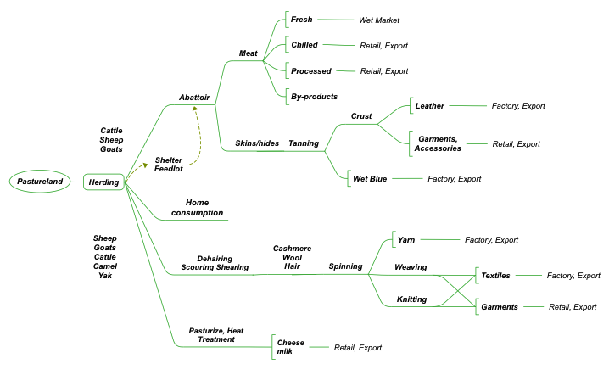

32. The meat sector has much potential for export growth estimated at US$ 800 million per year. The mapping of the locations of the slaughterhouses and processing plants in Table 10 is useful in the support of the site selection of the 8 hubs for consolidation and other livestock services. These 8 sites could be expanded for cashmere, wool and leather. At present, the World Bank identified the following potential hubs: Uvs, Khovsgol, Bulgan, Arkhangai, Ovorkhangai Tuv, Khentii, and Sukhbaatar. Now, all slaughtered meat is taken to Ulaanbaatar and most of the value is lost before reaching the market. Bagakhangai, near Ulaanbaatar, is the main hub to export. There are

Map 4. Locations of Proposed Agro-Processing Freight Villages

Table 10. Meat Processing Plants
Name | Location | Capacity per shift (tons) |  |  | Refrigerator capacity (tons) |  | Exports  meat | Current  Utilization
 |  | Total | Large | Small | Freeze | Store
Makh ImpexJSC | UB city | 2240 | 240 | 2000 | 120 | 10000 | + | 50%
Baganuur Makh Market | Baganuur district (UB) | 1450 | 250 | 1200 | 30 | 900 | - | 10%
Zavkhan Huns Group | Zavkhan | 1450 | 250 | 1200 | 30 | 500 | + | 10%
Mongema | Orkhon | 1450 | 250 | 1200 | 30 | 500 | + | 15%
Erdenet Makh Market | Orkhon | 1450 | 250 | 1200 | 30 | 500 | + | 15%
Makh Market | UB city | 1200 | - | 1200 | 50 | 6000 | + | 50%
Montuva | Uvs | 620 | 120 | 500 | 15 | 500 | + | 20%
Erdmet | Orkhon | 550 | 150 | 400 | 30 | 500 | + | 30%
Bagakhangi MPP | Bagakhangai | 510 | 210 | 300 | 12 | 300 | - | 0%
Bumnomin | Uvs | 450 | 100 | 350 | 10 | 300 | + | 10%
EDGS | Zavkhan | 370 | 70 | 300 | 10 | 100 | + | 10%
Et transit | Bayan-Ulgii | 370 | 70 | 300 | 10 | 300 | + | 10%
Mista | Nalaikh | 350 | 50 | 300 | 5 | 200 | - | 0%
Mongol Makh Expo | UB city | 330 | 80 | 250 | 30 | 260 | + | 10%
Uvs Makh Market | Uvs | 330 | 80 | 250 | 30 | 260 | + | 10%
Mongol Eco Makh | UB city | 300 | 50 | 250 | 15 | 200 | + | 10%
Tes shim khorshoo | Zavkhan | 300 | 50 | 250 | 10 | 200 | + | 10%
Sayan-Uul | UB city | 250 | 50 | 200 | 15 | 200 | + | 10%
EMF | UB city | 150 | 50 | 100 | 10 | 300 | + | 10%
Zavkhan Makh Market | Zavkhan | 100 | 100 | - | 30 | 380 | - | 10%
Zerger | Bayan-Ulgii | 50 | 50 | - | 7 | 300 | + | 5%
Total |  | 14,270 | 2,520 | 11,750 | 529 | 22700 |  | 21%

a total of 67 slaughterhouses throughout Mongolia and summarized as follows:

Ulaanbaatar-21 Darkhan-2 Orkhon-4 Tuv-4 Arhangai-1
Bayan-Ulgii-5 Bayan Khongor-1 Dornogovi-1 Gobi-Altai-2 Zavkhan-4 Khenti-4 Khuvsgul-4 Khovd-3 Selenge-2 Sukhbaatar-2 Uvs-3 Bulgan-1 Uvurkhangai-3

Total refrigerated warehousing in tons is 57, 550 and deep freeze capacity in tons is 2,245. An Excel document in detail is available from the Mongolian Meat Association.

33. Existing meat processing facilities have alignment with the proposed eight freight villages. Map 5 shows the red dots and the number of current meat processors by aimags. For example, the Uvs aimag has one meat processing facility and nearby in the blue dot indicating three slaughtering facilities which is also the site of the proposed freight village in Uvs. Meat processing facilities are important for the increased market export demand for the heat-treatment method which is a requirement for China. Other processing methods are for Halal to Muslim export markets and frozen meat for Russia and Kazakhstan export markets. These facilities and freight villages will also need reliable road and rail infrastructures, supporting power sources for refrigerated container shipments as well as information systems to monitor temperatures of the shipments from source to export customers. This map from the UNCTAD report estimates US$ 300 million in revenue for Mongolia per year by exporting meat products.

Map 5. Logistics Mapping for Meat Industry
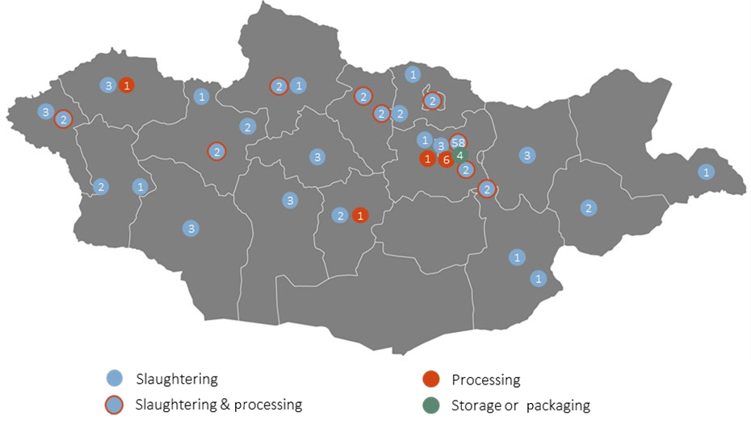
(source: “Survey on the Domestic and Export Meat Value Chain in Mongolia,” Gantulga, A, UNCTAD, 2021, Figure 11, p. 18)

34. Local roads are needed to withstand the truck weights to and from the proposed eight hubs throughout Mongolia. These critical logistics consolidation centers (warehouses) will also serve the very important need of refrigerated facilities for an unbroken cold chain logistics. Equally as important is the full construction and operations to international standards of the main freight village, Bagakhangai, near the main road and transport corridors for exporting. These eight hubs can be served by mobile abattoirs as well as storage for feedlots, veterinary health needs and other regulated services to international standards. The hubs will also assist in forming cooperatives and implementing the Mongolia Law on Cooperatives.

35. This recommendation addresses the most important in Mongolia to diversify the economy at the macroeconomic level away from mining and at the microeconomic enterprise level to provide value additions across all stakeholders in the livestock value chain. Construction of these 8 facilities targets potential incomes and markets that are now lacking cold storage for perishables. Losses can amount to one third per year. These livestock logistics hubs also work to reduce the Mongolia logistics cost as a percentage of GDP from 30%. The forming of logistics consolidation centers works towards economies of scale in traditional and niche markets for organic food demand. Value additions from these hubs are: cooperatives, packaging, labeling, quality control from private and public entities. Exports of nuts and sea buckthorn would also benefit, especially for e-commerce exports.

36. The second InfraSAP recommendation is the need to connect rural herders, middlemen/trade representatives and logistics service providers to mobile internet and mobile device applications for market information and on time deliveries in real time. “The backbone digital connectivity is in place, but there are gaps and needs to improve, especially expanding 4G connectivity in rural areas”. This is both a hard infrastructure and soft infrastructure recommendation and will be essential in a digital economy where e-commerce opportunities can be in the hands of the household herders and farmers. These recommendations are possible from international development bank support as accomplished already in rural agriculture remote PRC provinces.

37. The potential Mongolia meat export demand from PRC markets is estimated earnings of hundreds of millions of dollars per year and up to US$1 billion. Also, there are global markets for heat treated (PRC), frozen (Russia) and Halal Muslim (global) requirements. In addition, the dairy sector would grow and benefit from these eight hubs and one main freight village as well as the leather, wool and cashmere sectors of the livestock agribusiness value chains.

III. Logistics Chains and Level of Services to Satisfy Demand

38. Apart from controlling logistics costs by commodity producers using consolidation hubs in locations throughout Mongolia, there are costs and lack of logistics services on the Mongolia Central Economic Corridor for road, rail and transit. This corridor extends north from the Russia border at Naushki for all markets en route to Europe. This corridor also extends south to Ulaanbaatar container terminals to Zamiin-Uud dry port to Tianjin, Xingang seaport to overseas markets.

Map 6. Mongolia Central Economic Corridor
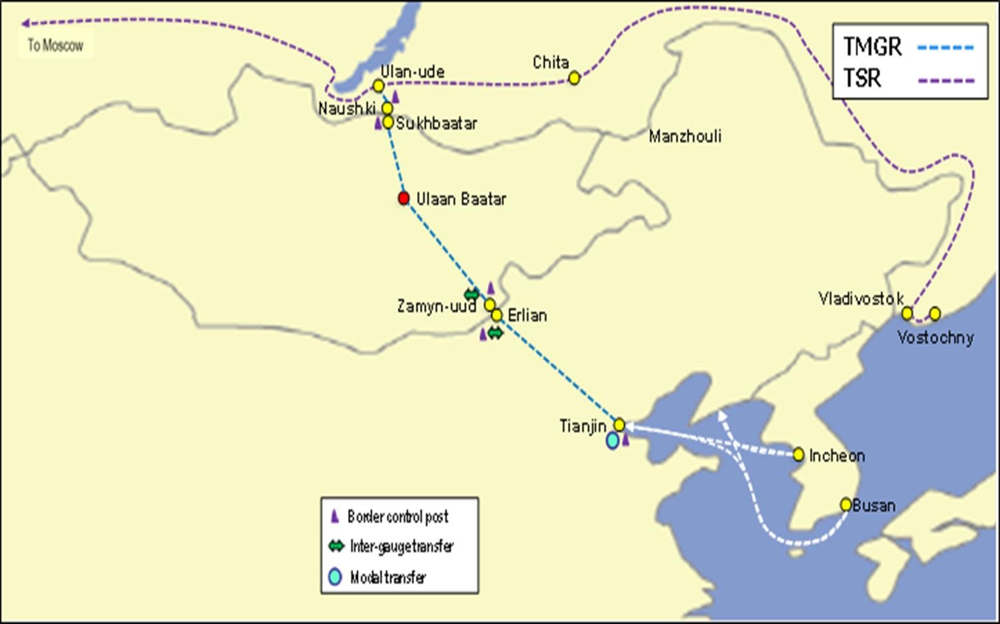

(source: MRTD presentation document, 2022)
39. Digital infrastructure is unreliable along the entire corridor and overall underutilized throughout Mongolia, especially on key corridor nodes. The digital economy deficit is a main issue in the InfraSAP, World Bank report. In the near and long term, Mongolian producers adding value to commodities will find the need to meet stricter customer requirements involving more logistics services. One essential customer requirement is for on-time deliveries (OTD), a key performance indicator (KPI) in advanced economies, which need digital infrastructures and software applications to monitor end to end shipments. The shipments can extend from pastureland through the processing facilities and then through logistics facilities to the end customers with a signature of receipt upon delivery. This chapter will highlight the current level of logistics services in Mongolia and those services required in the global marketplace based on international standards.

40. The Federation of Mongolia Freight Forwarders (FMFF) described in detail the difficulties in managing costs and delays. These include costly delays from the PRC’s state-owned container and railway companies by excessive container rental fees (detention and demurrage) from Xingang seaport to Zamiin Uud and Ulaanbaatar. There are also the Russia-UBTZ container train fare problems. The FMFF estimates that 21 percent of the price of consumer goods on retail shelves is from transportation and logistics costs. In addition, there are higher cargo storage costs, increased transportation time, traffic congestion and delays in Xingang of 20-30 days for containers to be released to Mongolia. The pandemic contributed to many costs and delays, but for many years Mongolia experiences 30 percent of GDP attributed to transportation and logistics costs which is higher by comparison to Uzbekistan of 17 percent and the United States of 8-9 percent.

41. The FMFF cites anti-corruption activity in container rental and brokerage fees by the PRC and Russia for road and rail shipments as a matter of Mongolia’s national security and domestic markets. Information technology solutions used to provide advanced shipment notices (ASN, 856 electronic data exchange, EDI transaction set) scheduling and locations of containers and rail wagons are not functioning, smoothly. Real-time data is not occurring with neighboring countries of Russia and the PRC through the corridor and at key nodes. “To organize the transportation of loaded and empty rail wagons by Ulaanbaatar railway and to process and exchange transportation and other documents electronically by many train exchanges is not constant and difficult to recover the investment long term.” There is not shared software along the corridor with neighboring countries of the PRC and Russia. However, information on containers through Mongolia is used by UBTZ’s Transportation Management System (TMS).

42. Railway traffic through the north-south corridor is increasing due to the tariff concession by the Mongolia-Russia-China railway agreement. There are seven trains per day of which 4 are transit. This increased transit traffic coupled with lack of capacity in Zamiin Uud border crossing port causes increases in prices of all goods. Import traffic is of agriculture, mining, renewable energy and construction materials for large scale projects are also losing time and money because of congestion and China restrictions.

43. The PRC side determines the container exchange and provides information to Mongolia. In fact, there are 300 containers exchanged per day. Although the empty containers are not taken back by the Chinese causing terminal congestion and costly late fees at all nodes along the corridor. It is unclear how to communicate with border port authorities in neighboring countries and the infrastructures are uneven. There is poor coordination among border agencies and with the private sector businesses.

44. FMFF suggests the Mongolian, “National Transport Corporation, Ltd”, a private sector entity, to invest in rail wagons and scheduling systems in cooperation with the forwarding companies. They also identified the “Ulaanbaatar Freight Transportation Integrated Logistics Center”, at the Bayan station, 34 kilometers southeast from the city center, as the designated dry port to resolve corridor congestion. Zamiin Uud and Tianjin problems will also need to become stronger links in the corridor chain.

45. These proposals by the FMFF are longer term and short- term information technology solutions could resolve some of these issues. FMFF cites the “technical aspects of the terminals,” slow customs procedures and document requirements transiting ports of the Russian Federation causing unexpected costs. Also, the need to resolve customs clearance and border inspection of cargo coming through Altanbulag and Zamiin-Uud ports with seals regardless of whether they have international CMR or Transport Internationaux Routiers (TIR) documents. There is a lot of idling of vehicles in Altanbulag port because of lack of road space for inspections. In addition, the Altanbulag and Zamiin-Uud customs clearance by road has a lack of payments of customs duties and value added tax (VAT) on imported goods because of traffic congestion.

46. A prominent Mongolia freight forwarder (Mongolian Express, Ltd) handles imports and exports of PRC and third countries in cooperation with PRC COSCO. In particular,they manage shipments of mining, agriculture, industrial machinery and equipment at border crossing points of Zamiin Uud, Altanbulag, Sukhbaatar and Gashin Sukhait. This company described the difficulties in coordinating the use of shipping containers with PRC COSCO for the returning of empty containers and congestion at the dry ports. These difficulties contribute to delays to meet customers’ on time deliveries which increase the logistics costs.

47. One Mongolian freight forwarding company found it It is difficult to obtain permission from the China Railway to export mining products. For example, prior permission must be obtained for the transportation of copper concentrate, fluorspar and other mineral product commodities. Here is a sampling of the mining logistics services, ports and modes:

- Coal transportation: Container transportation terminals have been established in Gashuun Sukhait and Shivee Khuren ports. The decision to buy coal in containers is made by the Chinese side. In the future, there will be a tendency to receive bulk cargo in containers. Therefore, in the future, the demand for open top containers will tend to increase. A project for AGV driverless and automated transportation from the container terminal of Gashuunsuhait and Shiveehuren ports to the Chinese border port is being implemented.

- Iron ore: Mongolia transports 5-7 million tons of iron ore annually from Selenge, Khentii, Erdenet, and Central provinces through Zamin Uud port. Iron ore is transferred to Erlian and supplied to the Bugat metallurgical plant in Inner Mongolia, PRC. Iron ore is transported by rail in semi-carriages.

- Copper: Erdenet's copper is transported in large packages by rail through Zamiin Uud port. Oyu Tolgoi copper is being transported by road to Gashuunsuhait port in big packages.

- Zinc: Zinc is transported from Sukhbaatar province in big packages by road transport, transferred to the railroad in Dornogovi province, and exported through Zamin Uud port.

- Flourspar: Fluorspar is mined in Khentii and Dornogovi provinces and transported by railway in bulk and exported in bulk through Zamin Uud port.

48. One Mongolian freight forwarder described the lack of cold chain logistics for meat exports. The use of refrigerated containers is limited. The refrigerated containers are from Tianjin and Erlian and are owned by the Chinese companies. They are dropped off at the road gate at the border and quickly returned to China since daily user fees are so high. In essence, there is no end-to-end export cold chain. There is no dedicated refrigerated facilities at the border crossings. The requisitioning of refrigerated containers can cause delays for shipments and costs can increase per day once in use by slow processing of shipments. Similarly, there are no warehouses for wool or other livestock raw materials in rural areas. In addition, agriculture cooperatives are not functioning as envisioned under the Law on Cooperatives. These cooperatives could be useful by livestock supply chain stakeholders agreeing to consolidate shipments to lower logistics costs.

49. Furthermore, the Mongolian freight forwarder describes the operational, cooperation and coordination issues for meat exports between Mongolia and China that could improve with paperless documents and better information systems. The problem of meat production and meat export is related to the Chinese ban and the agreement between Mongolia and China. Mongolian meat export factories are inspected and licensed by the Chinese Quarantine Department. The factory that passes the inspection gets a license to export meat, and it is transported by truck in a refrigerated container to the port of Zamin Uud according to the requirements of the Chinese side. The freight forwarding company prepares export border documents in cooperation with the Chinese side. However, the lack of a system of mutual approval of laboratories at critical points in the meat export chain means that every container needs to be checked
on the Chinese side. The alternative ease of using rail does not exist since the PRC and Mongolian railways do not have systems to transport refrigerated containers.

50. The freight forwarding sector suggests that in order to increase meat exports and make it a continuous flow, attention should be paid to the following issues:

1. Include nomadic animal husbandry more in the agriculture sector
2. Better coordination among slaughterhouse processing, packaging and transportation
3. Optimum placement of slaughterhouses
4. Establish a logistics cold chain
5. Establishment of control laboratory network
6. Increase the number of meat export ports
7. Creation of an information system for animal husbandry, meat production and export
8. Training in trade and transport facilitation for meat export
9. Development of export production through market attraction system

51. China does not issue permits for Transports Internationaux Routiers (TIR) cargo. Beijing checks supporting documents and permits for meat and the Mongolia truck unloads the meat at the Erlian refrigerated warehouse, then the Chinese consignee completes the import customs clearance releasing the meat to the final destination. Because China has a Customs system that completes Customs clearance at the first border station or port of entry, cargo cannot be transported to the final destination by “Customs-trusted” transportation (i.e. TIR).

52. There are 18 Mongolian transport companies that own 160 refrigerated trucks with a TIR certificate, which proves that the product exported conforms with relevant standards and regulations of the TIR Convention. According to the National Road Transport Association of Mongolia, the following companies have TIR certificates: 1. Nord Trans LLC 2. EZU Trans LLC 3. Karport LLC 4. Batkhuld Trade LLC 5. Baka Trans LLC 6. Dulguun Trans 7. Khar Anar LLC 8. Montir Trans LLC 9. Suld Logistics LLC 10. Forever Zuun Trans LLC 11. Oros Gerel LLC 12. World Management Group LLC 13. Montrans Auto LLC 14. Navi Star Trans LLC 15. TTGJ 16. Mongol Hurd LLC 17. Ikh Ayni Joloo LLC 18. Instant Trans LLC.

53. Mongolia has established 16 intergovernmental agreements for transporting goods. The countries with which these agreements have been established are the Russian Federation, China, Kazakhstan, Kyrgyzstan, Ukraine, the Democratic People’s Republic of Korea, Belarus, Latvia, Hungary, Turkey, Lithuania, Poland, Germany, Czechia, Georgia and Slovakia. The agreements permit a truck to enter and exit these countries to move goods. Furthermore, the trilateral Intergovernmental Agreement on International Road Transport and the Asian Highway Network involving Mongolia, China and the Russian Federation took effect in 2019. This agreement enables the countries to connect territories by allowing access to traffic rights for international road transport operations on portions of Asian Highway routes AH3 and AH4. Lack of digital highway designed, tested and operational could be preventing deliveries to these markets.

54. The Mongolian freight forwarder described truck shipments at the border crossings that could use an important information technology solution in cooperation with China. The weight of the vehicle registered in the road vehicle register often deviates from the declared weight. Because the weight on the car's documents varies depending on the fuel and additional equipment installed in the car. Therefore, auto weight needs a lifting crane to lift the loaded container and weigh the car separately. Because of its registration in the Chinese customs system, Mongolian car trailers are registered only at the port of entry. If you enter through a different port, you will be removed from the registered port and have to register anew at the port of entry, making foreign trade more difficult.

55. Investment needs cited by freight forwarders, especially in Zamiin Uud.
- Wheeled and other overhead port cranes
- Heavy-duty wheel lifter (reach stacker, Kalmar cranes
- Forklifts for loading and unloading cargo from containers, cars and wagons
- Refrigerated warehouses
- Port trucks

56. The Tianjin-Dongjiang Mongolia Area is designated as a special area for Mongolia international trade logistics. Mongolia agreement with China at Tianjin seaport set aside 10 hectares of land to develop import and export logistics services with refrigeration facilities in a free trade zone. This should resolve corridor congestion issues with functioning real time data and visibility of containers along the corridor while improving international standards. The status of this project is not clear. Currently it takes an average of more than 90 days for containers to arrive in Mongolia from Tianjin port, which is a heavy blow to Mongolian transport and brokerage companies, which in turn increases the price of imported goods and is inflationary.

Photo 1. Tianjin-Dongjiang Mongolia Area
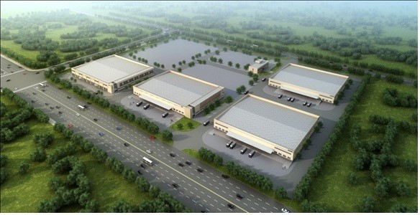
(source: www.mtz.mn, projects)

57. At present, the level of logistics services in Mongolia needs upgrading within the freight forwarding sector, between agencies, among road, rail and transit stakeholders and along the whole north-south corridor. The most effective and impactful upgrade is to the level of information technologies. At Ulaanbaatar, for example, an electronic data interface (EDI) has been put in place for pre-arrival information and pre-approval by Customs and other government agencies. Nonetheless, shippers continue to use hard copies. At Zamyn Uud, EDI is used for communication between border agencies, though its habitual use by exporters was less apparent. Poor connectivity ensures that manual declarations are still relatively common, particularly in border areas. EDI is well established in trade logistics worldwide and still very important to international trade from factories in Asia to freight forwarders to ocean carriers to destination markets to their distribution centers and to retailers and customers. EDI is found in warehouse management system (WMS), TMS, enterprise resource planning (ERP) systems and Single Electronic Window (SEW) applications and now integrated with real-time web services.
58. EDI is basic form of automating processes. The World Bank estimated that automating Customs processes can save US$ 115 per container. Connecting all supply chain stakeholders is needed to compete in the global marketplace. Logistics services needed are from the pastureland to the Tianjin port with reliable communications technologies such as EDI, web services with real-time data from application programmer interfaces (API). These systems use EDI as a basic underlying technology for ordering, fulfillment and settlements which are not fully functioning in Mongolia. The use of blockchain is expensive and recently abandoned by the Maersk and IBM, TradeLens partnership. “Blockchain has complexity of technology, time required to get a blockchain into operation and the difficulties in enlisting participants.”
59. Logistics services from neighboring and global customers will require value added services. Customers of value-added commodities in mining and animal products will place orders with specifications coded into the EDI documents that could be provided by established freight forwarders or third-party logistics (3PL) providers. These include information systems applications such as TMS, WMS and value-added services such as packaging, labeling, barcoding based on international standard practices. These services are apparent in meeting halal and other branded meat products. Ulaanbaatar plans to begin using Radio Frequency Identification (RFID) systems in 2023 for control of vehicles to reduce traffic congestion.
60. Mongolia’s increasing transit and corridor traffic by road and rail and need to improve paperless documentation should make use of the Central Asia Regional Economic Cooperation (CAREC) Advanced Transit System (CATS). Mongolia is designated in CAREC as corridor 4b from Naushki to UB to Tianjin and corridor 4c from UB to Bichigt. The CATS Information System (CATS IS) should provide data exchange (primarily in the agreed format of a single transit document) and message exchange features. This program will be complementary to the TIR system with more flexibility and open to transport operators within the region.
61. Customs authorities of the CAREC countries use a variety of platforms and approaches to the automation of processes. Therefore, it is proposed that CATS IS would provide a unified interface for all participants, supporting the interchange of all data, messages, and notifications within the proposed CATS. It is expected that each of the customs authorities will implement a communication gateway using the unified interface. The ASEAN Customs Transit Systems is a good example. Azerbaijan (AZ) and Kazakhstan (KZ) have advanced IT systems along with Georgia (GE) as shown in Figure 2 to pilot the CATS. The TIR Transit System complies with the World Custom Organization (WCO) Framework of Standards to Secure and Facilitate Global Trade.

62. All stakeholders are involved from the traders to government agencies. Mongolian Customs, freight forwarders and traders would benefit from the CATS platform as unified system of transit document in the CAREC region as denoted in the below systems architecture. This system will improve messaging and notifications from the transit document since at present transit movements within the region are still extremely cumbersome, unpredictable and disjointed. The Asian Development Bank plans that this unified IT Customs transit system will increase trade among the 6 CAREC corridors. Mongolia could benefit by aligning their IT systems by freight forwarders in coordination with Customs to eventually participate in order to increase exports for businesses.
Figure. 2 Suggested Systems Architecture
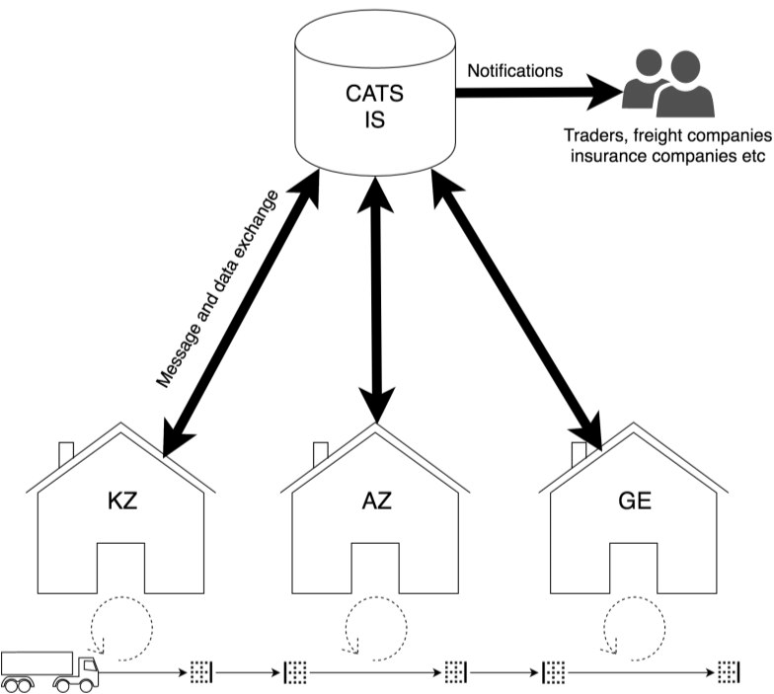

IV. Conclusion
63. Mongolia’s trade logistics demand assessment of nine main export commodities shows 92.4 percent of exports are concentrated in the mining sector, with total export of value of US$ 8.5 billion, for which road transport has been the primary means of shipment, although completion of new rail lines from large mines to the border is expected to sharply increase the share being shipped by rail. The most important by volume in 2021 were coal, iron ore, copper, gold and crude oil, respectively. Forecasted growth of mineral products will increase with improved railways. Estimates are to increase exports to between US$ 14 billion to US$ 17 billion in 2025-2028. The livestock or agribusiness sector was 7.6 percent of total exports, with total value of US$ 705.3 million in 2021, with cashmere, wool, meat and leather the main products and road, again, the main means of transport. Most exports across all commodities are to China with the need to diversify to other global markets, especially for agribusinesses such as meat. The export forecasts for the meat sector showed estimates of US$ 300 million to US$ billion per year.
64. Total imports were US$ 6.8 billion, 86 percent of which, with total value US$5.9 billion, were industrial inputs. Consumables, including perishables , comprised 14 percent of the total or US$ 962.7 million of traffic. Imports are shipped by rail in 70,000 TEUs containers per year of which 90 percent are from China’s Tianjin seaport. Transit traffic by rail is a growing sector of Mongolia’s Central Corridor by 2,093,600 tons in 2015 to 4,241,000 tons in 2021 for a CAGR of 12.4 percent.
65. The pandemic worsened the capacity problems handling the growing volumes of traffic in Ulaanbaatar, Zamiin Uud-Erlian and in Tianjin seaport. These costs and delays among other upstream or rural transport and logistics issues led to high transport and logistics costs, which in turn reduced the competitiveness of Mongolian exports and the profitability of export sectors. Transport and logistics costs add up to 30 percent of Mongolian GDP, a very high number by international standards as shown in Table 10.
66. For all commodities there is a need to improve the roads and railways and for logistics facilities of warehouse storage, especially for refrigerated and cold chain infrastructures. The routing and transit times of all commodities for on time deliveries, a key performance indicator for businesses, is constrained by the lack of adequate consolidation centers. Currently it takes an average of more than 90 days for containers to arrive in Mongolia from Tianjin port which is one of many indicators proving delays in shipments along the corridor. Eight planned strategically located freight villages and one main consolidation center, if successfully implemented, will improve logistics functions and lower costs. These consolidation hubs are designated for meat, but needed for all livestock and agribusinesses: Uvs, Khovsgol, Arkhangai, Bulgan, Ovorkhangai, Tuv, Khentii, and Sukhbaatar and the main hub Bagakhangai district of Ulaanbaatar, located near main road and transport corridors.
67. At present, there is a need to upgrade the logistics services to meet the requirements of the global customers. The Mongolia Central Economic Corridor for rail, road and transit stretches from markets in Europe to the Northeast Asia (Japan, Korea) and United States passing many ports of congestion in Mongolia, China and Russia. Digital infrastructure is needed to improve connectivity among all stakeholders from rural Mongolia to end customers, and especially for freight forwarders transitioning to logistics service providers with value added services. These value-added services include, EDI, TMS, WMS, Single Window, packaging, labeling, barcoding, RFID, especially for time-sensitive refrigerated products.
68. The digital highway will work to improve road, rail, and transit. First by scheduling platforms for identifying less than truckload for full truck load opportunities, the CATS transit document platform to complement TIR, reduce paper documents by automation with EDI through the SEW, and improve location of containers both dry and refrigerated from the Tianjin-Dongjiang Mongolia Area and up and down the corridor. Overall, there is a need for better flows of products, data and financials with Russia and China. Implementing these plans with inter-agency and cross-border institutions meeting on a regular basis will go far in reducing Mongolia’s 30 percent costs of logistics and transportation as a percentage of GDP. These changes should make Mongolia products more competitive for growing export demand worldwide.

Mongolia, NSO, Foreign Trade, 2021, p. 11.
“Economic and Technical Assessment of Ulaanbaatar, Zamiin Uud and Altanbulag Sainshand Ports Included in the Dry Ports Discussion,” Professor Davaasuren Avirmed, Ministry of Foreign Affairs, UNESCAP, UB, 2022, p. 30
InfraSAP, World Bank, November 2020, p.38.
InfraSAP, World Bank, November 2020, p. 77.
Mongolia NSO, Foreign Trade 2021, pages 14 and 16.
Mongolia NSO, 2019, 2021 and InfraSAP, World Bank, 2020.
“Mongolian Railways in the Era of Deglobalization of Energy,” Foreign Policy, Lkhaajav, B, Turnbull, A., May 2, 2022.
InfraSAP, World Bank, 2020, pgs. 85-86.
“Meat and Food by-products”, 0201 Fresh Beef, 0202 Frozen Beef, Table 1., Exports of Goods, 2006-2021, Foreign Trade 2021, NSO, Mongolia, spreadsheet.
“Export of Thermally Processed Beef and Meat Products to China,” GIZ, Germany, 2020, p.47.
“Review of the Five Key Destination Markets for Mongolian Meat Exporters,” UNCTAD, Geneva, 2020, p. 7.
“Raw Hides and Skins and Processed Hides and Skins”, for HS 4104,4105, 4106, Table 1., Exports of Goods, 2006-2021, Foreign Trade 2021, NSO, Mongolia, spreadsheet
“Xi Pressured As Economic Fixes Falter,” Wall Street Journal, November 28, 2022.
“Economic and Technical Assessment of Ulaanbaatar, Zamiin Uud and Altanbulag Sainshand Ports Included in the Dry Ports Discussion,” Professor Davaasuren Avirmed, Ministry of Foreign Affairs, UNESCAP, UB, 2022, p. 30
Foreign Trade, 2021, NSO, pg. 21.
Foreign Trade, 2021, NSO, pgs. 21-24.
Foreign Trade, 2021, NSO, pg. 22.
Davaasuren, UNESCAP, 2022, p. 30
Interview by e-mails, National Development and Reform Commission (NDRC). Transport, Beijing, October 25, December 20, 2022.
Interview, NDRC, Transport, Beijing, December 20, 2022.
Interview, NDRC, Transport, Beijing, December 20, 2022.
Davaasuren, UNESCAP, 2022, p. 138; CAGR by Wallack, consultant
Davaasuren, UNESCAP, 2022, pgs. 17-18.
“TA-8939 MON: Bogdkhan Railway Bypass Improvement Program, Final Report”, ADB, November 2022, p.23
“InfraSAP,” World Bank, 2020, p.64.
“InfraSAP”, World Bank, 2020, p. 77.
“InfraSAP,” World Bank, 2020, p. 74.
“TTFA, Cashmere, Wool, Meat, Leather, World Bank, 2018, p. 47.
InfraSAP, World Bank, p. 78.
“InfraSAP, World Bank, p. 79.
“TTFA, Cashmere, Wool, Meat, Leather, World Bank, 2018, p. 56.
“InfraSAP”, World Bank, 2020, p. 18.
Survey on the Domestic and Export Meat Value Chain in Mongolia,” Gantulga, A, UNCTAD, 2021, Figure 11, p. 26.
Davaasuren, UNESCAP, 2022, pg. 32.
“TTFA, Livestock Industries, World Bank, 2018, p.109.
“Countdown to the Single Window”, Kulisch, Eric, American Shipper, April 2014, p. 8
“Blockchain Fizzles in Shipping”, Wall Street Journal, December 16, 2022, p. B4.
“Facilitation of Regional Transit Trade in Central Asia Regional Economic Cooperation”, PADECO, ADB, March 2017, pgs. E-4-5.

