Russia’s Port of Novorossiysk expanding to handle larger volumes of grains
By: Robert L. Wallack | Issue #679 | Nov 27 2018 at 11:21 AM | Channel(s): Ports & Terminals Ports
Port of Novorossiysk’s expansion key to Russian grain exports to Middle East and Africa.
Russia is diversifying its economy to agriculture production of grains to counter United States’ sanctions and unstable oil and gas revenues. The Black Sea basin deep-water Port of Novorossiysk is undergoing a commercial seaport modernization program as the country passed the U.S. as the world’s top wheat exporter in 2015-16. In addition, major international and domestic grain houses are expanding grain exporting infrastructure in competition to capture Middle East, North Africa and beyond markets.
Wheat, barley and corn harvests are booming on the fertile and mineral rich black soil steppe of southern Russia where farmers are running their own fleets of trucks to move abundant supplies to the Novorossiysk port 200 miles by road, according to a recent Wall Street Journal article. Lower costs of land and transportation and higher quality output from modern high-tech tractors and combines are displacing European and U.S. grain exports to Middle East and North Africa importers. President Vladimir Putin called for an increase of grain production to 120-125 million metric tons (mmt) per year by 2020 with exports of 35-40 mmt per year.
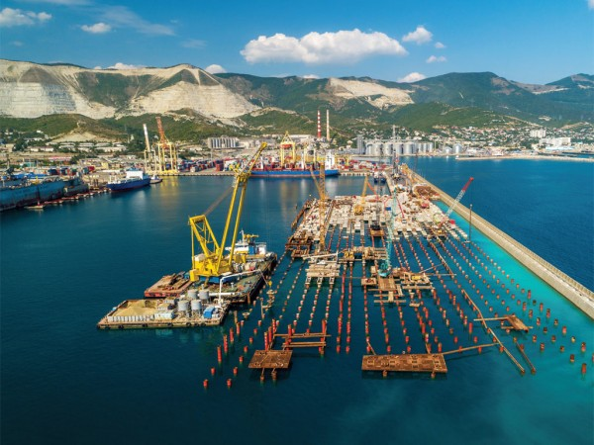
Construction at NUTEP new deep water terminal at berth 38, Novorossiysk Port

This year’s grain crop forecasts indicate that farmers are approaching the 2020 annual output targets. SovEcon, based in Moscow, is the oldest Russian company specializing in Russian agriculture markets since 1991. They forecast, “a 2018 grain crop of 113.9 mmt of which wheat accounts for 69.6 mmt, barley, 16.9 mmt and corn, 12.5 mmt.” The year over year increases are impressive where “July-September (wheat+barley+corn) amounted to 15.2 mmt (12.2 mmt., 2017) which includes 4.6 mmt (3.9 mmt, 2017) from Port Novorossiysk, according to Andrey Sizov, Jr., Managing Director, SovEcon in a recent e-mail to the American Journal of Transportation.
Black Sea Port of Novorossiysk
The Black Sea holds an historical place in commerce and military operations. The ancient Romans called the Sea Pontus Euxinus meaning friendly sea and recently archeologists discovered an ancient Greek trading ship intact dating back 2,400 years at a depth of 1.24 miles since below 300 feet is oxygen free. In fact, on the shores of Tsemess Bay were once ancient Greek grain traders. The important shipping route to the Mediterranean Sea for Southern Russia farmers passes through the 19 miles long and one half to 2 miles wide Bosporus Strait to the Sea of Marmara and then the Dardanelles Strait connects with the Aegean Sea to the Mediterranean to reach Middle East and North Africa grain markets where Egypt is one of the largest importers. The Black Sea is 750 miles long and 380 miles wide with an area larger than California of 170,000 square miles. The Sea is 7,000 feet at its deepest and not salty because it receives fresh-water rivers of Danube, Dnestr, Dnepr and the Don.
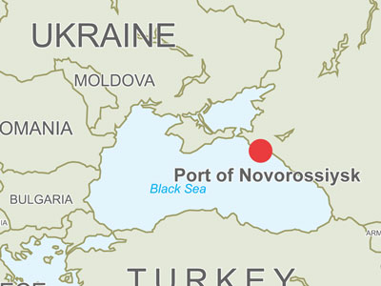

Port of Novorossiysk is located on the northeast coast of the Black Sea with a population of 300,000 in Krasnodar Krai. This Port city is the fourth busiest seaport in Europe with 131 million tons cargo turnover behind number one Rotterdam, 461 million tons, then Antwerp and Hamburg in 2016, according to Ernst & Young, “Overview of Stevedoring Sector in Russia in 2016.” Of the 5 Russia cargo sea basins (Baltic, Caspian, Arctic, Far-Eastern) and 25 seaports, Novorossiysk on the Azov-Black Sea basin is number one with 92.8 million tons liquid cargo and 38.6 million tons dry cargo. Dry cargo in Russia increased 169% and liquid cargo 127% from 2009-16. Investment projects to 2022 are to keep up with development trends in transshipment activities for the Azov-Black Sea basin. Dry cargo is expected to increase 135 million tons, liquid cargo 12 million tons and 3.7 million twenty equivalent unit (TEU) containers, according to the report.
Terminal Investment
Over the last twenty years, the inefficiencies of the collective farms have given way to market driven forces creating bottlenecks on the rail, road and terminal logistics systems. Delo Group is one of the largest private transportation and logistics holding companies in Russia. As a shareholder, the Group is undergoing terminal improvements for the growing grain exports and container imports and exports traffic which will help to lower costs from current inadequate export infrastructure.
The NUTEP container terminal investment program is occurring at a new Berth 38 and involves dredging from 12.3 meters to 15.1 meters. This will shift the terminal from 4,000 TEUs per vessel feeder service via Piraeus/Istanbul to handle ocean going vessels up to 10,000 TEU and will increase throughput capacity to 700,000 TEUs from 400,000 TEU. Berth 38 will become the only berth in Novorossiysk for Post-Panamax vessels. The opening is planned for the second quarter of 2019. Benefits to shippers will be an increase of delivery speed by 4-12 days for inbound cargo, container line costs of delivery to decrease by $300-$400 per unit and cheaper bunker fuel as well as additional storage area from 12,000 to 21,000 TEU. Stage two involves 2 additional ship to shore cranes and 6 additional rubber tire gantry cranes.
RUSCON Group is the multimodal and logistics business of containerized cargo at NUTEP container terminal under Delo Group and works with Delo Ports, the stevedore business. In 2016, RUSCON integrated with Yug Terminal’s new warehouse logistics center. RUSCON operates the new warehouse logistics center equipped with alongside rail connections, M4 and M5 motorways nearby and seaport connection range of 4 miles. In addition, they own a fleet of wagons and trucks and operate 3 weekly express block trains through Russia of which one is between Novorossiysk to Togliatti from NUTEP. The Ernst & Young report estimates that 50% of cargo is delivered to Russia seaports by railways and that construction of access routes to the ports of Azov-Black Sea basin over 2017-2020 amounts to $1.855 billion.
ROSCON also operates a new automated complex for handling breakbulk and bagging of a wide range of fertilizers. “It may be cross-stuffed from trucks and rail cars directly into containers by breakbulk or into the big bags,” explained a Delo Group spokeswoman in an e-mail to AJOT. This rail operation accepts rolling stock hoppers of all types and open cars with bottom hatches with 10 cars capacity at the ramp. They boast a performance of 200 metric tons per hour direct loading into containers and 60 metric tons packaging into big bags of beads and crystals of 1-40 millimeters in size of urea, anthracite, ammonium nitrate, potassium chloride among other range of goods. RUSCON’s share of container traffic through Novorossiysk is 25% and partners with Maersk, MSC, CMA CGM, ZIM and Evergreen.
KSK Grain terminal
Delo Group and RUSCON also are competing in the receiving and exporting of grains at the Kombinat Stroykomplekt (KSK) Grain Terminal where they and Cargill are investing to improve capacity. KSK has 19 percent of the market share in the deep-sea grain terminals of Novorossiysk behind Novorossiysk Grain Plant (NGP) and Novorossiysk Grain Terminal (NGT) owned by Novorossiysk Commercial Seaport (NCSP), but ahead of Glencore Kernel and TCSP grain terminals. The Azov Sea is mostly shallow-water operations and unable to transship large volumes and is less profitable for major traders. SovEcon estimates the grain capacity modernization in Russia will add 7-10 mmt medium term and for Novorossiysk terminals, 4.5 mmt.
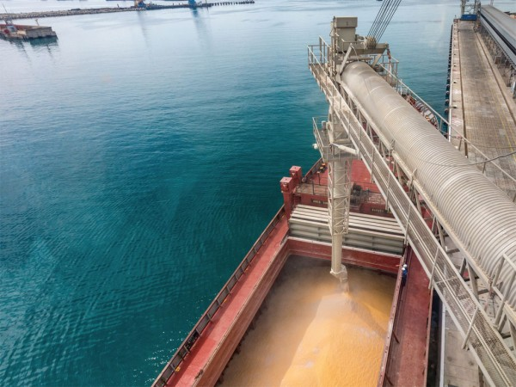KSK Grain Terminal loading grain

By 2020, Delo Group plans to complete construction of a new berth 40A to allow vessels with dead weight up to 100,000 tons, dredging to 16.9 meters and expected throughput capacity of 6.5 million tons along with grain storage increasing by 102,000 tons for total grain storage capacity by 2019 to be 218,000 tons. This will enable the KSK Grain terminal operated by RUSCON to receive 15 railcars and 40 trucks per day of grains (any kind of cereals and legumes), weighing for reloading into 6 silos of 10,000 mt capacity to reloading of 650 mt/day or 25,000 MT/month for shipping in containers.
Cargill, the largest privately held corporation in the US with annual revenues of $114.7 billion, is based in Minnetonka, Minnesota and has a 25% stake in KSK. Increased capacity will lower grain handling costs for a more profitable grain trade and timely return on investment. The Cargill Corporate Affairs office-Europe, Middle East and Africa based in Belgium replied by e-mail to AJOT, “we can confirm that Cargill indirectly owns a minority participation interest in the KSK terminal. The expansion project is on track and aims to increase the capacity of the terminal to improve transshipment activities.”
The leading position among deep-sea terminals is held by state grain transshipment, trader and processor United Grain Company (UGC) with 30 percent market share that controls the Novorossiysk Grain Plant (NGP) in the Port of Novorossiysk. UGC traces its grain handling to 1882 when it was the largest silo barn elevator in Europe and now is embarking on expansion projects. Investments are to increase transshipment volume from 3.4 million tons to 6.1 million tons per year; storage capacity from 140,000 tons to 250,000 tons per year and maximum dead weight of ships served from 72,000 to 80,000. UGC was in a minor stock holder meeting and declined to comment. UGC investment report estimates world population to increase to 9.2 billion by 2050. There is great potential for Russia to improve crop yield based on 40% of world black soil area and 34.1 million acres of unutilized cultivation area.

