Share to Google+Share to LinkedInShare to Email

Thailand and Cambodia logistics infrastructure gaining importance for cross-border trade
By: Robert L. Wallack | Aug 07 2017 at 08:00 AM | Channel(s): Transport Intermediaries
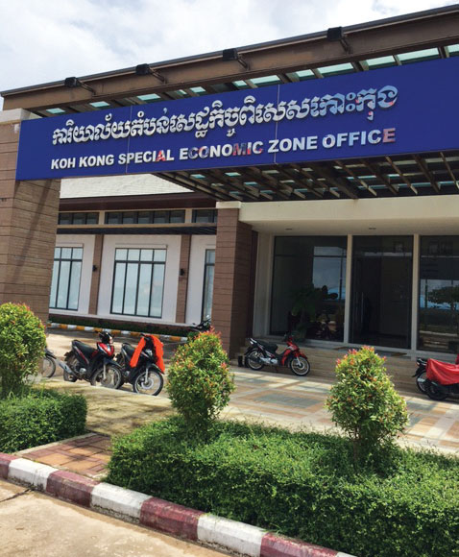
Koh Kong Cambodia border to Thailand

Thailand and Cambodia are focusing on cross-border trade logistics to improve their economic competitiveness. Although these two kingdoms are on different levels of economic development, both are benefitting from Greater Mekong Subregion (GMS) and One Belt, One Road projects. All modes of transport are improving for better logistics performance to attract more investors.
Thailand’s consumer goods and construction materials are finding buyers in Cambodia, Lao PDR and Myanmar. The government invested along the border areas and in the tourism sector. As a result, these three countries accounted for the highest value by $13.3 billion of total border trade value of $15.8 billion in the first five months of this year. This is a total border trade rise of 6.4%. Border trade is also expected to help improve Thailand’s overall annual export volume to a 5% growth target for 2017, according to the Commerce Ministry in a recent Bangkok Post article.

Cross-border Trade
Unithai, a Bangkok freight forwarding and warehouse company, remarked on the improving logistics facilities and infrastructure for cross-border trade in Thailand. “In the past 10-15 years there are more cross-border trade points. International shipments of construction materials from China such as steel to Vientiane, Lao PDR and for Thai domestic products to Lao have smooth Customs clearance for us. We contract out to 6-10 trucking companies for all trades,” said Mr. Michael Yuen, Head of Break Bulk (Parceling), Senior Director, Unithai.
A further boost to cross-border trade growth and investments is the East-West Economic Corridor (EWEC), one of several corridors in the GMS backed by the Asian Development Bank (ADB) by constructing roads, bridges and border ports to connect all six countries. Mukdahan on the east is across from Lao’s Savannakhet and along the corridor to eventually Vietnam to Danang seaport (327 miles) passing by millions of potential customers along the route. Further linkages are possible to southern China, specifically to the established China-Thailand Chongzuo Comprehensive Industrial Zone along the route to Nanning, Guangxi, PRC (837 miles).
A June conference in Bangkok presented prominent speakers in the “Mukdahan: The Logistics Hub and SEZ on EWEC to ASEAN+.” Mukdahan governor Sorasit Ritsorakai stated that, “If planned infrastructure projects are completed, trade value along the border areas is expected to rise to $5,977 billion a year in 2019, up from $4, 033 billion.” These projects include a 4 lane road, rails and an airport. China’s One Belt, One Road project could link the 994 mile rail lines under construction from India’s Manipur to Myanmar’s Mandalay and Thailand’s Mae Sot and Mukdahan, Laos and southern China. Dr. Thanavath, a Thai professor, noted the new investment promotion in Mukdahan by the government for a Special Economic Zone (SEZ) with full infrastructure and facilities, but needs an industrial strategy. He cited, “Mukdahan beef, rubber, sugar and electronics,” as possible with markets by sea from both Laem Chabang and Danang ports. The governor stated that a feasibility study is now a plan submitted to the Cabinet for approval for an investment need of $90-60 million for an airport and other logistics infrastructure in Mukdahan.
The Thai government’s 12th National Economic and Social Development Plan aims to cut the country’s logistics costs to 12% of gross domestic product (GDP) by 2021 after succeeding in reaching 14% percent in 2016 after the 11th plan of 2012-2016 ended, according to the Bangkok Post. The new plan seeks to facilitate more connectivity to neighboring countries and make better use of rail and river trade away from dependence on road transport. Targets are for “rail transport load to be 4% of total transport from 1.4% and goods transported by waterways up to 15% from 12%, while reducing road transport to 80% of total transport in 2021 from 88%.
Since the end of the troubled era in 1991, Cambodia managed to grow on average of 7.6% GDP from 1994 to 2015. The economy is maintaining that level in a $15.5 billion economy of 15.5 million people compared with Thailand’s lower growth of around 3 percent GDP, $387.2 billion economy of 67.7 million people. Cambodia’s services sector, which includes logistics, is the largest piece of their GDP of about 42.3% in 2015. International donor agencies and foreign direct investment (FDI) are flowing from China (32% of FDI), South Korea and Japan to bridge the development gap from neighboring GMS countries.
A modern international airport in Siem Reap greets visitors and investors built by ADB assistance. However, roads, rails, seaports, dry ports and waterway infrastructure are in constant need of upgrading and are approximately on the level of development of Shanghai 25 years ago by this author’s estimate. “Investing in logistics infrastructure is vital for a strong services sector. Cambodia would need about $15 billion in infrastructure development from 2013 to 2020 to keep up with its economic growth rate of around 7 percent,” according to a June 19, 2017 article in the China Daily, “Cambodia Charts out Master Plan for Logistics.”
Sin Chanthy, President, Cambodian Freight Forwarders Association (CFFA) in Phnom Penh in June explained some of the operational, policy and infrastructure obstacles confronting cross-border trading in Cambodia and how the government recognizes the importance of logistics to economic growth and investments. “In February, the government appointed a General Director of Logistics in the Cambodia Ministry of Public Works and Transport.” There is now a General Department of Logistics led by Pich Chhieng and a newly formed National Cambodia Logistics Council co-chaired by Prime Minister Hen Sun, he added.
Both of these new institutions will complete a National Logistics Master Plan by the end of 2017 for Cambodia’s logistics roadmap for the next five years. The CFFA will provide valuable input to the government in this first endeavor for logistics sector development. Prime Minister Hen Sun will focus on four areas: improve public-private dialogue for logistics, promote competition in transport and logistics, improve regulations and more private investments for multi-modal and cross-border transport and logistics services.

Silk Road
Old trade routes dating from thousands of years ago by the so called Silk Road are reviving since 2013 when the PRC began a $1 trillion infrastructure policy under the land based Silk Road Economic Belt and the ocean lanes 21st Century Maritime Silk Road, or “One Belt, One Road” initiative. Cambodia figures into both the cross-border cooperation and inter-connected infrastructure pillars of this massive endeavor to link Asia with Europe, the Middle East and African nations by the PRC.
In October 2016, President Xi visited Cambodia to outline partnership to the One Belt, One Road plans and proposed over $230 million in soft loans. Also, China is behind a plan to develop 1,385 miles of national expressways by 2040 to a cost of about $26 billion. The first expressway from capital city Phnom Penh to coastal port Sihanoukville in the southwest is already under construction, according to the China Daily article.
The National Logistics Master Plan will have impact on the Cambodia border SEZs in Bavet border with Vietnam, Poipet border with Thailand and Koh Kong border with Thailand. Manufacturers in these border SEZs are exporting to regional and global markets well-known branded products of sporting goods, apparel, footwear, electronics, automotive products. “We need wider access roads and better dry ports,” said a spokesperson in the Bavet city, Manhattan SEZ in a June visit.

