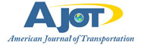

US FTZs provide a new deal for exporters
By: Robert L. Wallack | Sep 23 2015 at 08:00 AM | Channel(s): Ports & Terminals Ports
The US Foreign Trade Zone (FTZ) programs have been around since the “New Deal” and a new wave of industries is utilizing the benefits.
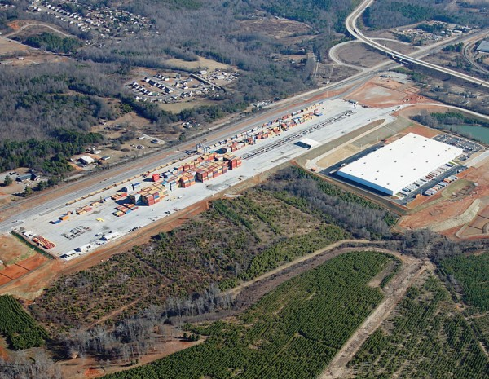
The South Carolina Inland Port at Greer, SC
FTZs A New Deal
The United States Foreign-Trade Zone (FTZ) program is growing in importance to large and small companies across many industries of the economy, especially for “re-shoring” of production. The benefits are to reduce or eliminate duty payments on imported merchandise for distribution, production and exporting. The Port of South Louisiana is leading the nation at subzone 124 for shipbuilding and oil refining.
The Foreign-Trade Zones Act of 1934 by President Roosevelt’s New Deal aimed to create jobs, stimulate the economy and promote international trade while protecting American industries to counter the debilitating Great Depression. After a slow start, the FTZ program grew from 10 general purpose zones and 2 subzones in 1970 to 1994, the year of the North American Free Trade Agreement (NAFTA), for merchandise received of over $100 billion to almost $800 billion in 2014. President Obama’s 2010 National Export Initiative together with the incentive from the U.S. shale oil and gas boom grew FTZ export activities from warehousing, distribution and production from $34.8 billion in 2010 to $99.2 billion in 2014 within 179 active FTZs (based on material imports not including value added), according to the 76th Annual Report of the Foreign-Trade Zones Board to the United States Congress of August, 2015.
NAFTZ
Bollinger Shipyards LLC is family owned since 1946 and a supplier to the U.S. Coast Guard (USCG) for military vessels and for commercial offshore and inland vessels. “All of Bollinger facilities in Louisiana are all part of Foreign Trade subzone 124-H. We are allowed to import foreign components into the U.S. without paying duties as long as they are incorporated into the vessel during construction or repair process. We improve cost effectiveness to remain competitive in our industry. We successfully delivered over 150 Cutters to the USCG and U.S. Navy customers,” said Dennis Fanguy, Vice President, Quality Management System, Bollinger Shipyards in a recent interview with American Journal of Transportation.
In order to receive the benefits of operating within the FTZs, companies need to comply with the U.S. government regulations of the Department of Commerce and are granted authority by the FTZ Board under the supervision of the U.S. Customs and Border Protection. “A Foreign-Trade Zone is a secure area at or near a U.S. port of entry that is considered outside U.S. Customs territory. Zone activity can be in a general-purpose zone, where multiple users enjoy FTZ benefits at a zone site, typically a warehouse district or industrial park. A subzone is a site used by a single company for designated zone activity. A subzone can be an oil refinery, an auto manufacturing plant, a retail distribution center, or a number of other operations,” said Daniel Griswold, President, National Association of Foreign-Trade Zones (NAFTZ) in a recent interview with the American Journal of Transportation.
The NAFTZ is an advocacy and education organization to promote the interests of the FTZ community of 650 members from the public and private sector. NAFTZ is instrumental in improving the application process and the automation of FTZ processes. For example, “the Alternative Site Framework (ASF) was introduced in 2009 to streamline the application for zone use. It allows the designation of usage-driven sites within a multi-county service area that offer the same benefits as a subzone, but with a more user-friendly approval process. Most active FTZs have converted to ASF,” said Griswold.
Moreover, imports to FTZs account for 12% of total U.S. imported goods. “Like most of the importing and exporting sector, FTZ-using companies are anxious for a smooth transition to the Automated Commercial Environment (ACE) in 2016, including the single-window system for reporting to import-monitoring agencies such as the FDA and USDA,” said Griswold. He continued, “Sophisticated software is already on the market to manage FTZ inventory control and record keeping systems. NAFTZ is asking of Customs for the necessary time to test FTZ entries in the new system and fully participate in any pilot programs.”
FTZ Beneficiaries
The main beneficiaries of the FTZs are the oil refineries. In Louisiana, sub-zone 124, Valero, Motiva (Shell), and Marathon are large users and all declined to comment for this article. “In 2014, $147 billion in foreign-sourced crude oil was admitted to FTZ refineries in the United States. Operating in a zone allows refineries to eliminate duties on imported oil that is then refined and exported, and to speed supply-chain velocity,” said Griswold.
The U.S. shale oil and gas boom is impacting the oil refineries in the FTZs. “In 2014, petroleum accounted for 51% of FTZ imports, its lowest share since 1996. As recently as 2008, oil had accounted for more than 80% of FTZ imports. The flip side of the story is that non-oil FTZ imports, including industrial components and consumer goods, continue to surge, largely offsetting the decline in oil imports,” concluded Griswold.
Automotive is the second highest user in the FTZs. In recent years, many major international automobile manufacturers established subzones. These include BMW, Mercedes-Benz, Honda, Hyundai, Nissan, Subaru, Toyota, and Volkswagen as well as domestic, such as, Tesla Motors in Fremont, California FTZ. “Reshoring” of production to U.S. FTZs is also an important strategy by GE Appliances from China and Whirlpool from Mexico. In Clyde, Ohio, Whirlpool has opened a 2.4-million-square-foot facility that it calls the largest washing-machine plant in the world. FTZ status allows the company to reduce or eliminate duties on such imported components as circuit boards, pumps, and motors, which would otherwise face duties as high as 9%, according to the NAFTZ Annual Report of 2014-2015.
On a weekly basis, the FTZ Board is reviewing applications and seeking public comments for Mercedes Benz seeking to add a new passenger vehicle product in their subzone, or to authorize production at a resin plant for polyethylene terephthalate or for food stuffs, footwear and juice concentrates. All users seek to benefit from the cash flow savings from duty deferral, reduction or elimination among other market entry advantages enjoyed by producing, warehousing or distributing in the U.S. FTZ program.
“The relationship with the FTZ and Port of Louisiana has allowed our organization to expand over the years as well as increase our activity through the zone while remaining compliant,” said Fanguy.

