Vietnam economic growth challenges transportation and logistic services
By: Robert L. Wallack | Issue #608 | Aug 10 2015 at 08:00 AM | Channel(s): International Trade
Vietnam’s export oriented economy is growing fast. The challenge is for transportation and logistics services to keep pace.
The United States and Vietnam are strengthening economic ties as the U.S. became the largest export market in 2014 with $30.6 billion in value of goods, or 14.7% increase over 2013, surpassing the European Union as Vietnam’s top export market. Vietnam is also attracting worldwide trade and investment by steady economic growth averaging 5.8% since 2010 through the first quarter of 2015, a population of 90.7 million averaging 28 years and a strategic location in Southeast Asia with a 2,140 mile coastline. However, necessary reforms are slowly occurring for the inadequate infrastructure and low efficiency in order to improve Vietnam’s regional logistics hub status and to benefit fully from the U.S. led Trans-Pacific Partnership.
April marked forty years since American forces withdrew from Vietnam and twenty years from establishing diplomatic relations. Vietnam’s most populated areas are the Red River Delta in the north bordering China and the fertile Mekong Delta in the south. Cambodia and Laos are to the west. Total gross domestic product (GDP) in 2014 was $186.2 billion and $2,052 per capita, whereas China was $7,593 and Cambodia, $1,084, according to the World Bank. Total U.S.-Vietnam trade is estimated to reach $57 billion by 2020.
Apparel and footwear are an important and leading sector to the growing economy and to adding more value to exports. Many U.S. brands and retailers such as Nike, Crocs and Kohl’s are sourcing more from Vietnam over China for lower costs in labor. In fact, the American Journal of Transportation, February 2015 survey, “Top US Sources of Imports,” showed Vietnam listed as number 16 with a total value of goods of $27.9 billion to China’s top position of $246 billion.
In order to move up the value chain in apparel and in other sectors, Vietnam is improving technological quality by foreign investors from Hong Kong, South Korea and Taiwan. Companies from these countries are building textile factories with modern machinery that feed their own garment factories. As a result, these foreign investors can benefit from the Trans-Pacific Partnership (TPP) and Vietnam will rely less on China for textiles (yarn and fabric) and machinery as well as bolster its productive competitiveness.
Vietnam relies on foreign direct investment (FDI) for its economic development and exports in particular. Shipments by FDI companies are 68% of total export value or $101.2 billion in 2014, which are a 14.8% increase over 2013, according to Vietnam Economic News reports. Total FDI in 2014 was $21.92 billion from 63 countries and across 18 sectors of the economy. Manufacturing and processing captured $15.5 billion or 70% of total FDI projects, according to the Vietnam Foreign Investment Agency. To April 2015, the leading provinces of FDI capital were Ho Chi Min city (HCMC), $540.2 million, Binh Duong (north of HCMC), $402 million, Hai Phong (seaport in the north), $235.21 million and Hanoi (capital in the north), $167.2 million.
In 2014, South Korea was the top investor with $7.7 billion which included a $3 billion expansion of Samsung Electronics in the northeast province of Thai Nguyen and a $1.4 billion Samsung CE Complex in HCMC. In addition, Intel chose Vietnam over the Philippines for its trained workforce in their recent site selection process.
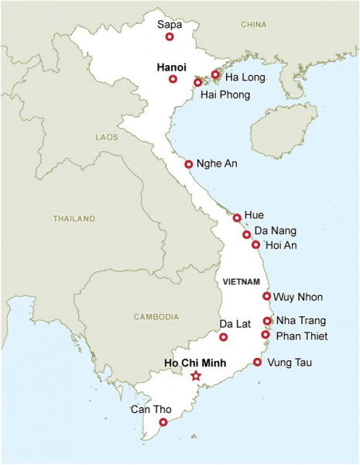
Vietnam and Trade Agreements Apart from TPP, Vietnam is strengthening economic and trade ties with countries worldwide by lowering tariffs through free trade agreements (FTA). In August of 2014, the Association of Southeast Asia Nations (ASEAN) and China re-negotiated the ASEAN-China Free Trade Area (ACFTA) for bilateral trade of $500 billion with 7,000 items for zero percent tariffs. Other signed or under negotiation agreements are with India, Australia/New Zealand, Korea, Japan, Chile, EU and Russia (Customs Union) in recent 2014 reports from the Vietnam Economic News. Moreover, Vietnam is the 150th member of the World Trade Organization (WTO) from January 2007.
Vietnam is a leading global producer and exporter of numerous agriculture commodities. The nation is the number two producer of Arabica coffee, second to Brazil, and number one in Robusta coffee. Vietnam accounted for 15.2% of the world total production, according to the Vietnam Coffee-Cocoa Association. The country is number three in rice production and one of the world’s biggest producers and exporters of pepper. Vietnam exported 134,000 tons of pepper valued at $889 million to over 80 countries in 2013.
The full benefits of trade agreements and export growth cannot be realized without reforms to key sectors of the economy. Supporting industries are under developed and hinder connectivity to internal and external markets. The Ministry of Transport (road, rail, water, air) is now realizing that logistics and related costs are an important part of transportation to improve the nation’s competitiveness as a potential regional transshipment hub of not just feeder services and for competitive global value chains across many sectors of the economy. “From 2011-2014, the average growth for freight was 15.5%,” said a Vietnam government official in his presentation in April in HCMC at the Air Freight Logistics, Vietnam international conference. “We realize the importance of logistics in transportation requires actions as soon as possible to enhance systems to develop Vietnam logistics,” he emphasized.
Restructuring SOEs
Vietnam ports are one sector of the government’s restructuring of state-owned enterprises (SOEs) crucial for economic development. State-run Vietnam National Shipping Lines (Vinalines) is the largest shipping firm in Vietnam and reduced its holdings in Saigon port to 64% from 75% in an initial public offering (IPO) on June 30th. Saigon Port Company Limited sold 35.71 million shares to raise $18.83 million at the HCMC Stock Exchange according to Saigon Giai Phong News on July 1st. Vinalines is also reducing its stake in a number of other ports, such as, its $9.8 million-valued, 56.58% in the north in Cai Lan International Container Terminal, a joint venture with SSA Holdings, based in Seattle, Washington. These equitization plans are a small part by Vietnam for partial privatizing of 432 SOEs, which are one half of the country’s loans and account for only one third of the GDP.
Air & Ground World Transport (AG-World), a San Francisco based global logistics and Customs brokerage provider, has a primary agent in Vietnam. “There will be more manufactured goods shifted from China to Vietnam. Wearing apparel will continue to be a strong export for Vietnam. I had a gardening account which used to manufacture in China, but ten years ago already sourced from Vietnam,” said Evey Hwang, Licensed Broker, AG Customs Brokerage, Inc. in a recent interview with the AJOT.
The Vietnam government economic policies indicate gradual reforms to attract more foreign investors needed to improve supporting industries of transportation and logistics. Some international logistics service providers from the U.S. and Europe are setting up offices in Vietnam. They intend to benefit from the increasing intra-Asia and global trade as more manufacturing of labor-intensive apparel and footwear and of higher value goods such as electronic products shifts from China. However, “there is a lack of collaboration between government and business and by human resource capacity to capture the growth of logistics,” cautioned the government official presenting in the Air Freight Logistics Vietnam conference

