Multitranche Financing Facility People’s Republic of China: Guangxi Regional Cooperation and Integration Promotion Investment Program – Tranche 3

Asian Development Bank
Project Number: 50050-005
Loan Number: 0096
December 2020

Chongzuo Cold Chain Demonstration Project
(Draft Final Report)

Robert L. Wallack, Cold Chain Logistics Specialist, U.S.A.

Richard Xu, Cold Chain Logistics Specialist, PR China

ABBREVIATIONS
ADB | - | Asian Development Bank
ASRS | - | automated storage and retrieval system
BCP | - | border crossing point
BDS | - | Business Development Services
BEZ | - | border economic zone
CAGR | - | compound annual growth rate
CFC | - | chlorofluorocarbons
DC | - | distribution center
DI | - | design institute
EC | - | electronically commutated
EDI | - | electronic data interchange
ERP | - | enterprise resource planning
FSR | - | feasibility study report
GFSI | - | Global Food Safety Initiative
GHG | - | green-house gas emissions
GMS | - | Greater Mekong Subregion
GWP | - | global warming potential
GZAR | - | Guangxi Zhuang Autonomous Region
HCFC | - | hydrochlorofluorocarbons
HFC/HFO | - | hydrofluoroolefins
LEED | - | certification process aimed at rewarding sustainable and environmentally friendly construction processes
MOU | - | memorandum of understanding
MFF | - | multitranche financing facility
NDRC | - | national development and review committee
NOU | - | national ozone unit
NSEC | - | North-south Economic Corridor
OCR | - | ordinary capital resources
ODP | - | ozone depletion potential
ODS | - | ozone depleting substances
PRC | - | People’s Republic of China
PIE | - | project implementation entity
PMO | - | project management office
PPTA | - | Project Preparatory Technical Assistance
RCI | - | regional cooperation and assistance
RFID | - | radio frequency identification tags
SPS | - | sanitary and phytosanitary
SME | - | small and medium-sized enterprise
UNEP | - | UN Environment Program
WMS | - | warehouse management systems
WRS | - | warehouse receipt system

Table of Contents
I. Market Demand Analysis 7
A. Chongzuo Market Overview 7
B. Guangxi Market Demand 12
C. Cross Border, Vietnam, ASEAN Markets 17
II. Operational Analysis 19
A. Before and After Scenarios: Transaction Business Models 19
III. Management and organization analysis (SUpply Chain Finance) 20
A. Public or Private Business Models 20
B. Warehouse Receipt Pledge Finance System (Basis for Payment) 22
C. List of Services 27
IV. Engineering and Technical Analysis (IT Systems: WMS/TMS, cross-border) 29
A. Cold Storage Design Improvements, “Analysis and Comparison of Different Technical Designs” and “Lessons Learned from International Practices” 29
V. Environment Analysis (refrigerants: freon, ammonia, carbon dioxide, Cascade System) 32
VI. Conclusion 39

APPENDIX 1 Sample Job Descriptions

List of Tables

Table 1: Distances from Chongzuo 11
Table 2: Cold Storage Temperatures 12
Table 3: Guangxi Agricultural Indicators (2016) 13
Table 4: Guangxi Agriculture Products Traffic Flows (Source to Markets) - 2016 13
Table 5: Volume and Value of Major Export Agricultural Commodities in Guangxi, China( 2016-2019) 15
Table 6: Volume and Value of Major Import Agricultural Commodities (2016-2019) 16
Table 6: Guangxi Cities and Product Types 17
Table 7: Guangxi's Total Import and Export Values to ASEAN 17
Table 8: Cold Storage Capacity Situation in Some Provinces 18
Table 9: Examples of Zero ODS, Low GWP HCFC Alternatives 32
Table 10: Characteristics to Alternatives to ODS 33

List of Figures
Figure 1: Chongzuo Cold Chain Logistics Markets 7
Figure 2: Process Flow for Cold Chain Logistics Project Market Demand 8
Figure 3: Refrigerated Vehicles and Innovative Technologies 11
Figure 4: Traditional Flow of Goods in PRC Agriculture Logistics 19
Figure 5: Modern Flow of Goods in Agriculture Logistics 20
Figure 6: Basic Concept of Warehouse Receipt Finance 22
Figure 7: Electronic Automating the Warehouse Receipt Pledge 24
Figure 8: JD.com Cold Chain Supply Technology Platform Architecture 31
Figure 9: Carbon Dioxide/Ammonia Cascade System Equipment 35
Figure 10: Technical Diagram of Carbon Dioxide/Ammonia Cascade System 35

Executive Summary

- Improving the Chongzuo Cold Chain Logistics Demonstration Project feasibility study report (FSR) can be divided into several areas. This report will show enhancements to market analysis, operational analysis, management analysis, engineering-technical and environmental analysis. The suggested improvements and enhancements are presented by chapter.
- Indeed, the purpose of current and forecast market data is to be more specific to each agriculture perishable that needs temperature-controlled logistics in storage and by transport vehicles. For example, the FSR, Table 5.1-1 “Cold Storage Inventory Demand” distinguishes imports and exports of fresh and dried fruits and nuts from cattle and pigs raised by local cooperative enterprises in Chongzuo. The goal of the project is to store 12% of imported and exported fresh and dried fruits and nuts and 25% of the meat products from the local cooperative enterprises. The main items to be stored are perishables from imports and exports whereas there are very little perishable meat products imported and exported. The project storage space for meat will account for only 5.5% of the total cold storage space. In fact, all indications are that fruits and nuts will outweigh meats in capacity utilization rates.
- As such, the market demand data can more clearly show the exact volumes of each of the product categories and by customers (anonymous) for adequate planning of operations for inspections, temperatures, sorting, processing, packaging, labeling, handling in the cold storage space and the subsequent refrigerated transport to customers. As demand for cold storage grows, the competition for space in the Chongzuo facility will grow among users. A survey questionnaire of the widest number of users could offer more information during this transaction technical assistance.
- The “Supplementary Document 3” for the section only on the cold storage and integrated logistics hub information platform indicates “deficiency of the subproject” in these areas:
- Analysis and comparison of different technical designs
- Technical and economic viability
- Lessons learned from international practices and previous ADB-financed projects
- Operation and maintenance considerations
Improvements in these areas of the FSR report are predicated on a refinement of the existing demand study by identifying the main commodities and goods to be handled at the proposed border area zone(s) and for circulation in the Chongzuo, Guangxi and other domestic customers requiring cold chain logistics services. One technical area with environmental implications is for the transition from ozone depleting substances (ODS) such as freon to alternatives with lower global warming potential (GWP) by the carbon dioxide/ammonia cascade system as described in Chapter V, Environment Analysis, Refrigerants in this report.
- All indications in the FSR are that “specialty food industry base” of Chongzuo will be for fresh and dried fruits (citrus), nuts and vegetables requiring cold chain logistics. Meat will also be stored in the Chongzuo facility of 39,691 m². The packaging plant will be 7,480 m². The market demand data in the FSR’s tables is supports the customer’s requirements for meat products, but could be more specific as more information is gathered from customers and their requirements.
- An improvement could be made by listing all the cooperative enterprises, perhaps in a table, rather that cited separately in the text of the FSR, since cooperative enterprises will be important customers in terms of volumes, especially for inventory turnovers and for supply chain finance and payment mechanisms. The FSR states: Guangxi-Sino Pastoral Ltd, Zhengyu Hengrui Group Co. Ltd. and Guangxi Four Wild Pastoral Live Animals, numbers 134, 137 and 138, respectively in Chapter 2, Table 2.3-1 list of 143 enterprises in the Chongzuo-Thai Industrial Park, then Hongfeng ecological farm pigs in Chapter 5. If there are other cooperatives, then they could be all listed in one table in the report for easy reference.
- The FSR, Table 5.1-2, “The Cold Storage Area Calculation” shows the importance of measuring in terms of cubic meters where imports of fresh and dried fruits and nuts dominate and for the cooperative enterprises’ meat storage and processing. Indications of volumes in terms of cubic meters are important since the cold storage facility will be using equipment and spaces in cubic measurements for the areas dedicated to ambient, refrigerated and frozen storage. Also, operations and management use standard measurements for pallets in modern cold chain logistics storage and transport practices which are stacked on racks by standard heights. Proper measurements in cubic meters will also be important for collecting, storing, processing and transmitting of data elements used in the multimodal logistics information system platforms for desktop and mobile devices.
- The Baise FSR (Table 5) and the Guangxi Cold Chain Logistics Development, 2018-2020 report (Tables 2,3,4) provided the best data as shown in this report. Further improvements to the market demand data are from the DI and from other sources such as the National Development and Review Committee (NDRC) which can result in a better Chongzuo FSR. (See Appendix data updated to 2020.) The survey responses by the users (agriculture enterprises, importer/exporters, logistics companies and technology company(s)) to a questionnaire prepared by the Consultant, will also improve the quality of the market demand data as well as provide insight to the Project enhancements to the operations, management, engineering-technical and environmental.
- Improving the refrigerated agriculture products’ value chain from the farm fields to final customer destinations depends on a modern cold chain logistics infrastructure for Chongzuo. Insufficient and inefficient capacity of temperature-controlled logistics warehousing and refrigerated or insulated vehicles for transporting Guangxi perishables of specialty and tropical or sub-tropical fruits, vegetables, meats, dairy and aquatic products will hinder Chongzuo’s economic growth. Lack of modern and energy efficient cold chain logistics facilities, equipment and training will also hinder Chongzuo’s competitiveness for regional cooperation and integration (RCI) along the Eastern North-South Economic Corridor (NSEC) from Nanning to Pingxiang and cross border to Vietnam at Dong Dang/Lang Son to Hanoi and to other Greater Mekong Subregion (GMS) markets.
- New food quality and safety regulations and implementing cold chain logistics standards as well as growing demand for fresh, chilled and frozen foods will compel Chongzuo to advance cold chain logistics practices over the next five years. The Chongzuo Cold Chain Logistics Demonstration Project and the accompanying multimodal logistics e-commerce service information system platform and bonded warehouse is a good foundation to build the needed capacity to satisfy the different temperature control requirements of the various Guangxi and imported agriculture and aquatic products.
- Another improvement to the FSR could be to write three separate FSRs: 1.) Cold Storage and Processing Factory; 2.) Bonded Warehouse; and 3.) Multimodal Logistics Information System Platform. These are three distinct subprojects with differing commodities, regulations, processing, pricing, financing and customer requirements.
- Chongzuo could capture a growing market share of the cold chain logistics business for agriculture and aquatic products since demand is rising for better quality food. More value is created by the growing demand from e-commerce and urbanization in Guangxi if food spoilage is reduced. Post-production losses are too high as cold chain logistics circulation and transportation rates of agriculture and aquatic products increase. There is a need to reduce spoilage of foods which are 25% or higher for fruits and vegetables, 15% for meats and 18%for aquatic products in Guangxi. The components of this subproject 3 will enable Chongzuo to offer higher quality cold chain logistics services and become a needed local distributor and key distribution center (DC) among the numerous cold chain logistics and agriculture processing projects in Baise, Pingxiang, Nanning, Qinzhou and Fangchenggang.
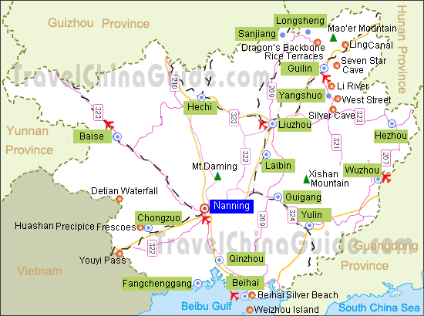
Figure 1: Chongzuo Cold Chain Logistics Markets
Key Recommendations
- Write three separate FSRs: Cold Storage, Bonded Warehouse, multimodal IT platform
- Microeconomic (firm level) survey of customers and users for market demand
- Perform Business Process Analysis (farmers, wholesalers, cooperatives, petty trade)
- Select the management company for selection of the IT company
- Licensed refrigerated management group needed for warehouse receipt system
- Detail the list of services
- Identify lead logistics companies for cold logistics training and certification
- Reference JD.com cold chain for IT platform development and partnership
- Analysis of refrigerants for environmental Impact

Market Demand Analysis

Chongzuo Market Overview
- Understanding the sources of demand from the various customers is necessary. In modern practices, each customer has specific requirements in their purchase orders for temperatures, biodegradable packaging, labeling/bar coding/traceability, pallets, standard refrigerated container, and on time delivery. Each agriculture product conveyed across the cold chain logistics value chain has different temperature requirements. These customer requirements will become more important as Chongzuo incomes increase to afford the value that cold chain logistics provides. It is understood that the main markets for the Chongzuo cold storage facility will be specialty fruits, vegetables and meats with various specifications in the multi-temperature cold storage facility.
- Hence, knowing the current sources of market demand and forecasting the demand over the next five years will improve the design and construction of the Chongzuo Cold Chain Logistics Demonstration Project. (DI is revising the FSR with forecast demand for the next five years.) Gradually, Chongzuo’s cold chain logistics stakeholders will trust and adapt to the data sharing in information systems based on collaboration among growers, wholesalers, retailers and logistics companies. The innovative cold chain technologies which depend on increasing demand for economies of scale. An improved assessment of the demand analysis will also provide the Project with sound financial and economic return on investment.
- Another goal is to introduce modern refrigeration technologies that are now available. As an example, a single refrigerated truck load shipment of cherries, oranges and lettuce could be divided based on different temperature requirements set by wire sensors on each of the three pallets and then, transmit the three temperatures to databases for monitoring over the internet on computers and mobile devices. Hence, spoilage is eliminated, and more volume and variety can be transported in one truck load.
- Any deviation from required temperatures will cause spoilage and loss of value along the agriculture supply chains from the “first kilometer” to the “final kilometer.” The below shows the agriculture process flow where delays will reduce the shelf life of products. Each “line” is the logistics transport. Knowing the cold chain capacity of the customers and along the agriculture and food value chain from field to destination is important in the demand analysis and in fact, demand creation. Knowing the sources of the customer market demand for cold chain logistics is also important to the design and construction of the Chongzuo Cold Chain Logistics facility and to be served by how many refrigerated vehicles for freight movements.
Supply Chain Map for Lettuce Business Process Analysis
Producers
Farmer’s Market in Production Area
Farmer’s Market in Consumption Area
Supermarkets
Node 1
Line 1
Line 2
Line 3
Line 4
Node 2
Node 3
Node 4
Node 5
Wholesale Market in Consumption Area
Source: Development Research Center of the State Council.
Figure 2: Process Flow for Cold Chain Logistics Project Market Demand

- As much accuracy and detail as possible is needed for identifying the customers and their commodities in Chongzuo and in Guangxi at the farmer cooperatives, family farms, supply and marketing cooperatives, wholesale markets (70% of trade), large commercial supermarkets and chain stores, agri-businesses and at the border ports, industrial parks, cross-border small and medium enterprises as well as including the cross border day traders or “petty trade”. The demand analysis will also assist in understanding the requirements of the small and larger cold chain logistics enterprises for freight movements by commodities for possible consolidation of shipments and eventually of their businesses forming cold chain logistics leaders. Demand profiles of postal courier enterprises for their home deliveries of e-commerce food orders are also needed.
- The preliminary answers to the stakeholders’ questionnaire by the DI identified temperature control logistics anchor customers and agriculture wholesale entities. These are potential customers to this subproject that need to be fully understood and included in the FSR. As mentioned in the Executive Summary, a list of the cooperative enterprises is important to market demand.
- It is suggested to combine both Chapter 2, Table 2.3-1, “List of enterprises currently in the park”, by forming a list of the 14 perishable related enterprises of 143 enterprises with Chapter 5, “The Content and Scale and Program of the Project”, 5.1, the size of the cold storage construction subproject is determined (table 5.1-1, cold storage inventory demand, table 5.1-2, cold storage area calculation) and other related quantitative demand data. Then, both Chapters 5 and 2 can be inserted into Chapter 3, Market Analysis and Forecasting. In this way, there is easy reference and analysis to customers and their demand for the design, build and operations of the Cold Chain Project.
- The cold chain facility is a separate operation from the bonded warehouse operations. The bonded warehouse handles freight of all kinds such as mining and wood products. It is suggested to separate Table 3.2-1, “Chongzuo city Imports, 2017-18” and Table 3.2-2, “Exports” into a separate table for only the perishable commodities. The following are suggested lists provided by the DI’s answers to the survey questionnaire to be included in Chapter 3, “Market Demand and Forecasting”:
Customer Base (anchor customers)
- Fujian Dali Food Group Co., Ltd.,
- Guangxi Bailijian Food Co., Ltd.,
- Guangxi Fengtai Fruit Industry Food Co., Ltd.,
- Guangxi Origin Agricultural Technology Co., Ltd.,
- Guangxi Zhongnan Food Co., Ltd.,
- Zhonghe Hengrui (Guangxi) Co., Ltd.,
- Guangxi Yanjinpuzi Food Co., Ltd., and
- Guangxi Yuexiangyuan Dairy products Co., Ltd Ltd.,
- Guangdong Xingrong Food Co., Ltd.,
- Zhangzhou Jialiang Food Co., Ltd.

Agriculture Wholesale Markets

- Chongzuo Jiangnan agricultural products wholesale and retail market
- Chongzuo Haiyu comprehensive agricultural trade market
- Chongzuo Didong agricultural trade market
- Fusui Nanmen market
- Fushui comprehensive agricultural and sideline products wholesale market
- Nanning agricultural products trading center
- Nanning Haijixing international logistics fruit wholesale market, etc.

Customer Types of Businesses

- Import/Export Trading Companies
- Agriculture Products Production
- Processing and Sales Companies
- Agriculture Products Wholesale Enterprises
- Agriculture Products Breeding Enterprises
- Agriculture Products Logistics Companies

- At present, the following categories of potential customers are relatively small, but will grow in importance as the value of the service offerings of the facility increases with demand:
restaurants, supermarkets, convenience chains, hospitals, hotels, schools, universities, government agencies. The requirements of these potential customers will bring more profits to the Chongzuo facility and improve the cost-effectiveness of the project.

- Equally important is understanding the Chongzuo cold chain logistics enterprises and the capacity to serve the customers of the Cold Chain facility. It is important to note that the main products of the Chongzuo facility are temperature sensitive (fresh and dried fruits and nuts and meats) where shelf life is an important indicator. Any excursions from the temperature-controlled environment from origin farms to end customers will cause spoilage. Hence, refrigerated trucks by certified cold chain logistics enterprises are needed, perhaps in later phases. Truck transit times and product temperatures will be closely monitored key performance indicators (KPI) once the day to day operations begin.
- The stakeholder brief questionnaire could reveal more details to benefit the FSR and the Project design, build and operations. For now, the following are known:
Cold Chain Logistics Companies, Chongzuo
- Pingxiang, Business Department of Shunfeng
- Pingxiang, China Post Branch of Guangxi (31,394 pieces January-April, 2020)
- Guangxi Express (OTL), certified, regional cold chain firm ()

- It is suggested to identifying the Chongzuo city cold chain logistics companies for cold chain training and certification in order to close any gaps in knowledge and services prior to building the subproject. The FSR states there are “306 logistics enterprises in Chongzuo, including 97 transportation logistics enterprises, 15 warehousing logistics enterprises, 29 comprehensive service-oriented enterprises, 13 logistics agent enterprises and 152 other logistics enterprises.” Also, FSR table 3.3-2 lists 29 logistics companies. There is a need to transform some of these logistics companies in the near future to serve the cold chain logistics customers. This might involve consolidating or merging enterprises. The objective is to improve the functionality and efficiency of freight transport and logistics facilities in the project border regions for the Cold Chain site.
- However, there needs to be clear identification of which of these firms are cold logistics certified within Chongzuo and not just for Pingxiang located 78 kilometers or 1 hour from Chongzuo city. The FSR identifies the main business is to provide cold chain logistics delivery service for fruits (durian, wulian, pitaya and other Southeast Asian fruits) passing through Pingxiang from Vietnam. In this report and the DI’s FSR, the import/export data for perishables supports the need for many cold chain logistics companies with refrigerated trucks, especially based in Chongzuo city. The market demand data needs to not only identify the main commodities and goods handles at the proposed border area zones and in the Guangxi and Chongzuo areas, but also capture recent and future freight transport demand in the project area. The survey questionnaire answered by logistics enterprises could reveal such data.
- On time delivery (OTD) and landed cost analysis (truck fees, cross border duty/fees, overhead costs) are indicators that the cold chain logistics firm and their customers will need to capture with the automated, real-time data from the information systems platforms. These KPIs are especially important with temperature-controlled logistics and will need cooperation in the cold chain logistics network in Guangxi. The following shows the truck transit distances and times for carrying perishable products:
Table 1: Distances from Chongzuo
To | Distance | Method | Travel Time | Purpose
Pingxiang | 78 km | Via G7211 | 1 hr
Baise/Longbang | 273.9 km | Via S60 and G69 | 3 hr 40 min | Agriculture Processing
Xinhe |  | Via S60 | 46 min
Fangchanggang | 184 km | Via S60 | 2 hr 15 min | Agriculture Processing
Qinzhou | 167.8 km | Via S60 | 2 hr 14 min

- Furthermore, there needs to be an understanding of the location of cooperating and competing cold chain logistics facilities in the area of Chongzuo city. The DI indicated that cold storage for Chongzuo city is mainly developed in Pingxiang which is one-hour transit time. The transport distances are underscoring the need for refrigerated truck capacity and a connecting information systems platform.
- Possible future enhancements to the Chongzuo Project could include refrigerated vehicles with modern technology innovations such as radio frequency identification (RFID) tags/readers and environmental-friendly features such as energy and carbon emission saving truck cooling units that can monitor temperatures during truck routing.
Figure 3: Refrigerated Vehicles and Innovative Technologies
Source: Carrier Transicold, Web-based telematics, temperature recorders

- At present, the FSR shows the total number of refrigerated vehicles in Guangxi of over 2,500 and more than 500 refrigerated containers (reefers). The preliminary answers to the questionnaire by the DI indicated that, “we do not plan to buy refrigerated vehicles or reefers for the time being. We will cooperate with third-party logistics enterprises or rent refrigerated vehicles and reefers, if necessary”. Also, that “we are understanding and planning to use” radio frequency identification tags (RFID) and standard pallets for operating cold chain logistics. A future project design could pilot test such innovative technologies as a demonstration. More information is shown in Figure 7 of this report.
Cold Storage Facilities (existing/planned) in Pingxiang city:

- Guangxi Pingxiang comprehensive bonded zone (cold storage area of 6400 m², storage capacity of 51200 m3),
- Pingxiang Huijia Logistics Center (cold storage capacity of 50000 tons),
- China ASEAN (Pingxiang) agricultural and sideline products specialized market (cold storage capacity of 50000 tons)
- Xianghui Jia Logistics Center integrated bonded cold storage of 6400 sq m.
- Fuyu Tianyu Farmers Market Development Co. Ltd.
- Guangxi Ronggui Group Co. Ltd, Fuyi Airport Economic Zone

- Chongzuo can become an important inland border port along the NSEC with the construction of the Cold Chain project by adding new cold storage capacity of 39,691 m² facility at an investment cost of $53.68 million, which includes a 7,480 m² packaging plant. Refrigerated logistics is highly specialized requiring different temperatures and processes (pre-cooling, blast chilling, refrigerated, chilled, frozen) and customer order fulfillment requirements (quality control, packaging, labeling) across specialty fruits and nuts, vegetables, meats, aquatic products and dairy products (ice cream, milk). As such, Chongzuo could find a competitive and comparative advantage niche among the competing and cooperating cold chain logistics regions in Guangxi.

Guangxi Market Demand
- Market demand data is also needed from GMS economies in Vietnam, Laos and Thailand for the (Sino-Thai Industrial Park) along the GMS route 12 on the NSEC. Knowing the potential export demand and current imported supply from the more developed markets in Thailand and Singapore could impart good cold chain logistics practices, knowledge and skills in Chongzuo. At present, the FSR, 2.3.3, “Resource Advantage Analysis,” groups together the ASEAN countries by various trade commodities and could separate each country with their perishable agriculture commodities in a table. This report used the Baise, FSR to assess the ASEAN trade for Chongzuo as found in the below Table 7. Understanding these trade lanes by data and the cold chain logistics capacity will be important to develop the “ASEAN specialty food industry base, processing nuts, fruits.”
- There are domestic and cross-border contract farming opportunities that could be a source of both demand and supply. Indeed, the cost structure of cold chain logistics infrastructure is more affordable in higher income markets and could prove to quicken the learning curve of cold chain logistics in Chongzuo and provide premium pricing to Chongzuo and Guangxi farm businesses and result in affording higher levels of cold chain technologies.
Table 2: Cold Storage Temperatures
Refrigerated Facility | Temperature Ranges
Refrigerated Storage | 0-10 C
Frozen | <-18 C
Constant Storage | 18-22 C
Cold Storage | 0-4 C (cold, chilled meat, poultry)

- The cold chain logistics market for the PRC is growing at a double-digit percentage since 2010. “The Guangxi Zhuang Autonomous Region (GZAR) Cold Chain Logistics Industry Development Plan (2018-2020)” indicated the PRC cold chain logistics industry in 2016 of $31.4 billion (220 billion CNY) for a year over year increase of 22.3%. “In 2019, the cold chain logistics market was $39.48 billion (276.37 billion CNY) for a compounded annual growth rate (CAGR) of 10.5% from 2010-2019. This market is estimated to grow to $73.18 billion (512.25 billion CNY) by 2026 based on a compound annual growth rate (CAGR) of 9.4% from 2019-2026.”
- Based on available demand data, there is a large addressable market to capture for the project from the region, cross border and potential national cold chain logistics development as shown in Table 3, Table 4, Table 5 and Table 6.
Table 3: Guangxi Agricultural Indicators (2016)
Indicator name | 2016 actual value | Average annual growth rate  (%)
Total output value of agriculture, forestry, animal husbandry and fishery (100 million yuan) | 2,798.61  ($400 million) | 3.4
Garden fruit output (tons) | 15,252,000 | 11.4
Vegetable planting area (hectares) | 1,269,700 | 6.0
Output of vegetables and edible fungi (tons) | 29,288,100 | 5.1
Pork production (tons) | 2,498,000 | -3.5
Poultry production (tons) | 1,350,000 | 1.9
Total meat production: pigs, cattle, sheep, poultry (tons) | 4,028,000 | -1.5
Total output of aquatic products (tons) | 3,615,200 | 4.6
Source: GZAR Cold Chain Logistics Industry Development Plan (2018-2020)

Table 4: Guangxi Agriculture Products Traffic Flows (Source to Markets) - 2016
Supply  Source | Type and Scale  Of Supply | Main Flow Direction | Cold Storage Capacity (tons) | Cold Storage Demand | Cold Storage Gap
Nanbai Area: Nanning, Baise | Vegetables: 7.1 million tons  Fruit:  4.5 million tons  Aquatic products:  500,000 tons  Livestock products: 650,000 tons | North China,  Guangdong, Hong Kong and Macau | 286,800 | 432,000 tons | 145,200 tons
Qin Beifang area  Qinzhou,  Beihai,  Fangchenggang | Vegetables:  2.75 million tons in the Qinbeifang area  Fruits:  2 million tons  Aquatic products:  3 million tons, of which 2.5 million tons were self-produced and 500,000 tons were imported from ASEAN countries.  Livestock products: 400,000 tons | North China  East China  Guangdong, Hongkong,  Macao | 386,500 | 538,700 | 152,200
Guiliu area  Guizhou,  Liuzhoui | Vegetables:  6.2 million tons  Fruit:  5.5 million tons  Aquatic products: 250,000 tons  Livestock Products: 800,000 tons | North China  Chongqing and other southwest regions | 73,500 | 160,300 | 86,800
Wuzhou, Huzhou area | Vegetables:  3.862 million tons  Fruit:  1.38 million tons  Aquatic products:  200,000 tons  Livestock Products: 300,000 tons | Guangdong, Hong Kong and Macau | 13,000 | 96,500 | 83,500
Guigang Yulin  Laibin Area | Vegetables: 5.75 million tons  Fruit  1.8 million tons  Aquatic products:  500,000 tons  Livestock Products:  1.3 million tons | Guangdong, Hong  Kong and Macau | 66,800 | 140,400 | 73,600
Other Areas | Vegetables: 2.5 million tons  Fruit:  1 million tons  Aquatic products:  1 million tons  Livestock products: 400,000 tons | Major domestic sales | -- | -- | --
Source: GZAR Cold Chain Logistics Industry Development Plan (2018-2020)

Table 5: Volume and Value of Major Export Agricultural Commodities in Guangxi, China( 2016-2019)
Unit of Value: USD 10 000 (1USD ≈6.74RMB)
Serial number | Item（Product Category） | Unit of Volume | 2016 year |  | 2017 year |  | 2018 year |  | 2019 year
 |  |  | Volume | Value | Volume | Value | Volume | Value | Volume | Value
1 | Total export trade value | ─ | -- | 22506933.7 | -- | 27525245.3 | -- | 32277687.5 | -- | 38533346.1
2 | Live Hogs (except for the boar) | 10 000 heads | 283 | 8001.0 | 243 | 6743.9 | 341 | 7840.4 | 164 | 4325.7
3 | Meat and offal | ton | 246 | 546.3 | 1137 | 1703.3 | 672 | 3065.7 | 555 | 2606.1
4 | Of which: pork | ton | 37 | 219.4 | 15 | 65.6 | 645 | 3017.2 | 474 | 2270.2
5 | Frozen chicken | ton | 209 | 327.0 | 1122 | 1631.0 | 27 | 45.0 | 80 | 197.6
6 | Aquatic and Seawater Products | ton | 68678 | 373996.0 | 48844 | 276132.9 | 38359 | 185545.0 | 40725 | 184869.3
7 | Of which: live fish | ton | 2124 | 8860.5 | 3705 | 18383.8 | 4177 | 20811.7 | 6876 | 28777.4
8 | Frozen fish. Frozen fish fillet | ton | 46434 | 157700.4 | 29517 | 97359.1 | 21138 | 62994.7 | 17359 | 48527.2
9 | Fresh. Frozen prawns | ton | 1681 | 21139.6 | 1469 | 15187.7 | 494 | 4354.0 | 341 | 3306.5
10 | Frozen shrimp | ton | 6110 | 74732.9 | 4536 | 58290.4 | 3831 | 50904.3 | 2492 | 32307.7
11 | vegetables | ton | 413475 | 539816.6 | 500312 | 698755.8 | 486920 | 688748.2 | 585889 | 812059.1
12 | Of which: fresh or chilled vegetables | ton | 401148 | 509658.6 | 489050 | 673147.5 | 473557 | 659925.7 | 571423 | 780101.2
13 | Fresh. Dried fruits and nuts | ton | 351125 | 363801.9 | 276000 | 366968.5 | 241672 | 345227.9 | 70953 | 113861.4
14 | Among them: Orange. | ton | 140499 | 138591.4 | 96058 | 119422.6 | 105659 | 141900.0 | 24500 | 34160.1
15 | apple | ton | 79443 | 79832.5 | 58961 | 83882.0 | 38329 | 60041.1 | 5074 | 6063.4
16 | pear | ton | 54665 | 54362.2 | 46504 | 54773.1 | 28163 | 37839.0 | 2627 | 3447.3
17 | Dairy products | ton | 185 | 576.6 | 418 | 1543.2 | 283 | 899.1 | 130 | 327.0
18 | Fruit and vegetable juice | ton | 4644 | 9167.5 | 2335 | 4375.4 | 2531 | 4930.7 | 1767 | 3681.8
Source: According to the "Statistical Yearbook of Guangxi Autonomous Region" and Nanning Customs data.

Table 6: Volume and Value of Major Import Agricultural Commodities (2016-2019)
Unit of Value: USD 10 000 (1USD ≈6.74RMB)
Serial number | Item（Product Category） | unit of Volume | 2016 year |  | 2017 year |  | 2018 year |  | 2019 year
 |  |  | Volume | Value | Volume | Value | Volume | Value | Volume | Value
1 | Total import trade value | ─ | ─ | 24283644.5 | ─ | 29838870.0 | ─ | 28617727.2 | ─ | 31120997.8
2 | Aquatic and Seawater Products | ton | 1522.0 | 4561.0 | 2134.0 | 5342.9 | 5898.0 | 20990.9 | 26550.0 | 89338.0
3 | Of which: frozen fish | ton | 538.0 | 2314.2 | 715.0 | 1418.8 | 423.0 | 786.4 | 1604.0 | 3110.4
4 | Meat and offal | ton | 370.0 | 1238.1 | 4215.0 | 9120.3 | 6536.0 | 17975.1 | 3266.0 | 7946.4
5 | Of which: beef | ton | 270.0 | 1016.0 | 1194.0 | 4945.3 | 2854.0 | 11640.9 | 514.0 | 2511.3
6 | pork | ton | 26.0 | 50.0 | 433.0 | 674.0 | 160.0 | 319.6 | 348.0 | 707.9
7 | Frozen chicken | ton | 26.0 | 44.2 | 1969.0 | 2577.3 | 127.0 | 358.3 | 779.0 | 2042.6
8 | Fresh. Dried fruits and nuts | ton | 782905.0 | 420796.4 | 770898.0 | 452216.6 | 944010.0 | 922694.5 | 904231.0 | 1198616.5
9 | Of which: Bananas (including plantains) | ton | 6329.0 | 1126.7 | 390.0 | 69.4 | 231.0 | 43.0 | 950.0 | 192.0
10 | Fresh Longan | ton | 252155.0 | 140651.6 | 337886.0 | 187674.6 | 325191.0 | 191563.9 | 165062.0 | 120492.4
11 | Dairy products | ton | 16.0 | 11.1 | 1.0 | 20.5 | 450.0 | 1167.4 | 352.0 | 638.7
12 | food | ton | 6827280.0 | 2635608.2 | 10573178.0 | 4241364.4 | 7650190.0 | 3192935.2 | 5660991.0 | 2339469.9
13 | Of which: cassava | ton | 456898.0 | 82728.9 | 635803.0 | 113747.2 | 268424.0 | 60061.6 | 84391.0 | 19662.8
Source: According to the "Statistical Yearbook of Guangxi Autonomous Region" and Nanning Customs data

Table 7: Guangxi Cities and Product Types
Guangxi Agriculture Product Source | Agriculture Products
Nanning | bananas, fertile oranges, vegetables and other fruits and vegetables;
Guilin | shatian pomelo, kumquats, tangerines, and persimmons;
Wuzhou | citrus oranges and shatian pomelo;
Beihai and Fangchenggang | sea and aquatic products
Qinzhou | lychee and longan and other marine and aquatic products
Yulin | Vegetables, longan, lychee and other fruits and vegetables, as well as livestock, poultry, and other breeding
Baise | mangoes, small tomatoes, oranges and other fruits and vegetables
Source: GZAR Cold Chain Logistics Industry Development Plan (2018-2020), page 12.

Cross Border, Vietnam, ASEAN Markets
- Chongzuo’s strategic location on the NSEC between Nanning to the north and Pingxiang Integrated Free Trade Zone border port to the south open new and growing cold chain logistics opportunities. Cooperation demonstration zones are occurring with Vietnam, Cambodia, Indonesia and Myanmar as well as new road and rail routes to Singapore. In addition, there is the China-Thailand Chongzuo Comprehensive Industrial Development Zone.
- In 2018, Guangxi’s total agriculture imports and exports were $7.533 billion of which total agriculture exports were $2.105 billion for an increase of 5.11 percent over 2017. Vietnam is the main export market for ASEAN agriculture products in Guangxi. In 2017, Guangxi imports and exports to ASEAN were $2.7 billion (189.39 billion CNY) for an increase of 3.7% over 2016 and accounted for 49% of Guangxi’s total foreign trade volume. Of that total, Vietnam accounted for 85.87% of Guangxi-ASEAN imports and exports at $2.32 billion (162.63 billion CNY). Table 8 indicates the growing Guangxi trade with ASEAN markets for agriculture products
- Guangxi is Vietnam’s largest fruit export market. Vietnam agriculture products in demand to Chinese consumer markets are dragon fruit, bananas, lychee and mangoes shipped to Guangxi for national distribution. Guangxi demand for cold chain logistics for agriculture products have an annual average growth rate of 6% of which fruits and vegetables are 80% of the demand. “Bananas and citrus fruits are the largest proportion of fruits, so the focus is on development of these two types of cold chain logistics.” Mangoes are the main fruit produced in the Baise area.
Table 8: Guangxi's Total Import and Export Values to ASEAN
 | 2015 |  |  | 2016 |  |  | 2017
Trading Partner | Import  Export | Export | Import | Import  Export | Export | Import | Import  Export | Export | Import
Totals | 1,807.05 | 1,211.74 | 595.31 | 1,835.44 | 991.93 | 843.5 | 1,893.85 | 1,062.46 | 831.39
Vietnam | 1,534.68 | 1,116.13 | 418.55 | 1,589.24 | 916.16 | 673.08 | 1,626.26 | 930.09 | 696.17
Indonesia | 99.22 | 15.76 | 83.46 | 30.25 | 10.84 | 19.42 | 67.31 | 25.90 | 41.42
Singapore | 51.26 | 44.16 | 7.10 | 32.21 | 24.5 | 7.71 | 51.06 | 40.37 | 10.68
Malaysia | 41.85 | 8.66 | 33.20 | 31.28 | 11.52 | 19.75 | 48.60 | 17.87 | 30.73
Thailand | 32.08 | 9.22 | 22.92 | 121.29 | 14.59 | 106.71 | 46.53 | 21.48 | 25.05
Philippines | 36.06 | 13.39 | 22.73 | 21.06 | 9.64 | 11.42 | 43.45 | 20.35 | 23.10
Cambodia | 2.74 | 1.37 | 1.37 | 5.2 | 1.52 | 3.68 | 4.35 | 2.32 | 2.03
Laos | 0.87 | 0.81 | 0.06 | 2.63 | 0.97 | 1.66 | 3.26 | 1.35 | 1.91
Myanmar | 8.22 | 2.18 | 5.98 | 2.22 | 2.14 | 0.08 | 2.73 | 2.44 | 0.30
(10,000CNY)

- Chongzuo and Guangxi represent a small percentage of the cold chain logistics storage capacity and refrigerated trucks in operations for a region destined to become the gateway for increasing agriculture and aquatic production. At present, Chongzuo has only 4% of the cold chain logistics storage capacity in Guangxi and only 3.7% of the refrigerated vehicles with 68 vehicles of the 1,794 refrigerated vehicles (1.5% of PRC total) in Guangxi based on 2016 data. By comparison, Nanning has 204,600 tons of cold storage capacity and 118 refrigerated trucks; Baise, 82,000 tons capacity and 109 trucks, and Qinzhou 86,500 tons capacity and 201 trucks.
- In the PRC, the number of refrigerated vehicles increased by 22,000 in 2016 to total 115,000 units for an increase of 23.6% over 2015. The PRC Development and Reform Commission of the State Council (DRC) and ADB report found that “cold chain logistics is still in its infancy in the PRC with only 7% of fruits and vegetables, 17% of meat products and 25% of fish and shellfish are distributed using cold chain logistics technologies.” Clearly, the cold chain logistics modernization is underway in the PRC, Guangxi and Chongzuo from insulated trucks with blankets and ice for storage and transportation.
Table 9: Cold Storage Capacity Situation in Some Provinces
Province | Storage capacity  (10,000 tons) 10000T | Year-on-year growth (%)
Shandong SD | 3,654,400 | 0.73
Guangdong GD | 270.35 | 37.63
Fujian FJ | 112.12 | 6.14
Hebei HB | 110.55 | 12.38
Yunnan YN | 105.5 | 4.39
Guangxi GX  Chongzuo | 894,800 tons  37,000 tons | 1.17
Guizhou GZ | 49.7 | 2 .9
Hainan HN | 46.16 | 2.91
Source: China IoT Cold Chain Committee and survey data

- The existing cold storage capacity in East China accounts for 40% of the PRC’s total. Integrating this cold chain project into the national cold chain logistics network will improve efficiencies. This Project’s multimodal logistics platform information system design could look to the information system network of the more established regions with cold chain logistics and their cold chain logistics enterprises. “The top ten cold storage operators have a total cold warehouse capacity of 25.15 million m³ in 2019 or 17.3% share of the PRC total. These leading companies with cold storage networks throughout the PRC include (i) Xianyi Holdings, (ii) Swire Cold Chain Logistics and (iii) China Merchants Americold. The PRC’s leading cold chain logistics companies for Chongzuo to partner and share data and information system platforms could be JD Cold Chain and SF Cold Chain. The small scale of the Chongzuo and Guangxi inventories of cold chain logistics storage and refrigerated vehicles will hinder growth without partnering with the larger and more established firms.

Operational Analysis

Before and After Scenarios: Transaction Business Models

Business Process Analysis: Product flows without IT systems/Common Platform
- The traditional PRC agriculture distribution business model relies on the wholesalers to move agriculture products from small farm holders to the end customer. This model is inefficient with many agents involved from fields to end customers and causes perishables to spoil and reduces the value since products’ shelf life are shortened. The whole purpose of the cold storage facility and attendant refrigerated transport vehicles is to increase value for each segment of the agriculture value chain. Innovative technologies can be piloted in this Project, or in later phases and revolve around automating processes by paperless trade resulting in a seamless movement of products from fields to end customers. Automation of processes will save money.
Producers
Producers
Producers
Farmer’s Market in Production Area
Farmer’s Market in Consumption Area
Supermarkets

Wholesale Market in Consumption Area
Source: Development Research Center of the State Council.
Figure 4: Traditional Flow of Goods in PRC Agriculture Logistics
- Modernizing the Chongzuo agriculture value chain will rely on the Chongzuo Cold Chain Logistics Storage facility and the information system platform. All agents in the process flow will be on the same platform from growing, sorting, inspecting, processing, packaging, labeling, storing, marketing and transporting. The innovative technologies are based on automating the processes with modern technologies such as radio frequency identification tags (RFID) with readers as well as enterprise resource planning (ERP) with electronic data interchange (EDI) and warehouse management systems (WMS).
- These technologies will also provide a foundation for constructing supply chain finance innovations such as the warehouse receipt systems and innovative inventory management systems that connect the cold chain warehouse to banks and to the end customers in real-time data. Ultimately, these innovative technologies will move Chongzuo towards a seamless and possibly, a vertical integration of the various business processes.

Flows: goods (inventories), data (IT platforms), financial (invoice/payments)/warehouse receipts, “warehouse single pledge” with IT systems

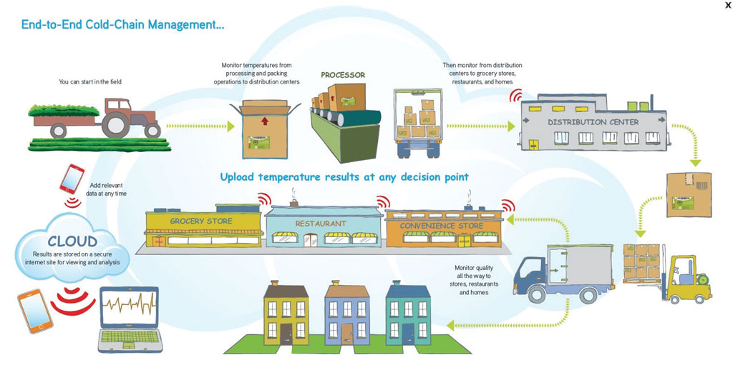
Figure 5: Modern Flow of Goods in Agriculture Logistics
Source: Developed Country Example. Xiangyang, Hubei is using cloud-based warehouse management system for peanut farming on a national scale. (ADB TA 9547 PRC, “Integrated Transportation and Logistics Planning and Strategic Study,” ADB, 2019-2020)

Management and organization analysis (SUpply Chain Finance)

Public or Private Business Models
- The PIE and owner, Guangxi Chongzuo City Industrial Development and Investment Group has the responsibility for ensuring the management and day to day operations of the Chongzuo Cold Storage facility and the packaging standard plant. The Project location is in the China-Thailand Chongzuo Comprehensive Industrial Development Zone with 143 enterprises. The feasibility of the Project depends on professional management and operations of the cold storage facility. The selection of the information systems provider is by the owner and or by the management and operations company. There are three business models for consideration by the Guangxi Chongzuo City Industrial Development and Investment Group.

Private Company
- Many public cold storage facilities are operated by private companies. In the United States, Lineage Logistics, Americold Logistics (with China Merchants in PRC) and U.S. Cold Storage are the main companies. JD.com cold chain is one PRC company that could be approached. These companies have established processes, operation plans, accounting procedures (financial statements) and necessary certifications to meet compliance regulations. An established operator could provide the needed investments sought by ADB to absorb short-term start-up costs and market demand fluctuations of operations better than the PIE. A clearer market demand profile of customers would be a good marketing tool to attract a private company.
- A single mode/investor operator is one possible private company business model. However, would not be suitable if the market demand is for smallholder farmers. A single mode investor/operator would, in effect, control the whole fresh produce supply chain, from ‘farm gate’ to ‘plate,’ in the same manner of major retailers in the US or UK (e.g., Walmart or Tesco). This creates a composite food supply chain system that uses its own vehicles, own warehouses, and ultimately has its own farms and supplies its own retail outlets. There are similar retailers in the PRC and perhaps Chongzuo that could operate and manage in this business model.
- The single mode operator poses the following risks:
- A single mode system aims to generate a commodity volume base rather than small diverse loads
- A single mode system would remove the all-important price-setting function of the markets (and its many growers/producers) and thus affect sub regional price variances
- A single mode system is a high risk for food security (i.e., continuity of supply and contamination).
- Advantages of the single mode system include:
- Efficiencies (process and financial) through standardization of the food supply chain platform
- A simpler process for importing and implementing food safety legislation and quality controls, and maintaining the relevant food safety, traceability, and logistics accreditations
- More efficient communication and transfer of customer trends/requirements and therefore crop and produce production within the farming base.

Landlord-Management/Investor and Tenant -Business Occupiers Structure
- This business model is traditional in areas worldwide for agriculture commodities and serves the public good. This model would be possible for Chongzuo since there are 143 occupiers in the Industrial Park and there are wholesale markets in the area needing to modernize to refrigerated capacity and services. This model will need an experienced cold logistics management company as the landlord.

Public Private Partnership
- This is a variation of the landlord-tenant model where long-term occupiers invest in infrastructure and have a more active role in management of the Project facilities. This model can take on the form of a limited liability company or a joint venture where the former public landlords want to transfer management and ownership of the facility or reduce the operating costs from the public budget. This business model would require proper legislation and institutional mechanism in place which may not be feasible at this stage of the Project as an investment structure. The transfer of ownership to a private entity could come at a later stage when the operations are proven profitable.
- Based on this analysis, the recommended feasible business model is for the private company with the cold storage experiences to manage and operate the Chongzuo cold storage and attendant factory building. Apportioning the risks will need to be considered between the owner and the operator management company. Private operator expertise would include the needed personnel of 6-8 full and part time employees with annual salaries slightly below the facility manager dedicating 75% of their time to operations and 25% to administration. All personnel need to have forklift experience as well as inventory control, cycle counts, product rotation, customer service and computer skills. See Appendix for sample job descriptions.

Warehouse Receipt Pledge Finance System (Basis for Payment)
- The DI FSR report introduced the “warehouse receipt pledge” supply chain finance concept for improving agriculture value chains in Chongzuo through the ADB supported Chongzuo Cold Chain Logistics Demonstration Project (Chapter 2.4.6) The concept and practice of warehouse receipt finance system involves proper legislation and institutional arrangements. These include commodity management for quality control and marketing; logistics management; electronic automation of processes away from time consuming paper documents; trust among all the stakeholders and swift inventory turnovers of perishable agriculture products to buyers.
- There are many variations on the basic warehouse receipt model as there are many different agriculture value chain financing mechanisms. The objective is to improve the cash flows and working capital of small holder farmers and small and medium sized enterprises (SME). There is a wealth of information on the warehouse receipt system over many years of practice in developing countries worldwide with the support of multilateral banking institutions such as ADB.
- Most practices are for non-perishable commodities where there is less risk of spoilage of the stored commodities. For example, grains can be stored during harvest season when supplies are higher and pricing is lower, and wait for selling when prices are favorable later in the season. The commodities in Chongzuo such as livestock, meats, specialty fruits, nuts, vegetables, aqua products and possibly dairy have a shorter window of opportunity. Therefore, understanding the market is very important.
- The basic concept of warehouse receipt financing is depicted in Figure 6 as follows:
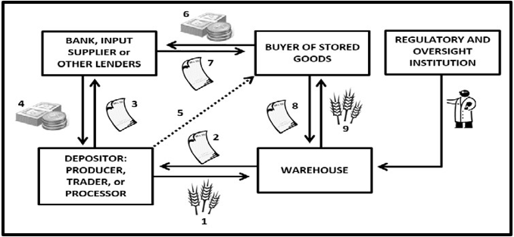
Figure 6: Basic Concept of Warehouse Receipt Finance
Source: “Designing Warehouse Receipt Legislation,” Food and Agriculture Organization of the United Nations, Investment Center, Rome, 2015, pg. 1.

1 The farmer or other agriculture producer deposits their goods in the warehouse
2 The warehouse issues a receipt to the producer
3 Producer uses the receipt as collateral
4 Obtains a loan from a bank or other financial intermediary
5 The loan is for a specific percentage market value of the goods in storage based on risk assessed by the lender
6 The producer sells the stored goods underlying the value of the receipt (higher price)
7 Depending on the contract the buyer pays the creditor directly or pays the producer who pays the creditor. Upon loan repayment the creditor returns the warehouse receipt
8 Allow the buyer to go to the warehouse to present the receipt and
9 Retrieve the bought goods.
- The success of the SMEs and smallholder Chongzuo farmers depends on them consolidating their perishable products in the refrigerated warehouse and sell jointly for higher prices to larger traders or processors further down the value chain. However, there is risk involved with perishable products over more stable agriculture products. Therefore, the farmers will rely on marketing groups (commodity management) to meet quality standards for reliable buyers.
- Quality standards are enhanced by the commodity management services offered by the licensed refrigerated warehouse management group. Postharvest handling and storage involve cleaning, drying, grading, packaging, storing and preserving the products’ quality for selling later at a higher price. Producers will also rely on warehouse regulations that guarantee accurate weighing and quality grading to ensure that their products are accurately valued.
- The success of the warehouse receipt system depends on the smallholder farmers and SME foreign traders to work with cooperatives since the costs are so high for the smallholder alone to bear along the agriculture value chain. There is a speculative issue to confront, if the stored perishable commodities’ prices do not rise prior to the selling of the products. “Prices must rise sufficiently to cover the costs of storing and maintaining the commodity in the warehouse, including the costs of security, insurance, quality control, utilities, and rental of warehouse space. Prices must also rise sufficiently to cover a host of transaction costs incurred upon depositing the commodity in, and withdrawing it from, the warehouse, including the costs of grading, cleaning, drying and bagging the commodity to meet legislated quality standards required for the issue of a warehouse receipt.” This Project needs to consider the transaction costs and the allocation of risks associated with the warehouse receipt finance system. The higher premium specialty fruits and nuts could pilot test the warehouse receipt system in the Chongzuo subproject 3.
- The transaction costs of warehouse receipt financing could be reduced in many ways. Among them are electronic registration of warehouse receipts (EWR); modern warehouses as proposed by this Project and improvements in commercial infrastructure such as refrigerated trucks. A more comprehensive approach to the warehouse receipt system is suggested to improve the FSR. Also, would benefit the Project to automate (paperless) the warehouse receipt system in a module on the proposed multimodal logistics platform information system to reduce costs.
- For the specific warehouse receipts collateral (WRC) financing, the cargo owner enterprises store their goods in the core logistics or warehouse enterprises. The core logistics enterprises supervise commodities for the cargo owners by virtue of the warehouse issued electronic storage vouchers or receipts to the bank or other financial institutions as collateral to apply for loans. Those banks value the goods and provide a certain proportion of the loan or financing credit to relevant enterprise. With the help of e-commerce or multi-mode transport logistics IT platform, the electronic warehouse receipts pledge realizes the online transactions between banks, core enterprises, logistics enterprises and agricultural products processing enterprises.
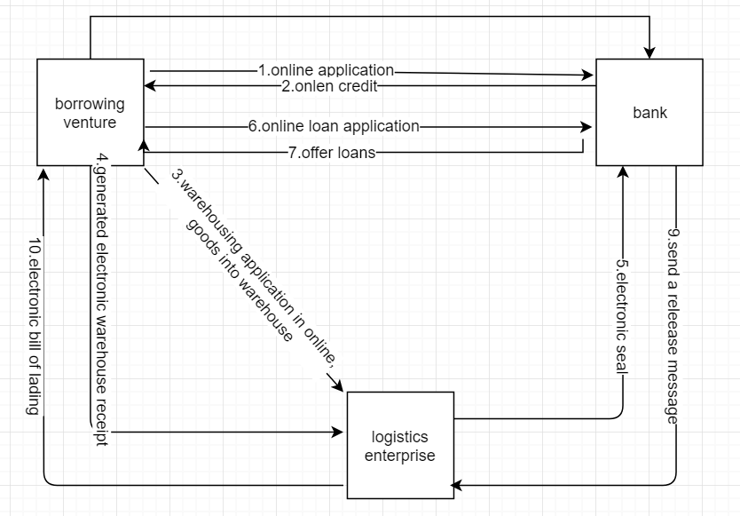
Figure 7: Electronic Automating the Warehouse Receipt Pledge
- Many listed companies in China stock market already have more distinctive characteristics of supply chain financial services. These include Yiyatong, Shengtun Mining, Rui Maotong, Shanghai Steel Union, Aijian shares and other representative listed companies. For example, Bank of Communications Jiaobohui e-commerce platform has joined enterprises that can enjoy the services of capital settlement and financing loans. In 2000, Bank of Communications first launched the warehouse receipt pledge loan business. Major domestic warehousing associations and enterprises include the China warehousing and distribution association with a sub- financial storage branch membership of 88 companies.
- Chongzuo city can launch the pilot warehouse pledge business for special storage of agricultural products. Under the guidance of Chongzuo Municipal Government, and its Financial Banking Regulatory Bureau, the captioned subproject owner, Chongzuo Zhong-Thai Industrial Park, and another suitable agency can lead the local agricultural development bank, rural credit unions or other interested financial institutions to launch and build a special storage of agricultural products. The pilot project in the first phase of credit could obtain a certain amount of about $14.9 -$29.8 million (1-200 million CNY) by warehouse receipts collateral financing on a stable and safe IT platform. In this way, the stakeholders could achieve the first large-scale local special agricultural products storage base which will allow the park enterprises to have more liquidity and working capital in order to carry out equipment updates and brand operations.
- For example, Chongzuo is known as China's largest nuts import production and processing base. The main cashew nuts trade accounted for more than 70% of cross border agriculture trade forming a local pillar industry and platform economy. At the Longzhou Shuikou cross-border port, the total volume of nuts imported each year is about 200,000 tons and the value is about $1,492.5 million (10 billion CNY). It is expected that by 2020, the annual import of nuts will exceed 400,000 tons and the processing output value can be $4,477.6 million (30 billion CNY).

Project Conceptual Design
- High-quality special agricultural products and other raw materials, if stored in the appropriate storage environment for a longer time, then their higher quality and other value add attributes from the warehouse operations will increase in value. Hence, these more valuable commodities will be suitable for financial operations and the establishment of this warehouse financial platform. Moreover, such an operation will attract a large amount of domestic funds to benefit the long-term development of Chongzuo cross-border agricultural product industry chain, the local economy and increase enterprise and individual incomes. The following conceptual design is suggested:
- Sound storage environment: This subproject plans to build a bonded warehouse and cold storage intelligent storage facilities to carry out Chongzuo City special agricultural products and commodities distribution. The pilot will select special agricultural products within a closed storage area of about 1-30,000 m². The subproject will need proven smart warehouse technologies with trained management that can automate processes with innovative technologies such as RFID tags on the special agriculture products stored in each box and/or on pallets. These new technologies will enhance labor productivity and reduce costs from growers’ fields to consumers with all information captured in the data available to all users along the agriculture value chain. This subproject can provide a standard storage demonstration model for special agricultural products.
- Quality service team: The supply chain finance component shall select a professional team from the mature manufacturing plants and enterprises with performances and experiences from excellent agricultural products, warehousing and the internet. As such, there can be better use of the proposed information technology model, actively integrate into the commerce of the region, provide an opportunity to reconstruct the business model, make full use of the mobile Internet's efficient linkages and provide the entire agriculture value chain with long-term strong online and offline professional operation and support.
- Local financial institutions: The Chongzuo agricultural development banks and rural credit union financial institutions are able to provide credit for the pilot project of $7.46 -$29.85 million (50-200 million CNY) while protecting the pilot project's entire financial flows, with assistance from their SCF banking professional team, IT system and e-commerce platform interfaces.
- The supply chain financial IT system adopts the concept of comprehensive risk-control and provides support for the borrower’s screenings and ratings through big data collection and analysis. As such, have big data analysis and decision-making for enterprises from multiple dimensions such as industry, core enterprises and trade quality, and automatically rate the borrowers. As a result, provide credit review before lending for risk identification and assessment and capital flow control during lending, automatically grading, and earlier warning and dynamic risk monitoring after lending. At the same time, the supply chain finance system can apply the most updated technologies such as block chain, software as a service (SaaS), financial service open platform, micro-service and so on.

Warehouse Receipt System (WRS)
- The pilot project, with help from ADB’s loan, provides the hardware and software facilities and even domestic working capital for WRS in the context of cross-border real trade in the agricultural industry chain. The pilot SCF may, along full closed and integrated industry chain, include domestic or overseas accessible production base; cross-border transport through train or truck; region of origin traceability and customs clearance; cold storage warehouse access and control; and cold chain logistics multimodal transport to downstream destinations of customers.
- Institutional arrangements will be necessary to the success of this subproject and pilot projects. The public and private sector business and government officials will need to organize and meet on a regular basis with agendas at each meeting. By a transparent membership participated system, it may involve the stakeholders of ADB, government, commercial banks, state-owned storage and transportation platform companies, trade associations, internal and external credit rating agencies, insurance institutions and enterprise customers. The WRS pilot can be implemented in phases at first. Specific contents include:
- Specific long-term models of ADB’s support include special financial intermediary loans (FIL) for storage hardware and software equipment, offline and online support for comprehensive technical advisory services contracts, and requirements for output and monitoring indicators for multi-batch projects.
- Study property law, security law, contract law, relevant judicial interpretation, the provisions of credit rating by People’s Bank and other relevant regulations and supporting polices issued by Ministries (e.g. industry financing without a license under banking supervision policy).
- Research local relevant government strategy and planning, including building brand pillar industries, business environment, free trade and cross-border trade, poverty alleviation and other related aspects; and agricultural product quality supervision, food safety, SPS inspection and quarantine, standard control, origin identification, brand promotion and marketing
- Understand the needs and current situation and foundation of local industrial well-known top enterprises and SMEs. Especially, the real trade background and prospects of storage-resistant agricultural products. As well as, the core enterprises and all participants along industrial chain upstream and downstream, and professional teams and their sector association.
- Research similar and successful operated relevant IT systems, including risk-controlled e-warehousing & distribution systems, SFC systems, and bank transaction public registration IT systems, multi-mode transport logistics, commodity traceability, cross-border customs clearance and technologies of GPS or Bedou, block-chain, internet of things and insurance intervention.
- According to the research results, set the pilot volumes of warehouse collateral based on real quantitative trade volume and determine the number of container trucks, warehouse capacity, equipment needs, etc. in closed cycle.
- Study and understanding relevant production and sales side market feedback information, specific commodity listing or bidding price information from acquisition of specific agricultural products by farmers' cooperatives. Also, understand sorting and packaging of origin, refrigeration preservation, storage and transportation, primary processing to establish gradually cross-border or regional agricultural product price forming information center in the long run.
- Research the introduction of international operations management resources and talent team and strive for more public–private concessions or corporations especially banks and state-owned enterprises (SOE).
- Research and further improve the storage and transportation hardware and financial services infrastructure, especially warehouse logistics system, optimize the business environment and build value chain product quality and brands.
- Research and enhance the willingness and ability of the core logistics storage enterprises in the park, assist in applying for more SCF opportunities based on high-quality facilities and excellent collateral assets,
- Research and encourage financial institution’s provision and integration of their existing supply chain financial systems, and strengthen their involvement in pilot SCF like payment settlement, supplement collateral and credit, and assistance on legal services, risk control like linkage between stored cargos and loans, client rating and screening, trade repurchase contract, mandatory closing, margin mechanism design. The financial institutions include commercial banks, agricultural risk funds, agricultural insurance and re-guarantee and other supporting policy mechanisms.
- Raise awareness of project implementation and supervision units and carry out institutional and capacity-building to promote inter-agency coordination like workshops and seminars. Organize site visits and study tours on experiences of similar successful projects.

- Other Suggested Basis for Payment (Developed Country Examples)
- Paying by pallet for food and agriculture companies (rates by 7 days and for 14 days)
- Combination of weight and pallet, by weight, square foot
- Fixed base, then per pound charge
- Per box, per container and by bin
- Some food and agriculture companies are paying handling fees and fees for in and out as well as fees for monthly storage that sits.
- By commodity and temperature control (chilled, frozen, ambient, blast freeze)

List of Services
- Services offerings will need to be clearly defined for the feasibility of the Project. These services could be more enhanced after selection of the operations and management company in order to attract customers needing for the revenue. Developed country private cold storage logistics companies have a website defining their services. Some of these services are:
- Chilled and frozen warehousing
- Managed dry warehousing
- Leased food processing facilities
- Freezing services and ice sales
- Rail Services

Sample from Website:
Our freezing infrastructure includes multiple refrigeration engine rooms that support a variety of blast, plate and spiral freezers several IQF freezing belts, and intensive fan/room freezing. BCS also supplies ammonia to our in-house customers, supporting their freezing equipment by utilizing our engine room’s capacity. This service saves them the cost of building, maintaining and staffing their own systems and nearly eliminates the regulatory compliance burden for our in-house processing customers.
- Ammonia supply to tenants’ contact freezers
- 17 individual IQF blast cells with over 400,000 pounds of total freezing capacity
- A Frigo Scandia IQF seafood freezing tunnel — over 150,000 pounds per day
- An IQF raspberry belt freezer (follows inline tenant liquid nitrogen freezer) — 100,000 pounds per day
- -20 F high air velocity warehouse freezing areas for large volume drum, pale, rack, case or tote freezing

- Information system platforms are vital to the feasibility of the Project. Cold storage companies offer inventory and shipping information to customers in real-time on a 24/7 basis. The company has a proprietary IT system platform built by internal software personnel:
- Inventory tracking by downloading reports for products stored in the warehouse
- On-line form for submitting inspection instructions
- Reports of lot detail and product history, with running balances on pallet level detail
- Printable documents: bill of lading, warehouse receipts, invoices, delivery tickets
- On-line management of export and domestic shipping orders, packing instructions.

- Some other service offerings to consider:
- Storage in various temperature ranges – chilled, frozen and ambient
- Handling of pallets, cartons, bins, drums, trays, crates.
- Cross docking / flow through of both pallets and cartons/crates
- Picking of full pallet, full carton/crate
- Container unloading/loading – 20 foot and 40 foot
- Export load out and documentation
- Rebranding/labelling as and when required
- Repackaging of goods
- Consolidation
- Weighing/sorting and Grading/sizing
- Picking and Packing
- Palletizing
- Quality Assurance (QA)

Engineering and Technical Analysis (IT Systems: WMS/TMS, cross-border)

Cold Storage Design Improvements, “Analysis and Comparison of Different Technical Designs” and “Lessons Learned from International Practices”
- There are numerous suggestions for improving the FSR in the design of the proposed Cold Chain project. The market demand profile determines more specifics based on the types of customers, their agriculture products moving through the facility, their volumes, values and various customer specifications as to packaging, labeling and traceability which is important for cross border trading. The most important question for designing and constructing is to answer: What is the customer problem? Also, how will the 7,480 m² packaging plant operations relate to the main cold storage facility?
- Suggested design improvements from developed country design and build enterprises:
- Palletization program, automated storage and retrieval system (ASRS), crane system/racking system for how many pallet positions? Distribution center with order fulfillment pallet building system, use of robots to automate workflows.
- Intralogistics is work-flows of moving product within the building from receiving to ship dock.
- Floor area width of aisles for fork-lift operations and racks with adequate high ceiling
- Automated conveyances
- Standards: Facility built to Global Food Safety Initiative (GFSI), SQF certified (checklist). LEED certification. The DI FSR has a good list of standards. Consultations with developed country design and build companies underscores the importance of standards that should be used in developing drawings in a cold storage building.
- Dock Doors/Truck Bays with curtains

Photo 1: Modern Design Truck Bay with IT Systems (RFID/Readers)
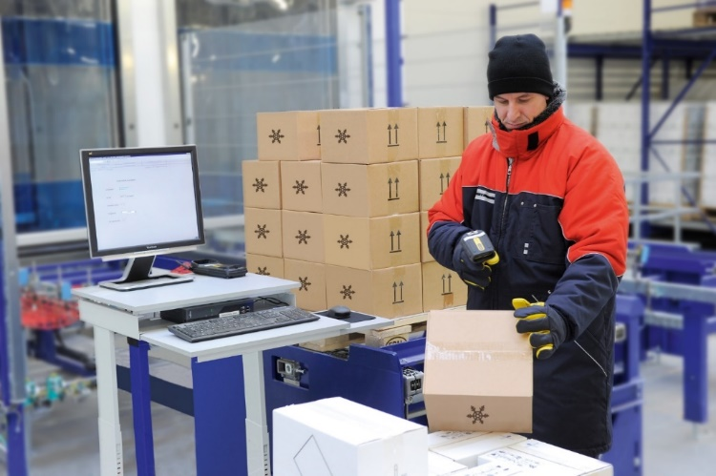
Source: foodlogistics.com
- Thermal Seals: walls, under flooring, roofing, vapor barriers, passage doors to keep right temperatures
- Banana Ripening Rooms (various refrigerants with gas an important variable)
- Automated Material Handling System
- Refrigerants and Blast Freezing Area (product blast cell) reduce ammonia with carbon dioxide for improving safety by using 30 percent less energy. (developed country case can be presented)
- T5 Energy efficient lights, freezers with LED lights
- Battery handling room for charging stations
- Truck parking areas outside in square meters (FSR indicates 26,467 sq m. yard area)
- Floor areas for food processing traffic movements to cold storage/freezer areas. (Have developed country company example of a chicken processing cold storage design with automated conveyance.)

Photo 2: Nuts Bulk Packaging on Pallets in Cold Storage
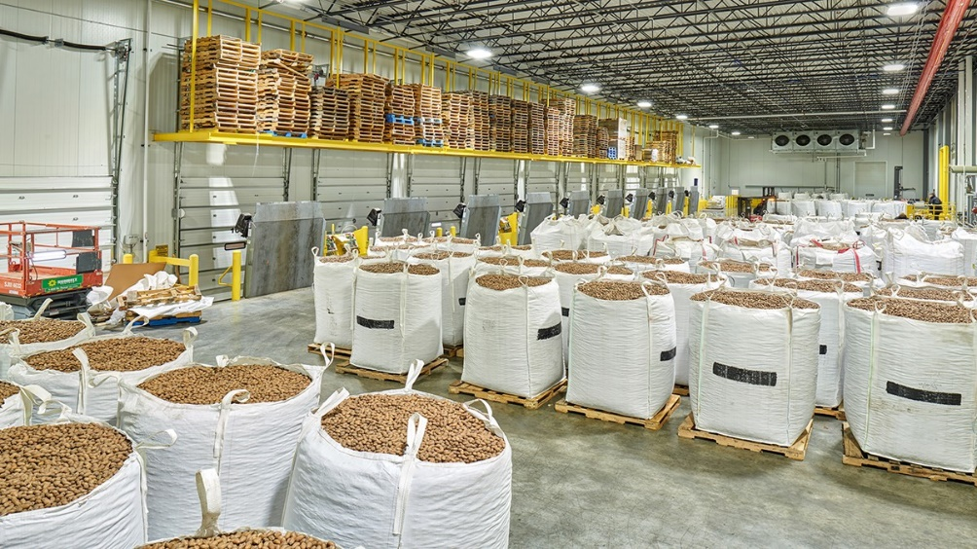
Source: Developed country cold storage design-build construction company
Photo 3: Nuts Racking System in Cold Storage
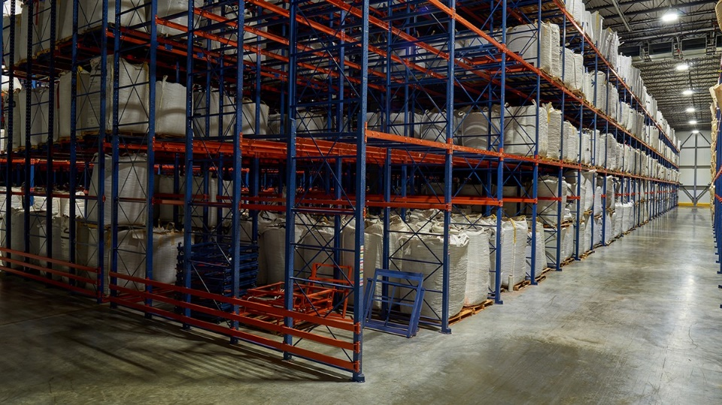
Source: Developed country cold storage design-build construction company

- The PIE and DI FSR introduces the multimodal logistics platform information system design. Clear understanding of the participants from business and government for ordering to fulfillment to payments by electronic paperless documents is essential as early as possible in the Project. The costs of the Project operations and the enhancement of services depend on the functioning multimodal logistics information system platform.
- Preliminary consultations occurred with JD.com cold chain logistics solutions. JD.com can be a useful reference and provide a benchmark of costs and for financial analysis information in the absence of a clear master plan for the information system platform and implementation strategy to date. Also, JD.com could work into the business models presented in this report in Chapter III, A. Public or Private Business Models.
- JD.com cold chain platform has a partner system which can provide connectivity to the Chongzuo Project and for the cold chain vehicles into their system for coordinated development. JD.com has a national network of regional distribution center warehouses which includes one in Nanning. JD.com began their network development in 2014. The platform uses their own temperature control monitoring in storage and in transit for real time evaluations. Cross border trade with Vietnam information system platform is possible and can be developed in partnership with JD.com cold chain, international business department.
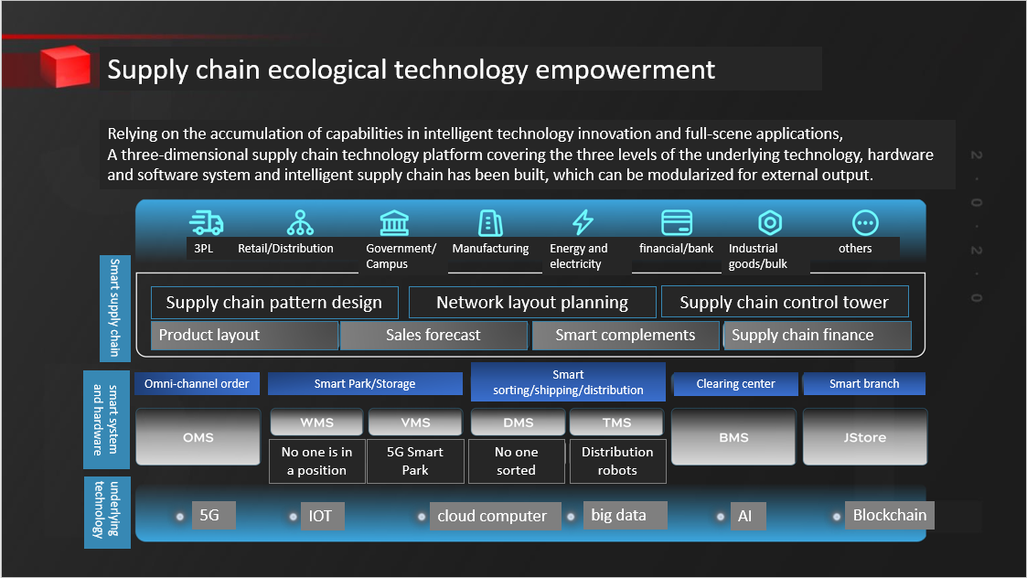
Figure 8: JD.com Cold Chain Supply Technology Platform Architecture
Source: “Cold Chain Supply Chain, the Path of Ecological Transformation Empowerment,” JD.com, 2019, PowerPoint, slide 20. (translated from Chinese language).

- Standards are also important to information system platforms and recommended for cross border and international trade for paperless transactions. The Digital Container Standards Association (DCSA), based in Amsterdam, is developing internet of things (IoT) standards for containers that will be important to Chongzuo using refrigerated containers and their interoperability for seamless cross border trading. “The standards release by DCSA is very important and complementary with the UN/CEFACT interoperability standards, namely the Multi Modal Transport Data Reference Model and the Smart Container Business Requirement.”
- Hence, the PIE, as owner, is recommended to select a management company that can begin working with an information system provider. The IT provider will develop the hardware and software for the multimodal platform such as warehouse management system (WMS) and supply chain finance modules. These modules will need testing prior to “live” production data and can be aligned with the schedules for the design and construction of the cold storage facility. The feasibility of this Project depends on a working IT platform. JD.com could be an important reference guide in the planning, implementing and operating of the IT multimodal platform and the packaging plant for the Chongzuo Project.

Environment Analysis (refrigerants: freon, ammonia, carbon dioxide, Cascade System)
- The purpose of this section is to improve the design institute’s feasibility study report and the PIE design plans as to the refrigeration process, related standards and institutions to implement refrigerant standards. Suggested revisions are to Chapter 1, Project Overview; Chapter 6, Engineering and Technical Solutions; Chapter 7, Energy Saving; and Chapter 8 Environmental. The use of freon (R-22) as a refrigerant is phasing-out worldwide and as of January 2020 production, import and consumption is banned in the United States. The PRC, Ministry of Environment has a policy on ozone depleting substances (ODS) and hydrocarbon management for banning chlorofluorocarbons (CFCs). The goal is to ensure sustainable reduction and elimination of prohibited processes, equipment and products of hydrochlorofluorocarbons (HCFCs) and transition to the production and use of low global warming potential (GWP) alternatives) that are climate friendly. These include natural refrigerants—hydrocarbons (HCs), ammonia (NH3) and carbon dioxide (CO2) and lower GWP hydrofluorocarbons (HFCs).
- Under the Montreal Protocol on “Substances that Deplete the Ozone Layer”, ratified by 197 United Nations Member States in 2009, there is a phasing-out of production and consumption of ODS of 100 industrial chemicals that include CFCs and HCFCs. Many transitional HCFCs have high GWP of up to 2000 times that of carbon dioxide. Both phased-out CFCs and the phasing-out of HCFC refrigerants had benign chemical characteristics of non-flammable, non-toxic and unreactive. Adoption of low-global warming potential and zero ozone depletion potential (ODP) alternative refrigerants together with their standards will result in energy savings and, especially improving the occupation, health and safety (OHS) of the operators in the Chongzuo Cold Chain Logistics facility. The Carbon Dioxide (CO2)/Ammonia (NH3) Cascade Refrigeration System is a suggested design option and solution for the PIE and DI to consider as described in this section of this report.
- The low GWP alternatives to HCFCs have properties such as flammability, toxicity and high working pressures which the HCFC and CFCs do not exhibit. These alternatives are natural refrigerants (used for decades before fluorocarbons)—hydrocarbons (HCs), ammonia (NH3) and carbon dioxide (CO2) and lower GWP HFCs both saturated HFCs (HFC-161 and HFC-152a) and unsaturated HFCs (also known as hydrofluoroolefins) or HFOs, e.g. HFC-1234yf, HFC-1234ze. As such, these alternatives to ODS require special training for handling. Moreover, equipment that operate with such refrigerants require a different approach for design, installation, servicing and operating which emphasizes safety. See the following tables.
Table 10: Examples of Zero ODS, Low GWP HCFC Alternatives
Natural Refrigerants | HCs (hydrocarbons)  Ammonia  CO₂ (Carbon dioxide) | e.g. R-290 (Propane),  R-600a (Isobutane),  R-1270 (propene)  R-717  R-744
Synthetic HFCs | Saturated HFCs  Unsaturated HFCs (known  as “hydrofluoroolefins” or “HFOs”) | e.g., R-161, R-152a  e.g. R-1234yf, R-1234ze
Source: UNEP

Table 11: Characteristics to Alternatives to ODS
Refrigerant | Natural Refrigerants |  |  | Synthetic HFCs
 | HCs | Ammonia | CO₂ | Saturated HFCs | Unsaturated HFCs (HFOs)
GWP(100 years) | ++ | ++ | ++ | --* | ++
Flammability | -- | - | ++ | ++* | -
Toxicity | ++ | -- | + | ++ | ++
Pressure | + | + | -- | + | +
Availability | + | + | + | ++* | --
Familiarity | + | + | - | ++ | -
(++ is very positive, + is positive, - is negative, -- is very negative
* This refers to conventional, widely used HFCs such as R-134a, R-404A, R-407A, R-410A, etc. Some saturated HFCs such as R-161 and R-152a have low GWPs, are flammable, and may not be as easily available as the common HFCs.)

- This subproject has supply issues with the availability, affordability and safety of alternatives to freon. National consultants and the DI reveal that “it is certainly desirable to use the least GWP refrigerant for the Chongzuo Project but need to understand the current state of the cold warehouse construction in China. Refrigerants will be refilled and there are leakages. So, the need to assess feasibility of using refrigerants based on cost and accessibility in China supplier markets.”
- It is advised to consider the two cold storage warehouses in the Baise agriculture processing project with each design of 1,000 m² for the sake of volume discounts in the sourcing and procuring of refrigerants. The IA and DI are considering R507 refrigerant as an alternative to freon R22. R507 has an ODP value of zero and does not contain ozone depleting substances. However, the national climate change specialist informs that R507 and R404A are to be phased out. “From 2020, R404A and R507 will be completely banned from stationary refrigeration systems which have a charge greater than 10 kilograms.”
- There is the possibility of blending the refrigerant components to reach ODP zero. These could be refrigerant R404A composed of R125/R143a/R134a at 44%, 52% and 4%, respectively and R507 composed of R125 and R143a by 50% and 50%, respectively. The R507 includes two components of the three components of R404a. The ODP to these two refrigerants is zero. R507 is widely used in China. Further consultation on the alternative refrigerants could be conducted with the Nanning Zhuang Ning Food Refrigeration Co., Ltd., subordinate to Nanning Industrial Investment Group Co., Ltd. and one of the eight industrial groups of Nanning municipality government, or perhaps JD.com cold chain in Guangxi that operates a distribution center in Nanning.
- Investigation also found that RS-22 is a non-ozone depleting near azeotropic refrigerant blend which can replace R22, R502 and interim ozone depleting blends (R402A, R403B, R408A, etc.) without the need to change the existing lubricant or make any changes to the system. The above revision is to the FSR Chapter 6.1.4.2, Refrigeration Process, “freon gas, liquid.” Further issues are discussed in detail below.
- The DI cautions on the use of carbon dioxide as a refrigerant in China. It requires highly professional operations and maintenance personnel. The pressure of CO2 refrigeration is high with potential for valve leaks and explosion causing safety of life dangers for operators. There is limited application and high construction investment costs.
- At present, ammonia refrigerant, NH3 is mainstream in large and medium sized cold storage in the PRC and abroad. When evaporation temperature is above -35 ⁰C, ammonia refrigerant is the most energy saving for compression refrigeration. The key issue is safety. In the development trend of refrigeration, CO2 systems are becoming the focus of a new generation of refrigerants. However, ammonia as a primary refrigerant combined with CO2 as a secondary refrigerant offers unique advantages in the Carbon Dioxide/Ammonia Cascade System option. Recent site visits in Chongzuo determined that a cold storage refrigerant used is liquid ammonia and that ammonia used instead of ethylene glycol as a refrigerant can reduce energy consumption of the system.
- One feasible option for the Chongzuo Project is to use the Carbon Dioxide/Ammonia Cascade System. Ammonia is used in the PRC for over 60 years for industrial refrigeration in processes, cold storage, sports facilities, power plants and agriculture processes and are gaining popularity for the Cascade system since 2013 in China. Today, more than 30,000 end users have ammonia in China with over 150 refrigeration cascade projects in the industrial sector for increased focus on safety and energy efficiency. In addition, NH3/CO2 systems are built and operating in Southeast Asia on the order of 14 in Indonesia, 11 in Thailand and 4 in Vietnam.
- The state-of-the-art CO2/NH3 Cascade refrigerant system reduces the NH3 charge below 10,000 pounds with only CO2 present in the processing or storage areas. A constant positive pressure in the Cascade system always operates in a positive pressure. So, there is a minimal concern for non-condensable build-up and air as moisture cannot invade the refrigeration piping through vacuum leaks. Leakage is a concern based on FSR and consultations with the DI. CO2 absorbs the heat and changes the state for energy savings of 20-30% of traditional NH3 systems. This can be effective for the Chongzuo Project, if blast freezing is a service offering and optimizes safety for both warehouse workers and the perishable products which in this subproject are mainly specialty fruits.
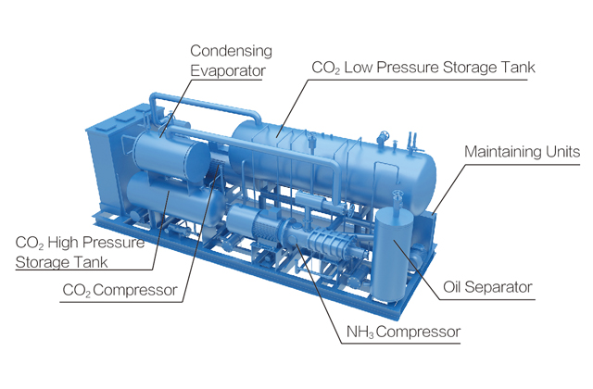
Figure 9: Carbon Dioxide/Ammonia Cascade System Equipment
Source: snowkey.id
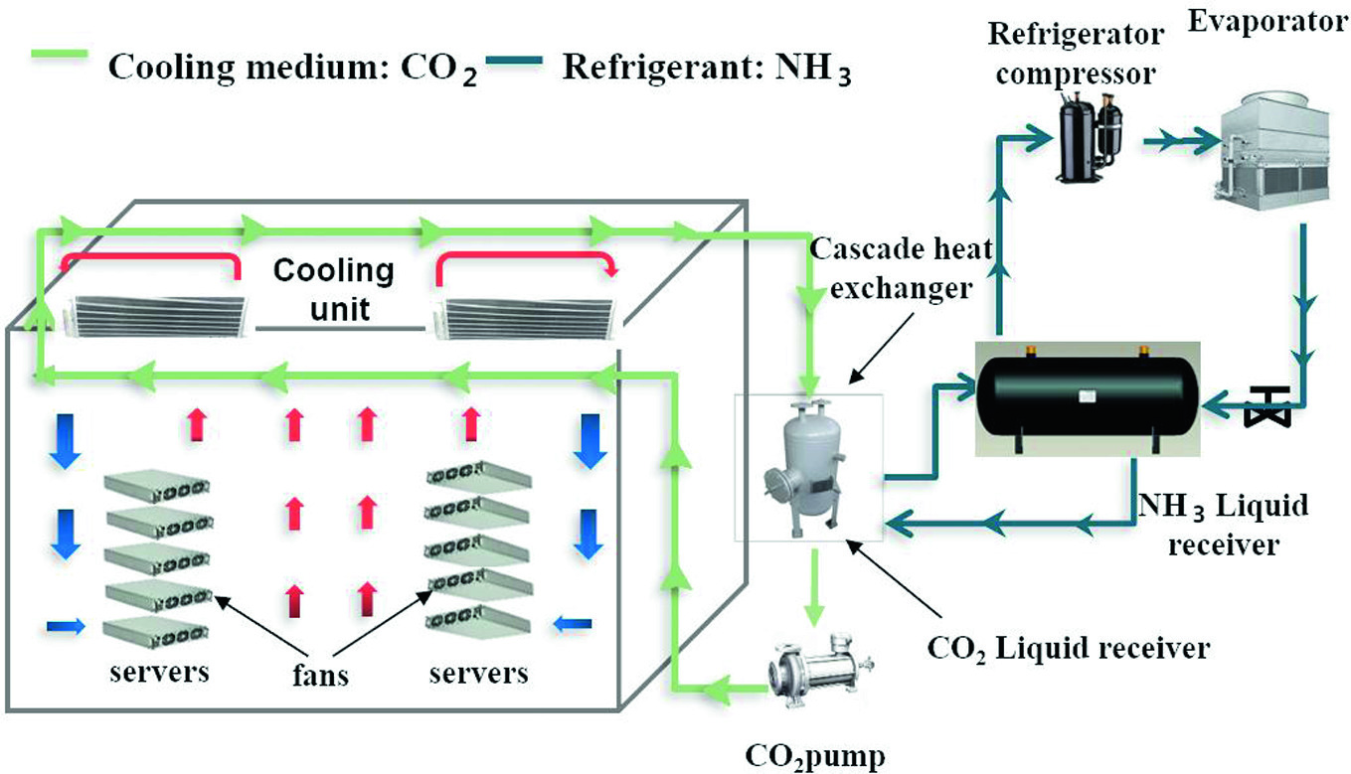
Figure 10: Technical Diagram of Carbon Dioxide/Ammonia Cascade System
- The Cascade system uses CO2 as a secondary refrigerant and has the advantage in that CO2 is non-toxic, non-flammable and less likely to damage food products, if there is release. Some benefits to plant owners:
- Lower operating costs by using less energy per ton of refrigeration than a typical two-stage ammonia system operating at evaporating temperatures of -35 degrees Fahrenheit to -60 degrees Fahrenheit. This could offset investment costs concerns over the life of the Project.
- Lower capital costs using CO2 instead of ammonia takes advantage of CO2 unique physical properties resulting in smaller pipes, smaller pumps, less insulation, and less installation labor as compared to two-stage ammonia systems.
- Quality and throughput improvements by making lower temperatures more practical. Low temperatures result in faster freezing, which optimizes food quality and enables increased food throughput.
- Environmentally Friendly: ODP is zero. GWP is one.
The above issues can be used to improve the FSR, Chapter 7, Energy Saving.
- The DI and the FSR could improve on the application of standards related to refrigerants (Chapter 1, Project Overview). This is especially important since there seems to be outdated CO2 methods and concerns for leakages. Standards are established at the international, national and need to be implemented at the local levels with the appropriate institutional mechanisms. In effect, Chongzuo’s cold storage design depends on adequate institutional design for proper refrigerants standards which are always being updated and need to be kept current at the build, operate and maintenance stages of the project.
- Standards are norms and adopting new standards shows technological progress. “Standards are useful to the HCFC phase-out, especially to cover the various aspects of the equipment, chemicals and servicing to ensure quality, efficiency and safety.” The FSR, Chapter 1, Project Overview lists national standards (Guo Biao) which could be improved to include standards specific to refrigerants in details. Suggested details are listed below.
- Consultations found that Chongzuo stakeholders could confront issues of leakages of refrigerants and outdated CO2 methods. These issues could be rectified by closer adherence and adoption of standards. Guidance is recommended from the United Nations Environment Program, Division of Technology, Industry and Economy, Ozone Action Program. The Ozone Action Branch assists developing countries comply with commitments under the Montreal Protocol as “Substances that Deplete the Ozone Layer”, especially HCFCs.
- By definition, standard is a formal document developed by experts to ensure a certain uniform level of products and services. Refrigerant standards can provide the framework as to how alternative refrigerants can be adopted with low disruption, especially for safe handling and preventing hazards. Consultations can provide guidance to stakeholders prior to adoption of a standard to make sure the PRC existing standards are amended.
- One mechanism to stay current on the phasing-out of ODS is by a national ozone unit (NOU) which could be delegated by the PIE for the Chongzuo Project. The NOU needs to understand standards and how to adopt standards and dialogue with the standardization bodies to fit the local situation. Ozone Action assists the country NOUs to raise awareness of the standardization process to phase-out HCFCs with non-ozone depleting, low GWP energy-efficient alternatives. Capacity building is part of the process at the national level and implemented at the local Chongzuo level. “Participation in the international standardization organizations requires considerable resources both in terms of personnel and cost.” The national body in the PRC is the Standardization Administration of China (www.sac.gov.cn).
- The scope of the refrigerant standards is safety for design and construction and installations of refrigerant systems; performance for efficiencies of systems and equipment; best practices; and quality for training and certification. The UN Environment Program (UNEP) found that developing countries have barriers to overcome in adopting low GWP refrigerants such as:
- Time consuming;
- lack of awareness;
- different requirements;
- lack of institutional bodies; and
- lack of formal connections to international bodies of standards or lack of cooperation with relevant national institutions and costs of adopting standards.

- Overcoming these barriers by designing an institutional mechanism such as a local ozone unit will realize the benefits of standards:
- Ensures safety considerations of products, people, production, and use
- Enables dissemination and harmonization of best practices
- Can minimize technical barriers to trade (Vietnam-ASEAN cross-border)

- The following list of existing standards related to the ozone depleting substances can be added to the FSR and considered by the PIE in the context of PRC national standards (GB):
- Standards for the substance specifications for refrigerant gas and refrigerant designation (ISO 817)
- Standards for systems, equipment and components-safety requirements for refrigeration equipment, codes/guides for refrigeration and air conditioning systems (ISO 5149) and refrigerant recovery/recycling equipment (IEC 60335-2-104 and equipment charge size.
- Standards for refrigerant containers-content of recovery cylinders (AHRI), color codes and pressurized cylinder standards.
- Other related standards such as foam final products, content and fire-retardant requirements, buildings codes (which could prohibit the use of flammable refrigerants), energy efficient labelling programs, installations and practice
- Refrigerant Properties-ISO 17584: 2005
  - specifies thermophysical properties of several commonly used refrigerants and refrigerant blends
  - applicable refrigerants R-12, R-22, R-32, R-123, R-125, R-134a, R-152a, R-717 (ammonia), R-744 (carbon dioxide) and to the refrigerant blends R-404A, R-407C, R-410A and R-507.
  - Includes specifications of several properties, including the following: density, pressure, internal energy (total energy contained by a thermodynamic system), enthalpy, entropy, heat capacity at constant pressure, heat capacity at constant volume, speed of sound and the Joule-Thomson coefficient.
- ISO 11650:1999 Performance of refrigerant recovery and/or recycling equipment
- The main international regulatory standards organizations are:
- IEC, International Electrotechnical Commission
- ISO, International Organization of Standardization
- CEN, European Committee for Standardization
- CENELEC, European Committee for Electrotechnical Standardization

- In 2019, ADB Shaanxi Transport and Logistics Port, TA 9613 PRC discussed the environmental impact of refrigerants for green-house gas emissions (GHG). One logistics company suggested the use of ammonia as a refrigerant which is better for the environment than freon. However, ammonia is difficult to receive approvals since needs highly skilled management and serious accidents occurred already from ammonia’s volatile properties and would be unsuitable for truck trailers. Freon has easy approvals and hazardous to the environment. Carbon dioxide is a new technology for cold warehouses and could be explored in more detail with other eco-friendly initiatives for the Chongzuo Project as illustrated above. There is a strong link to training and capacity building in the use of modern refrigerants that are less harmful to the environment.
- There is a need to understand more about the state of refrigerant production of China. Moreover, international standards need to be a basis for the refrigerant in the Chongzuo Project. Developed country design and build examples as introduced in Chapter IV, Engineering and Technical Analysis are for refrigerants in banana ripening rooms (viii) and reduce ammonia with carbon dioxide (x) and are discussed in more details above in this Chapter.
- Finally, there are several energy-efficient and climate friendly refrigeration technologies available which could be adopted for the Chongzuo Project. All such energy efficient technologies and practices can reduce up to 20-50% of energy consumption. Some of the state-of-the-art, energy-efficient cooling and storage technologies that could be considered for selection:
- Variable speed compressors: Standard fixed speed compressors work by monitoring the temperature of the fridge and reacting to it; they switch on when the temperature is becoming too high and switch off when the refrigeration unit is at its optimum temperature. However, this on/off operation consumes a lot of energy and costs more to run over the year. Variable speed compressors constantly regulate the temperature of the refrigeration unit which uses considerably less energy.
- Electronically Commutated (EC) fan motors: The variable speed fan motors can be set to the Cold storages’ specification so that they can decide when the fan motors work the hardest – and when they can take a break. This means that the fan motors can run at a considerably lower speed when the cold storage is not packed to capacity and the temperature will be maintained without the high cost of a powerful system running every hour of the day.
- Microchannel condensers: They use much smaller tubing than standard condensers so that less refrigerant is needed to keep the system running. This means that less energy is needed to pump the refrigerant through the cooling system and so a reduction in energy consumption means a saving in energy costs. Also, these condensers allow for the use of hydrocarbons (low GWP refrigerants) as the amount of refrigerant needed to run the system is low enough that it can run solely on hydrocarbons.
- Building Energy Management Systems to control and monitor the refrigeration unit’s energy usage as well as the energy usage of other systems. This would include measures like installation of occupancy sensors in intermittently used areas to cut lighting energy by up to 75%.
- Use of electric lift trucks for usage within the cold storage/warehouse

Photo 4: BYD Emission-Free Electric 3 Wheel Forklift
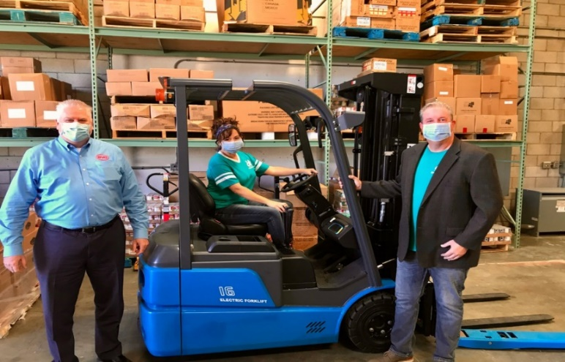
- Photo 4 shows a BYD emission-free electric ECB16 three-wheel forklift with an 110V wall charger. BYD forklifts and their reliable iron phosphate battery chemistry are the first anywhere in the world that can utilize 110V AC charging. No special equipment or installations are required.

Conclusion
- The customer market demand data is important to the feasibility study of this Project. Markets data shows the exact volumes of each of the product categories and by customers, microeconomic, firm-level (anonymous) for adequate planning of operations for inspections, temperatures, sorting, processing, packaging, labeling, handling in the cold storage space and the subsequent refrigerated transport to customers. A survey questionnaire of the widest number of users could offer more information during this transaction technical assistance. The commodity categories needing more details are fresh and dried fruits and nuts, meat products, aqua products and perhaps dairy products. The DI is preparing revised market demand data for further review.
- This report through the chapters on market analysis, operational analysis, management/organizational analysis, engineering/technical analysis and environmental analysis addresses concerns from the “Supplementary Document 3” about:
- Analysis and comparison of different technical designs
- Technical and economic viability
- Lessons learned from international practices and previous ADB-financed projects
- Operation and maintenance considerations

- An improvement could be made by listing all the cooperative enterprises, perhaps in a table, rather that cited separately in the text of the FSR, since cooperative enterprises will be important customers in terms of revenues, volumes, especially for inventory turnovers and for supply chain finance and payment mechanisms.
- The PIE, as owner, is recommended to select a management company that can begin working with an information system provider. The IT provider will develop the hardware and software for the multimodal platform such as warehouse management system (WMS) and supply chain finance, warehouse receipt system (WRS) modules.
- Environmental and safety issues are important and can be further enhanced in the DI FSR as described in this report. Refrigerants such as ammonia are difficult to receive approvals since needs highly skilled management and serious accidents occurred already from ammonia’s volatile properties. However, ammonia is available in many applications in China. Freon has easy approvals and is hazardous to the environment and is phasing-out in China and worldwide. Carbon dioxide is a new technology for cold warehouses and could be explored in more details as illustrated in this report by the CO2/NH3 Cascade System. Adopting the standards for phasing out CFCs and HCFCs with national and local ozone units as an institutional mechanism is recommended. Finally, other eco-friendly initiatives are listed for the Chongzuo Project across the 39,691 m² facility and the accompanying 7,480 m² packaging plant.

APPENDIX 1 Sample Job Descriptions
Job Descriptions for Cold Storage Warehouse (Developed Country Examples)-Training
Example 1: Lineage Logistics
At Lineage Logistics, our six values help guide how we behave and define what we hold most important: Safe, Trust, Respect, Innovation, Bold, Servant Leadership. We all play a position that is key to the company’s success. Join our Logistics team that is growing both domestically and internationally.
Lineage Logistics is currently seeking a Senior Manager, Logistics to join the team. As the Senior Manager, Logistics, you will be responsible for leading a team of logistics supervisors in the day to day transportation management and customer service for less than truckload and truckload temperature control shipments across North America. Additionally, the Senior Manager, Logistics is also responsible for operational performance and financial metrics, as well as supporting integration of new customers in pursuit of aggressive growth targets.
Position: Responsibilities of Senior Manager, Logistics
Lead a team of 4-5 supervisor with regional transportation responsibilities
- Develop staffing planning to support coverage 24 hours a day, 7 days a week
- Create and manage transportation operations productivity metrics to ensure efficiency in operations
- Support and monitor supervisors in the planning and coordination of multiple orders across several customers and locations daily
- Ensure compliance and completion of end to end transportation management process flow from order planning, tendering, track and trace and exception management
- Lead decision making on carrier alternatives and ensure freight is tendered based on cost and service requirements
- Lead interface with customer base to facilitate escalated problem resolution and improvement opportunities
- Manage carrier performance and recommend routing changes
- Manage internal and customer metrics and continuous improvement opportunities
- Work with cross-functional teams in sales, carrier management, engineering and warehouse operations to provide customer service, achieve growth targets and support continuous improvement efforts
- Ensure associate actions maximize profit margins while meeting customer requirements
- Lead creation, development and audit of standardized work instructions
- Support development and prioritization of employee training and development
- Establish performance objectives and review regularly with associates
- Support budget development and manage performance to budget
- Support Director of Logistics with key projects and initiatives
Required Qualifications of the Senior Manager, Logistics
- 3+ years’ experience in a shipper or transportation day to day shipment execution environment utilizing transportation management systems
- Ability to perform analytical carrier/shipment trade off evaluations
- Ability to multi-task across multiple activities, priorities and projects
- Excellent customer service, communication and leadership skills
- P&L Management experience
- Well versed in Microsoft office suite of products
About Lineage Logistics
Lineage Logistics is a warehousing and logistics partner committed to delivering sophisticated, customized, and dependable cold chain solutions to leading food, retail, agriculture and distribution companies. We serve customers who put a premium on excellence and reliability to ensure our nation’s food supply is handled, stored and delivered safely and securely through the entire supply chain
Example 2: Americold Logistics
Americold provides temperature-controlled warehousing and transportation to food producers, restaurants, schools, and retail outlets such as grocery stores. We're proud to provide an essential link in the food industry supply chain and to help put food on tables around the world.
Based in Atlanta, Georgia, Americold owns and operates 180+ temperature-controlled warehouses in the United States, Australia, New Zealand, Argentina, and Canada. We have nearly 13,000 associates and offer a wide variety of employment opportunities - from warehouse forklift operators and supervisors to accounting, customer support, engineering, transportation, and technology solutions positions.

Position: Responsibilities Manager Automated Facility Maintenance:
Improve asset performance, influence maintenance and energy spending to targeted levels, lead site reliability and engineering maintenance strategy in an automated refrigerated controlled warehouse, and support and maintain both People and Food Safety throughout the facility. Work closely with District, Regional, and Global support partners. Act as interface between Operations and Facility Maintenance to ensure that resources are effectively improving asset utilization, uptime, and throughput. Ensure responsive and proactive maintenance support to all internal customers by implementing sound work management processes, and build operational support through furthering cultural maturity of Americold’s Operating Systems.
Essential Functions:
- Provide technical leadership and management for Maintenance Excellence, Energy Excellence, and Refrigeration Excellence ensuring the duties of self and others meet all safety policies and regulations.
- Develop long term vision and strategic planning of the Facility Maintenance & Energy organization at an automated site (Capital Planning & Budgeting).
- Ensure planning and execution of site-wide maintenance and energy activities, capital projects & engineering, project management, maintenance of all assets (refrigeration, Material Handling Equipment, ASRS systems, building & grounds, etc.), and completion of root cause analysis to resolve reliability maintenance issues.
- Direct, coordinate, communicate, and interpret Capital Policy to ensure that projects are thoroughly planned, scheduled, scoped, estimated, staffed and implemented.
- Ensure development of a comprehensive energy plan that addresses energy consumption, defined rate goals, strategies, action plans, conservation plans and utilization effectiveness.
- Ensure planning, scheduling, and execution of planned and predictive maintenance activities as well effective dispersion of resources across shifts.
- Design, implement, modify, and improve asset maintenance plans based on failure modes, mean time between failures (MTBF), data analysis, throughput, condition monitoring, and statistics to improve processes to reduce and/or eliminate equipment and process failures.
- Work with internal resources as well as local, state, federal, and other agencies to ensure the facility meets all standard work practices and is in compliance with all regulations and internal policies and procedures.
- Prepare annual budgets, schedule expenditures, analyze variances, justify spend, and manage an accurate Facility Maintenance & Energy expense & capital budget with appropriate accounting information to achieve financial objectives.
- Lead and direct the continuous technical and reliability improvement of the facility, equipment, and systems in support of site operational goals.
- Lead the Optimization of Resource Labor, Contracted Services and Parts Usage.
- Accountable for talent management (acquisition, retention, and development) and ensuring appropriate level of technical expertise within the Facility Maintenance & Energy team to maintain effective operational throughput, equipment reliability, and develops technical staff utilizing Americold skills matrix and development planning process.
- Perform other duties as assigned.

Qualifications & Experience:

Education, Training & Professional Experience:
- Bachelor’s degree is REQUIRED. Degrees in engineering, business, and operations management are preferred.
- 7+ years of relevant maintenance leadership experience is REQUIRED. Relevant experience must in Industrial Manufacturing Maintenance & Engineering and/or Industrial Building Maintenance experience.
- Experience leading Failure Mode & Effects Analyses (FMEA), Failure Mode, Effects, & Criticality Analyses (FMECA), or other established Root Cause Analyses (RCA) is REQUIRED.
- Experience implementing/managing Predictive Maintenance technologies (Vibration, Infrared, Ultrasound) is REQUIRED.
- Demonstrated experience with PLCs and automation is REQUIRED.
- Substantial prior experience with a Computerized Maintenance Management System (CMMS) such as MAXIMO, E-Maint, PeopleSoft is REQUIRED. Experience with SAP is preferred.
- Experience implementing best-in-class maintenance programs and strategies such as Total Productive Maintenance (TPM), Reliability Centered Maintenance (RCM), Maintenance Excellence, and/or Predictive Maintenance.
- Certified Maintenance Reliability Professional (CMRP) or Certified Reliability Engineer (CRE) are preferred.
- Six Sigma experience (Green or Black Belt), demonstrated by successful completion of a major improvement project, is preferred.
- RETA course completion is preferred.

Knowledge & Employment Standards:
- Must possess strong skills in project management (PMP Certification Preferred).
- Ability to work in fast-paced, deadline-oriented environment.
- Requires strong leadership skills and the ability to obtain results through influence and mentoring relationships in order to contribute experience, skills, and wisdom to employees for their development.
- Excellent written and oral communication skills.
- Must have very strong customer service orientation with high sense of urgency in meeting objectives and deadlines.
- Ability to supervise and inspect work performed by all levels of maintenance personnel. Must be able to work flexible shifts, if required, including on call.
- Must be highly computer literate, with proficiency in Microsoft Office (PowerPoint, Outlook, Word, and Excel)
- Frequently works evenings and / or weekends in order to complete work or to attend meetings.

A recent cold storage feasibility study report in a developed country approached 180 companies and 78 responded: sixty-one food and agriculture companies, sixteen transportation companies and one technology company. The level of participation will show the interest in the Project.
“Improving Logistics for Perishable Agriculture Products in the People’s Republic of China,” ADB and the Development Research Center of the State Council of the PRC, 2016, p. 21.
“China Cold Chain Logistics Industry Report, 2020-2026,” BusinessWire, June 3, 2020.
“Cross Border Agriculture Industry Chain Upgrading Projects in Baixian City,” Feasibility Study Report, Hualan Design and Consulting Group, July 2020, p. 42, 3.1.2
“Cross Border Agriculture Industry Chain Upgrading Projects in Baixian City,” Feasibility Study Report, Hualan Design and Consulting Group, July 2020, p. 45, 3.1.2 (4).
“Cross Border Agriculture Industry Chain Upgrading Projects in Baixian City,” Feasibility Study Report, Hualan Design and Consulting Group, July 2020, Chapter 3, Market Supply, Demand & Forecast Analysis, Table 3-3
GZAR Cold Chain Logistics Industry Development Plan (2018-2020)
“Improving Logistics for Perishable Agriculture Products in the People’s Republic of China,” ADB and the Development Research Center of the State Council of the PRC, 2016, p. xiv-xv.
“China Cold Chain Logistics Industry Report, 2020-2026,” BusinessWire, June 3, 2020.
“Feasibility Study for Agriculture Food Logistics Hubs in Georgia,” USAID, 2012, pg. 74.
“City of Willows Feasibility Analysis and Business Case for a Potential Cold Storage Facility,” Morrison Co., Chico, CA, USA, March 29, 2019, pg. 36.
FAO, pg. 2.
“Warehouse Receipt Financing for Smallholders in Developing Countries: Short on Logic, Long on Imagination,” Miranda, Mario, J., Mulangu, Francis, M., Kemeze, Francis, H., International Food Policy Research Institute, November 21, 2017, pg. 3.
Bellingham Cold Storage (BCS), www.bellcold.com
www.dcsa.org
“International Standards in Refrigeration and Air Conditioning,” UN Environment Program, 2014, page 13.
UNEP, pages 10 and 14.
“Natural Refrigeration Conference,” IIAR, March 19-21, 2018, Colorado Springs, CO, USA
www.manufacturing.net
UNEP, pg. 14.
UNEP, pg. 20.
UNEP, pg. 24.
UNEP, pgs. 40, 42, 43.
“Developing Green Infrastructure and Estimating Potential Green House Gas (GHG) Benefits from the Green Logistics Projects in Xi’an, China,” KPMG, November 2019, pages 7-8.

